Terms of Reference (TOR)
End of Project Evaluation of the
“Equality Springboard, a joint Swedish-Ukrainian project aimed at withdrawal from gender stereotypes in education, at work, at home and in community life and creating a supportive environment and growing public demand for advancing equal rights and opportunities for women and men in Ukraine”

- Introduction
UNFPA, the United Nations Population Fund, is the United Nations sexual and reproductive health agency. Our mission is to deliver a world where every pregnancy is wanted, every childbirth is safe and every young person's potential is fulfilled. UNFPA has been working for Ukraine since 1997, having delivered technical assistance for programmes in sexual and reproductive health, gender equality and gender-based violence (GBV), youth empowerment, population research, and humanitarian response.
This TOR outlines the evaluation objectives, timeframe, evaluation methods and requested deliverables.

- Background of the project
Since September 2020, UNFPA has been implementing the "Equality Springboard" project supported by Sweden in cooperation with the Vice Prime-Minister for European and Euro-Atlantic Integration Office. It is aimed to provide social norms change and overcome gender stereotypes in education, at work, at home, and in community life and create a favorable environment, as well as increase public demand for the promotion of equal rights and opportunities for women and men in Ukraine.
The project has been implemented since September 2020 and will end in December 2023. Its fulfillment took place during two challenging periods - the Covid pandemic and a full-scale invasion of the Russian Federation. The scope and tasks of the project underwent changes twice: the first - during its expansion in November 2021 in connection with the successful implementation of the first year, the second - as a result of the crisis response to the war with inclusion of a humanitarian component.
In terms of its tasks, the project mirrors the state action program of the Biarritz Partnership, the State Strategy for the Prevention of Gender-Based Violence, and the Ukraine Recovery Plan and relevant strategies starting from 2022.
The objectives of the Project are as follows:
Objective 3
Objective 2
Objective 1
To enhance capacities of the education system to integrate gender sensitive and non-discriminative content and approach in the school curriculum, textbooks and education materials and teaching practices and to support educational practitioners to promote stereotype-free gender norms among young Ukrainian men and women; | To support men and boys’ engagement into advancing gender equality and women’s empowerment at the community level through applying equal distribution of duties in family life, including care of their children and participation in fathers programmes; | To engage the corporate sector and provide it with guidelines and tools to introduce family friendly gender sensitive approaches in their corporate policies and programmes for staff and corporate social responsibility programmes, including domestic and gender-based violence prevention practices.

The intervention work towards the following six outputs:
Output 1.1.
Output 1.2.
Output 2.1.
Output 2.2.
Output 3.1
Output 3.2.

Activities encompass: 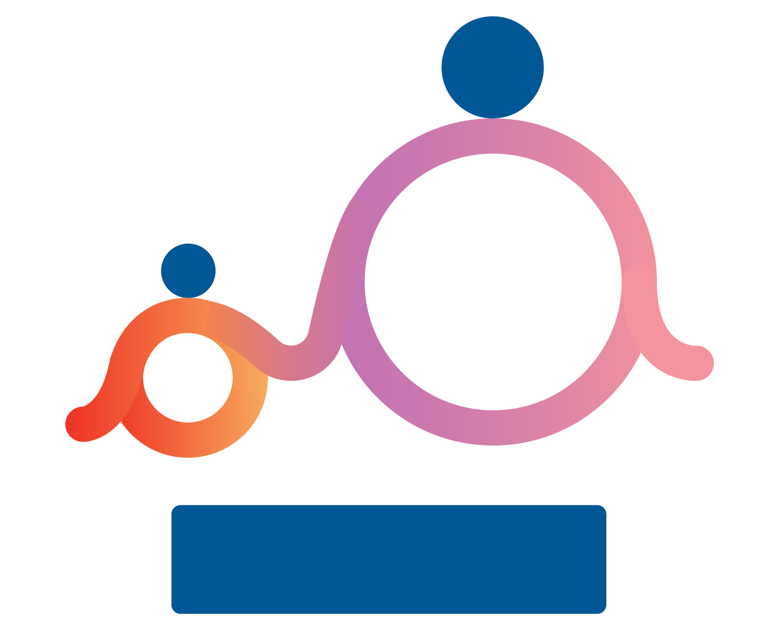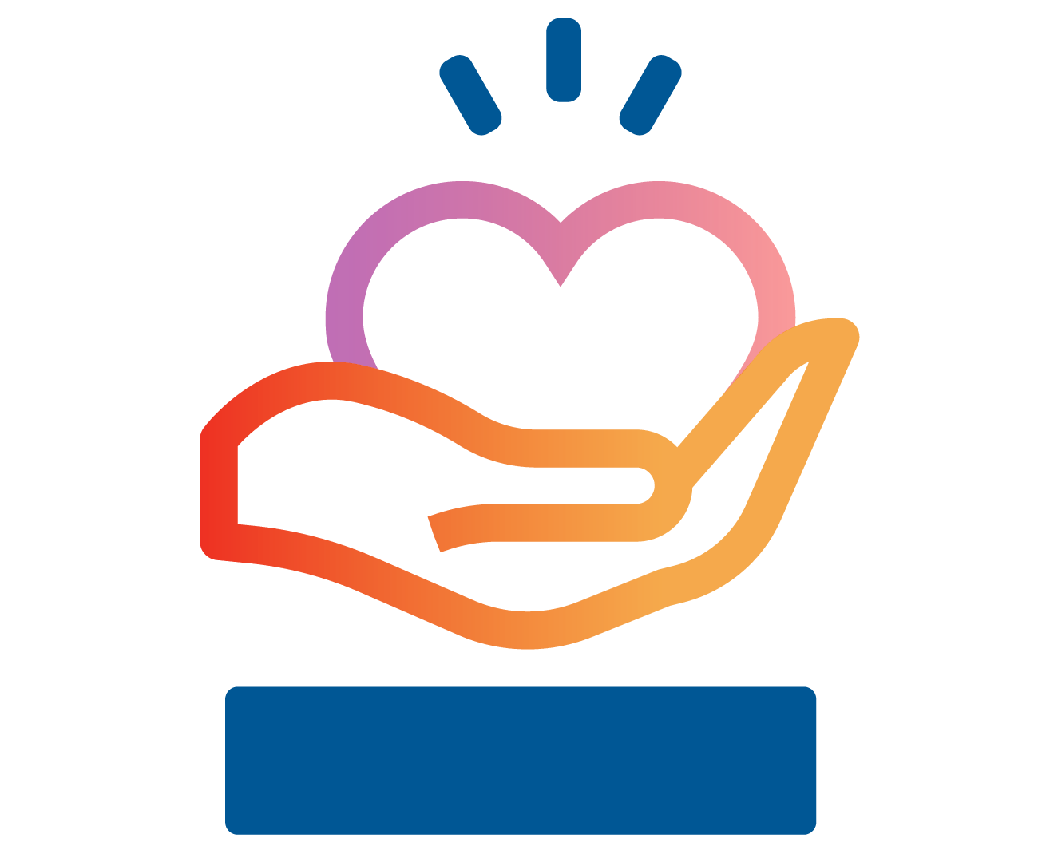

Responsible fatherhood promotion
Work with young families, especially men, to promote responsible fatherhood and the equal distribution of domestic chores
Opening of municipal father's spaces
Promo of paternity leave and father's engagement in parenthood

Gender-based violence response
Setting up crisis rooms for GBV survivors
GBV survivors reskilling through IT training
Prevention of early signs of violence among youth
Family-friendly and GBV prevention practices in the corporate sector
Work with the corporate sector on the development and implementation of family-friendly policies aimed to support a work-life balance and ensure zero tolerance for domestic violence in companies
Awareness building among representatives of the corporate sector on gender-sensitive practices and GBV prevention
First National Best family-friendly company ranking
Gender assessments of companies
Sensitization of the hotel industry on GBV response

Gender mainstreaming in education
Work with youth and educators, school children and parents to overcome gender stereotypes in education and in choosing a future profession
Development of gender strategy in education
Anti-discrimination expertise of educators, textbook authors and publishers and advocacy at the policy level
Promoting STEM professions among girls
Campaigning for stereotype-free career choice
Prevention of violence among young athletes at schools and sports sections
Key partners:
- Embassy of Sweden in Ukraine
- National: Office of the Vice Prime-Minister for European and Euro-Atlantic Integration Office, Міnistry of Education and Science of Ukraine, Government Commissioner for Gender Equality Policy, members of the Parliament
- Regional: Lviv city council, Department of Education of the Lviv City Council, Zaporizhzhia City Council, Poltava City Council, Khmelnytsky City Council, Ternopil City Council, Zakarpattia Oblast Council, Uzhhorod City Council, Berdiansk City Council.
- Civil Society organizations: EdCamp Ukraine, Junior Academy of Science, NGO "Posmishka UA", NGO "UAFishingClub", Molodvizh, Lviv Open Lab, Beetroot Academy, Association of Innovative and Digital Education, Ukrainian Educational Hubs’ Network
- Communication: StarLight Media group
- Companies (corporate sector partners)

UNFPA work on promotion of non-discriminatory and stereotype free approach in education, greater participation of women and girls in STEM, advancement of the responsible fatherhood and paternity leave, sensitization of the corporate sector towards family friendly and GBV response practices, and supporting of gender based violence survivors has made a significant contribution to the implementation of the Biarritz Partnership which was publicly recognized and supported by key government actors, including the Office of Vice Prime Minister in European and Euro-Atlantic Integration and the Office of the First Lady of Ukraine.
2.1. Context
Harmful social norms, beliefs and gender stereotypes are the root causes of all existing inequalities and gender-based discrimination.
The following context factors were taken in consideration while development and adjustment of the project design.
Education system:
Education system, and schools in particular, play an important role in promoting gender equality and free from stereotypes career choice. On the other hand, schools also contribute to creation and spread of societal values and norms among students. However, the attitudes and values shared by teachers include harmful stereotypes and the textbooks used by them are mainly gender blind. However, the education sector has a huge potential to influence the evolution of social norms and men’s and women’s equal opportunities including economic empowerment and acceptance of gender equality as a fundamental value. Therefore, timely gender mainstreaming at school curricula, teaching process and all the forms of interaction between teachers, parents and children is considered to be one of the best ways to improve gender equality in the long run.

In January 2021 the national baseline survey regarding the choice of professions among young people “What Ukrainians are driven by when choosing a profession: the results of national public opinion survey on key factors and stereotypes” was conducted in order to adjust the initial design of the project gender-transformative interventions regarding behavioral change in choosing career path and serve as a basis for measuring project efficiency at its end.
The survey revealed that a significant portion of Ukrainians (56% of those aged 14 and above) still support the division of professions into "male" and "female" categories. Some reasons cited for this division include physiological differences (73%), societal beliefs (38%), different upbringings of boys and girls (29%), and varying professional orientations (25%).
To identify the ongoing progress and project contribution the repeated survey was done in May 2023. It indicated shifts in Ukrainians' attitudes towards gender-specific professions and career choices in response to the war. Younger generations and women, in particular, show a trend towards breaking away from traditional gender norms in their career decisions. Among the Ukrainian population, 52% agree that there are professions exclusively suited for men or women, and 44% do not agree (in 2021 only 30% did not agree with this statement, which marks the growth of this indicator). Men are more likely to agree with this notion (55% vs. 49% of women).

Men engagement:

Rigid gender roles impact both men, women and their children. The rigid gender division of labour restricts men’s roles to the breadwinner and ties women to their reproductive role, maternal care, and household chores. Men suffer from limited engagement with children, based on the concept of fatherhood as a ‘parental status’ that differs from fatherhood as ‘parenting behaviour.’ The distribution of household responsibilities is highly unequal, with many more women shouldering the double burden of working a job and at home. Norms, culture and stereotypes perpetuate gender inequalities that can be expressed through violence and discrimination against women.

In autumn 2020 the national baseline survey on men engagement in child care and domestic chore was conducted in order to refine the design of full-fledged project interventions regarding gender-transformative behavioral change. To measure the contribution of men engagement interventions and social trends the repeated survey was conducted in 2023.

Compared to 2020, the participation of fathers in caring for children of all age categories has increased: in daily care (26% of parents testified to an even distribution of responsibilities in 2023 versus 10% in 2020), including taking care of sick children (16% versus 7%), buying goods for children (20% versus 12%), taking to kindergarten and school (27% versus 10%), studying (26% versus 17%), going for a walk (30% vs. 17%), communicating (42% vs. 20%), etc.

However, there are persisting gender stereotypes that influence fathers' involvement in childcare. Despite increased participation, some fathers still hold traditional beliefs that child-rearing is primarily a woman's responsibility. This points to the need for continued efforts to challenge and dismantle gender norms, promoting greater gender equality in parenting roles.

Corporate sector

Expanding choices for both men and women, engaging men in unpaid care work benefits the entire economy and society, promotes families’ work-life balance and allows everyone to fulfill their full potential at work and at home. One of the key interventions for addressing gender equality is integration of gender-transformative approaches within a corporate sector as a part of the corporate social responsibility agenda. Gender equality, family-friendly workplace policies, including paternity leaves for men can make a big difference in expanding choices for both men and women, removing pressure around decisions of if and when to have children, and allowing everyone to fulfill their full potential at work and at home.
Before the war according to the UNFPA studies in Ukraine:
- 62% of men recognize that usually the wife provides daily care for the child;
- 78% of men say that in their families the wife is a person who stays at home with a sick child
- Less than a half (45%) of the white-collar respondents agreed that the management treats women and men equally when they take a childcare leave due to a child’s sickness;
- Only a third of them admitted that women and men would be able to take equal advantage of parental leave until the child teaches 3 years of age.
- Men are only 5% among office workers who took advantage of parental leave until the child is 3 years old;
- 20% of men would like to take childcare leave for at least for some time, especially this trend is visible among the youngest men.
- 76% said that there are no special “family-friendly” policies for staff with family obligations
- 53% see a need in “work and life balance” corporate policies.

Domestic and gender based violence response
Domestic violence has multiple effects on the quality of life of the survivors and their children, it also affects their professional life, as 78% of respondents said that domestic violence had a negative impact on their professional development, 10% even had to change the place of work due to this. The estimated economic costs of GBV in Ukraine are believed to have reached USD 208 million in 2017.
A blended approach with short term and long term solutions is pursued to address GBV in Ukraine. As a part of immediate GBV response, crisis rooms serve as life-saving options for women and girls seeking refuge from abusers. GBV survivors can stay with their children for 10 to 20 days and receive 24-hour psychological and legal assistance until a more sustainable solution is found. During wartime some rooms expanded their functionality and also have hosted internally displaced women with children from conflict-affected areas.
From the long term perspective, lack of social and economic autonomy for women and girls increases their vulnerability to violence and decreases agency to respond and break out of the vicious circle of GBV. In addition, many women feel forced to cede control over earnings to their partners and tolerate their abusive behaviour to ensure the survival and financial support of their children. Economic empowerment of GBV survivors and women with disabilities, as most vulnerable to discrimination and GBV, enables them to acquire new IT skills, secure employment and encourage fulfilment of their potential. It strengthens the economic capacity of women at the household level and their autonomy to realize their opportunities while the corporate sector will gain skilled professionals working remotely (minimising operation costs for business).
Key trends in Eastern Europe illustrate that elimination of gender inequality and the push towards the empowerment of women and girls represent both a driver of progress towards the Sustainable Development Goals (SDGs) and a solution for the sustainable development of the whole region including Ukraine.

Key Project Results
Major project highlights in 2020-2023

More than 3,200 educators improved their competences in applying an anti-discrimination approach in education and acquired theoretical and practical skills of eliminating stereotypes in the education process

Education hubs in Ternopil and Volyn oblasts empowered 8,795 participants with new psychological and professional knowledge and skills.

UNFPA opened 5 TatoHubs in Poltava, Zaporizhia, Ternopil, Uzhhorod, Khmelnytskyi and supported the resume of TatoHub of Berdiansk

9 crisis rooms for GBV survivors in Ternopil, Lutsk, Chernivtsi, Uzhhorod, Khmelnytskyi, Zhytomyr, Khotyn, Kropyvnytskyi, Zaporizhzhia

More than 18,000 girls participated in educational events on non-discriminatory approach in education within the project

The #CVIDOMI career choice project communication campaign c reached over 20,210,000 of contacts with the audience.

485 GBV survivors empowered in IT
Contribution to development and adoption Legislation on equal opportunities for mothers and fathers to care for their children
Gender strategy in education
Education hubs in Ternopil and Volyn oblasts empowered 5,673 participants on stereotypes free career choice and capacited them through career guidance
40 business entities became signatories of UNFPA Corporate Alliance through signing of the Declaration for Gender Equality and Prevention of Domestic Violence

The key results of the “Equality Springboard” project include:
Education and stereotypes free career choice:
- Contribution to development and adoption of the Strategy for the Implementation of Gender Equality in the Education Sector until 2030 aimed at ensuring equal rights and opportunities for women and men, as well as prevention of and counteraction to any discrimination in the educational process at all levels;
- Adoption of methodological recommendations (сriteria) for gender-sensitive anti-discrimination examination of textbooks by the Institute of Education Content Modernization in November, 2022, which sets a basis for shaping a culture of inclusiveness and non-discrimination within the education system;
- National information campaign to promote free-from stereotypes career choices outreached more than 20 million people during 2021-2023 years;
- Over 18,000 girls have been capacitated through non-discriminatory approaches in education and career guidance, including STEM area;
- More than 3200 educators, experts on anti discrimination, publishers and authors of school textbooks improved their competences in applying an anti-discrimination approach in education and acquired theoretical and practical skills of eliminating stereotypes in the education process.
Men engagement:
Contribution to development and adoption of the national law No 1401-IX that ensured equal opportunities for mothers and fathers to care for their children in May 2021. It introduces a mandatory 14-day paid paternity leave for fathers at the birth of a child, an equal right to childcare leave until the child is 3, and an additional leave in case of a child’s illness or disability;
Establishing 5 TatoHubs and sustaining 1 TatoHub launched within another project in cooperation with local authorities and NGOs at the community level. TatoHubs are spaces for transforming rigid masculinity into caring one through involved parenting/fathering, educating men on child psychology, promoting gender equality and healthy partnerships, non-violent communication, prevention of domestic violence and engaging men in performing household chores. Since the start of the war to address both humanitarian needs and project goals, the network of TatoHubs was repurposed into community-based, resilience-building, family-friendly solutions for families with kids.
Behavior changing communication campaigns aimed at involving fathers in the active caretaking of children, developing parenting skills and nurturing the culture of partnership relations with the total outreach of more than 24,681 000 contacts with the audience during 2021-2023 years.
Corporate sector:
Integrating of gender-transformative approaches (family-friendly policies and policies on prevention of domestic violence and establishing zero tolerance to all its forms) as a part of the corporate social responsibility agenda. With the support of the project as of January 2022, 40 business entities became signatories of UNFPA Corporate Alliance through signing of the Declaration for Gender Equality and Prevention of Domestic Violence;
A baseline study of Ukrzaliznytsia's corporate policies regarding gender equality, family-friendly approach, non-discrimination and zero tolerance for violence was conducted to help the state company make its corporate policies more gender sensitive.
The media project «Equally valuable in business» in partnership with New Voice (NV) media holding engaged 9 companies, MP, gender expert to outline the most common corporate family friendly practices during the war time. 985,000 representatives of business-oriented audiences reached via various media tools.
GBV response
9 crisis rooms opened: Ternopil, Lutsk, Chernivtsi, Uzhhorod, Khmelnytskyi, Zhytomyr, Khotyn, Kropyvnytskyi, Zaporizhzhia.
485 women acquired new professions in IT (Design, QA Manual, HR in IT, DM, Project Management in IT, FrontEnd) in 2022.
The war outbreak in Ukraine considerably affected all project supported activities and initiatives leading to transformation to better meet beneficiaries’ needs. The adapted modalities include:
- men engagement (more focus on family friendly solutions addressing conflicts in families, sustaining close relations at distance, non-violent communication, dealing with losses; empowering TatoHubs’ psychologists on crisis counseling);
- exploring family friendly policies in the corporate sector during wartime and finding solutions to tackle gaps in knowledge in operating a gender-sensitive business;
- building psychological resilience of female educators and empowering them with basic trauma processing techniques to help school children within gender equality mainstreaming in education;
- transforming crisis rooms as temporary shelters for women with children fleeing the war from the regions of Ukraine with active hostilities;
- intensifying psychological support, mentoring for GBV survivors trained in IT and focusing on IT specialties with more flexibility to students to enhance their chances to complete the courses.
2.2. Geographical scope and timeframe
The project has national coverage, with local interventions in Poltava, Zaporizhzhia, Khmelnytskyi, Uzhhorod, Ternopil, Lutsk, Kyiv, Berdiansk. Some of the partners are located in front-line cities or cities with a high level of danger.

- Evaluation purpose, objectives, and use

The Project has been implemented for 40 months (September 2020 - December 2023). This end of project evaluation focuses on the entire implementation period.
The purpose of the end of project evaluation of the "Equality Springboard" project is to assess the overall effectiveness, impact, and possible sustainability of the project's interventions in advancing gender equality, responsible fatherhood, corporate sector, promoting women's empowerment, and addressing gender-based violence (GBV) prevention and response in Ukraine. The evaluation aims to generate evidence-based findings and recommendations that will inform future programming, policy development, and decision-making processes.
The specific objectives of the evaluation are as follows:
- Assess the effectiveness of the project interventions/results/impact in terms of alignment with the needs of beneficiaries within the national context (including Covid and the war) and correspondence with international instruments on gender equality, responsible fatherhood, stereotypes free career choice, women's empowerment, corporate sector and GBV prevention and response;
- Assess the organizational efficiency of the project in relation to delivering the desired results of the project.
- Analyze how the human rights-based approach and gender equality principles were integrated in the design and implementation of the project.
- Examine the efficiency and cost-effectiveness of project implementation, including the utilization of resources and the extent to which targets were achieved within the allocated budget and timeframe.
- Assess the possible sustainability of project interventions, partnerships, and institutional capacities developed during the implementation phase given the war context and its limitations and consequences.
- Identify good practices, lessons learned, and areas for improvement and provide recommendations that can guide future programming and policy initiatives in the areas of gender equality, responsible fatherhood, stereotypes free career choice, women's empowerment, corporate sector and GBV prevention and response. The findings will be shared with the key stakeholders of this evaluation (national and local) within the Project Steering Committee and UNFPA.
The evaluation findings and recommendations will be used to:
- Inform future programming and strategic planning within UNFPA and its partners to enhance the effectiveness and impact of interventions related to gender equality, responsible fatherhood, stereotypes free career choice, women's empowerment, corporate sector and GBV prevention and response.
- Enhance accountability and transparency by providing stakeholders with an independent assessment of the project's achievements, challenges, and lessons learned.
- Generate and share knowledge and best practices, reflect on challenges; lessons learnt and propose actionable recommendations for future programming for other organizations, policymakers, and practitioners working in the relevant fields.

- Evaluation scope, methodology and questions

4.1. Scope of the evaluation
The evaluation will encompass the entire duration of the "Equality Springboard" project, from its inception to its completion. It will cover all project interventions, activities, outputs and outcomes related to advancing gender equality, responsible fatherhood, stereotypes free career choice, women's empowerment, corporate sector and GBV prevention and response in Ukraine.

The evaluation will consider the geographical scope of the project, which also includes multiple regions and communities across the country. It will also take into account the various stakeholders involved, including UNFPA, project staff, government entities, civil society organizations, beneficiaries, and other relevant actors.

4.2. Evaluation methodology
The evaluation will employ a mixed-methods approach, combining both qualitative and quantitative data collection methods to ensure a comprehensive assessment of the project. The methodology will involve the following key elements:
- Desk review of project documents: thorough examination of project documents, reports, surveys, and relevant literature to gather information on project design, implementation, and outcomes.
- Key informant interviews: In-depth interviews with project stakeholders, including UNFPA staff, project partners, government officials, civil society representatives, and beneficiaries, to capture diverse perspectives and insights, to explore their experiences, perceptions, and feedback on the project interventions.

The evaluation methodology will be participatory, involving stakeholders at different stages of the evaluation process to ensure their meaningful engagement and ownership of the evaluation findings.

The evaluation methodology will follow a Theory of Change approach.

4.3. Evaluation questions

The selected evaluation consultant(s) will develop an evaluation matrix, which will relate to the questions below and refine them as needed, the areas they refer to, the criteria for evaluating them, the indicators and the means for verification as a tool for the evaluation. The list of questions below is indicative and will be validated/adjusted by the evaluation consultant(s).

The evaluation will address the following key questions:

Relevance:

- To what extent did the project achieve its overall objectives?
- Was the project relevant to the identified needs?
- To what extent did the project interventions address the specific needs and priorities of the target groups, particularly in terms of gender equality, responsible fatherhood, stereotypes free career choice, women's empowerment, corporate sector and GBV prevention and response?
- How well did the project align with the national development strategies and priorities related to promoting gender equality, responsible fatherhood, stereotypes free career choice, women's empowerment, corporate sector and GBV withdrawal in Ukraine?
- To what extent did the project engage key stakeholders, including government authorities and local communities, in design and implementation of activities including addressing the impact of the Russian war in Ukraine?
- Were the inputs and strategies identified, and where they realistic, appropriate and
- adequate to achieve the results?
- How well did the project adjust its interventions in order to adapt to the needs of beneficiaries affected by the war (including gender-sensitive approach)?

Coherence:

- To what extent does the "Equality Springboard" project adhere and contribute to the strategic priorities of UNFPA and align with its larger portfolio on gender equality, responsible fatherhood, stereotypes free career choice, women's empowerment, corporate sector and GBV prevention and response?
- Is the project achieving synergies and collaboration between UNFPA and national, local government counterparts, and civil society organizations in promoting gender equality, responsible fatherhood, stereotypes free career choice, women's empowerment, corporate sector and GBV withdrawal?
- To what extent the "Equality Springboard" project align with "Biarritz Partnership" and other legal frameworks that were the basis of the project?

Effectiveness:

- To what extent have the overall progress and results of "The Equality Springboard" project been achieved in terms of promoting gender equality, responsible fatherhood, stereotypes free career choice, women's empowerment, corporate sector and GBV withdrawal?
- How effective has the project been in responding to the needs of the beneficiaries, and what results were achieved?
- Have there been any unforeseen positive or negative results and outcomes from the project, and how have they impacted the target groups and beneficiaries?
- How effective have the selected strategies and approaches of the project been in achieving the desired outcomes and creating shifts in harmful gender norms and stereotypes?
- To what extent has the project introduced innovative approaches and practices to address gender norms and stereotypes and promote gender equality?
- How effectively has the project adjusted its activities to respond to the gender-specific needs of the project target audience impacted by the war?
- To what extent have the expected results and outcomes of the “Equality Springboard" project been achieved in the context of the Russian war in Ukraine?

Efficiency:

- Was the process of achieving results efficient? Specifically did the actual or expected results (outputs and outcomes) justify the costs incurred? Were the resources effectively utilized?
- How effective has the leadership and management of the project been in terms of ensuring efficient delivery and timely implementation of activities?
- Has the project demonstrated efficiency in terms of delivering the expected results within the specified timeframe?
- To what extent has the project's management structure facilitated or hindered the efficient implementation and delivery of the interventions?

Sustainability:

- What is the likelihood that the benefits of the project achieved results will be maintained after the project phase out?
- How effectively has the project generated ownership and fostered partnerships with relevant stakeholders, including CSOs, to ensure the sustainability of efforts and the continuation of work on gender norms?
- What critical factors will be essential for maintaining the project's results and sustaining the progress made in promoting gender equality, responsible fatherhood, stereotypes free career choice, women's empowerment, corporate sector and GBV withdrawal in the long term?
- What are the critical factors and challenges in maintaining the long-term impact of the project's interventions in the context of the ongoing war and its aftermath?
- Describe the main lessons that have emerged.
- What are the recommendations for similar support in future? (NB: The recommendations should provide comprehensive proposals for future interventions based on the current evaluation findings).
- Phases of the evaluation process
The evaluation of the “Equality Springboard" project will follow a systematic and structured approach, consisting of the following phases:

a) Planning Phase: In this phase, in consultations with the UNFPA team the evaluator/s will develop an evaluation plan, which includes the designed methodology, including evaluation questions, determining data, identifying key stakeholders and beneficiaries for the interview, and establishing a timeline for the evaluation process.
Submission of the evaluation plan to UNFPA for approval.

b) Data Analysis Phase: During this phase, the evaluator/s will analyze the available data and identify key findings, trends, and patterns emerging from the data and analyze them in relation to the evaluation questions.

c) Stakeholders’ and Beneficiaries’ Interview Phase: The evaluator/s will hold interviews with the involved stakeholders and beneficiaries to validate the analyzed data and gather insights and in-depth information on perceptions of project interventions and results by the project’s target groups.

c) Reporting Phase: The evaluator/s will prepare a comprehensive evaluation report that presents the findings, conclusions, and recommendations. The report will include an executive summary, evaluation methodology, key findings, analysis of results, lessons learnt and a set of actionable recommendations for improving the project's effectiveness and impact.

e) Dissemination and Utilization Phase: The evaluation findings and recommendations will be presented to the Project Steering Committee and shared with relevant stakeholders through various channels, such as workshops, presentations, and written communications.

Throughout the evaluation process, regular communication and coordination will take place between the evaluator/s and UNFPA project team to ensure transparency, quality assurance, and timely completion of the evaluation.
- Expected deliverables and timeframe

The evaluator/s will be expected to complete the tasks within the indicative timeframe:

Tasks/deliverables | Estimated timing
Planning and data analysis phase (desk review, elaboration of evaluation plan, which includes the designed methodology, including evaluation questions, determining data, identifying key stakeholders and beneficiaries for the interview, and establishing a timeline for the evaluation process  Submission of the evaluation plan for UNFPA review. | September 2023 (up to 5-7 working days)
Feedback on the draft evaluation report by UNFPA team | Up to 3 working days
Stakeholders’ and Beneficiaries’ Interview Phase | September, beginning of October 2023 (up to 5-7 working days)
Development and submission of the draft evaluation report and presenting of key findings to the UNFPA team | October 2023 (up to 5 working days)
Feedback on the draft evaluation report by UNFPA team | October 2023 (up to 5 working days) UNFPA team
Final report submission, including executive summary and annexes detailing methodological approach | October 2023 (up to 3-5 working days)

The main deliverables of the evaluator/s will include a comprehensive evaluation report that presents the findings, conclusions, and recommendations based on the evaluation objectives. The report will be written in both Ukrainian and English languages, clear and concise manner, highlighting the key findings, challenges, lessons learned and recommendations of the evaluation.

In addition to the submission of the report, the evaluator/s will also present the end of project evaluation findings in both Ukrainian and English languages to UNFPA Ukraine and project partners (including the Final Project Steering Committee Meeting in November).

- Evaluator/s’ requirements

The evaluation should be done by a national expert or 2 experts with proven experience and expertise in gender equality, women's empowerment, and related fields. The evaluator/s should be familiar with international frameworks and standards on gender equality, as well as the Ukrainian context and gender-related issues. Strong analytical and research skills, excellent verbal and written communication skills, and the ability to work independently and meet deadlines are essential for the evaluation. Cultural sensitivity and the ability to work effectively with diverse stakeholders will also be important.

Field missions or site visits are not foreseen. In-depth interviews and related meetings should be done online.

Evaluator/s estimated number of working days is: 24 (timeline for UNFPA review is not included).

Evaluator/s:

Duties and Responsibilities:
- Provide management of the evaluation process;
- Design the evaluation methodology;
- Analyze the available quantitative and qualitative data and perform desk review of the project related documentation;
- Prepare and conduct interviews with reference groups and other stakeholders;
- Assess the project's effectiveness, efficiency, and sustainability;
- Prepare the draft and end of project evaluation reports in both Ukrainian and English languages;
- Prepare visualization and presentation of findings;
- Ensure adherence to the evaluation plan and timeline.

Qualifications and Requirements:
- Advanced degree in social sciences, gender studies, development studies, or a related field;
- Extensive experience in conducting project evaluations, preferably in the field of gender equality and women's empowerment;
- Excellent knowledge of evaluation principles, norms, standards, methodologies, designs, ethics and practices;
- Strong data management, analytical, research and report writing skills;
- Technical evaluation skills;
- Knowledge of the Ukrainian context and gender-related issues;
- Proven experience in gender equality programming and evaluation;
- In-depth knowledge of gender mainstreaming approaches and methodologies;
- Familiarity with international frameworks and standards on gender equality;

Please visit this link for more information on UNFPA’s Core Values and Competencies: https://www.unfpa.org/sites/default/files/resource-pdf/UNFPA_Career_Guide_0.pdf
Payment Terms
The payment will be done in two installments in accordance with the completion of the following deliverables upon approval by the “Equality Springboard” Project Coordinator and submission of the service provider invoice:
The contract amount will be paid in installments as follows:
- 40% upon completion of the planning and data analysis phase (desk review, elaboration of the evaluation methodology and Stakeholders’ and Beneficiaries’ Interview accomplishment.
- 60% upon acceptance of the end of project evaluation report with respective annexes.
The payment will be done in UAH according to the UN exchange rate. The evaluation will be funded by the “Equality Springboard: Project on Social Norms Change and Gender Stereotypes Elimination for Better Resilience and Prosperity of Women and Men in Ukraine, funded by the Government of Sweden” (SEB14).
Monitoring and progress control, including reporting requirements, periodicity format and deadline: deliverables envisaged by these terms of reference should be submitted to the “Equality Springboard” coordinator according to the specified timeline.

The baseline survey was done within the “EU4Gender Equality: Together against gender-stereotypes and gender-based violence” (EU4 GE) implemented in cooperation with UN Women and the “Equality Springboard”. https://ukraine.unfpa.org/uk/omnibusEU4GE
The Biarritz Partnership promotes the adoption and implementation of progressive legislation for gender equality and the removal of existing discrimination that may persist. Ukraine has identified five areas in which it has committed to regulatory and legislative progress in favour of gender equality: - Improving parental leave legislation; - Promoting an inclusive, gender-sensitive public environment; - Addressing gender equality in the education system; - enforcement of domestic and gender-based violence legislation; - promoting women’s economic empowerment; reducing the gender pay gap. Components of parental leave legislation,gender equality in education, women’s economic empowerment, end gender-based violence response are in line with the Project. https://www.diplomatie.gouv.fr/en/french-foreign-policy/french-g7-presidency-2019/the-biarritz-partnership-for-gender-equality/article/ukraine-256678
2019 year - https://ukraine.un.org/en/90689-strategy-prevention-and-response-conflict-related-sexual-violence-ukraine
Research «Gender Equality and Response to Domestic Violence in the Private Sector of Ukraine: Call for Action», (2019); Masculinity research (2018); National omnibus on parents choices and behaviours regarding child care, paternity leave (2020).
Economic costs of violence against women in Ukraine, 2017, UNFPA Ukraine https://ukraine.unfpa.org/sites/default/files/pub-pdf/Economic%20Costs%20of%20Violence_2017_3.pdf
The national baseline survey “What Ukrainians are driven by when choosing a profession: the results of national public opinion survey on key factors and stereotypes” conducted in January 2021: https://ukraine.unfpa.org/en/publications/what-ukrainians-are-driven-when-choosing-profession-results-national-public-opinion
The Strategy for the Implementation of Gender Equality in the Education Sector until 2030 https://mon.gov.ua/ua/news/uryad-shvaliv-strategiyu-vprovadzhennya-gendernoyi-rivnosti-u-sferi-osviti-do-2030-roku
The role of men in parenthood during the full-scale war report. Eng: https://docs.google.com/presentation/d/1WjJ1bLgAb5ZfdAxnctiVjBAg3HwW7PWX/edit#slide=id.p1 Ukr: https://docs.google.com/presentation/d/1I65b8IKRE80D_DsDqdZ_VwzASPzmdKDP/edit#slide=id.p1
Operating: Zaporizhzhia, Poltava, Ternopil, Uzhhorod, Khmelnytskyi. Supported: Berdiansk
The influence of full-scale war on the choice of profession report. Eng: https://docs.google.com/presentation/d/1PdJn92zwt565vHuTGWwkxI92WP_kZac1/edit#slide=id.p1 Ukr: https://docs.google.com/presentation/d/1u0mAkzigM7_aWVsOwYm_VnOfE4P-2oik/edit#slide=id.p1

