United Nations Population Fund
Address: 42-44 Shovkovychna street, 01004 Kyiv, Ukraine
Telephone: +380 44 281 32 31
Website: www.unfpa.org

25 January, 2022

INVITATION TO BID
ITB No. UNFPA/UKR/ITB/22/01

Procurement of equipment and furniture for GBV specialised services in UK-supported cities.

Dear Sir/Madam,

- The United Nations Population Fund (UNFPA), an international development agency invites sealed bids for the supply of the following equipment for its programme in Ukraine:

- Mobile phone
- Laptop
- All-In-One desktop PC
- TVset
- Tablet
- Multi-Function Printer laser
- Laser printer
- Telephone (with cable)
- Electric meter
- Internet router (router)
- Office straight table (option 1)
- Recirculator bactericidal
- Stepladder
- Executive chair
- Chest of drawers
- Adult mattress (option 1)
- Bedding set 1.5 (bed linen)
- Towel
- Cleaning set
- Mop for a floor
- Dustpan and broom
- Kitchen towel
- Pillow
- Blanket
- Plaid
- Round bowl
- Corner computer table (option 1)
- Armchair
- Round coffee table
- Straight sofa (option 1)
- Shelving (bookcase)
- Mattress orthopedic 90 * 190 (option 2)
- Desk lamp
- Office guest chair
- Electric radiator
- Wardrobe
- IroSet of bathroom rugs
- Iron
- Ironing board
- Children's pot
- Clothes dryer
- Clock
- Bunk bed transformer
- Corner sofa
- Antechamber
- Rug
- Cordless vacuum cleaner
- Washing machine
- Kitchen faucet
- Electric kettle
- Microwave
- Two-chamber refrigerator
- Cooking surface / electric hob
- Hair dryer
- Kitchen hood
- Kitchen
- Lamp
- Set of pots
- Set of cutlery
- Tableware set
- Tray
- Sink
- Trash can
- Electric towel dryer
- Mirror with locker
- Glass shower
- Compact toilet bowl
- Bath faucet with thermostat and shower
- The brush
- Kitchen cabinet
- The kitchen table
- Kitchen chairs
- Set of hand tools
- Hammer drill
- Set of bathroom accessories
- Laundry basket
- Corner shelf quadrangular
- Projector screen
- Projector
- Armchair-bag
- Baby bed with bedside table and diaper table
- Toilet seat
- Children's blanket 110 * 140
- Children's pillow
- Mobile button phone
- Office safe
- Air conditioning
- Straight sofa (option 2)
- Office chair
- Children's chair
- Children's table
- Tablet
- The video surveillance camera wired
- Freezer
- Kitchen table (round)
- Vacuum cleaner for dry cleaning
- Children's highchair for feeding
- Walkers
- Call buttons
- Closet
- CCTV camera
- NETWORK IP VIDEO RECORDER
- NETWORK IP VIDEO RECORDER
- 4 TB hard drive
- Port switch
- Box hinged
- Cable duct (10 pieces)
- Cable (10 pieces)
- Connector
- Monitor min 23"
- Network cable
- Distribution box
- Wooden cutting board
- Dryer stand
- Measuring mug
- Knife set
- Iron teapot
- Cup
- Stainless steel bowl
- Bowls (set)
- Bed 90x200 cm
- Water cooler
- Blanket 1.5
- Towel for hands and face
- Round wall mirror for the bathroom
- TV bracket
- Extension cord
- Laptop
- Shredder
- Window bars
- Information stand
- Ramp
- Armored doors
- Multicooker
- Corner office table
- Cabinet for storage of didactic material
- Soft pouf
- Children's table 6-seater
- Straight sofa (option 3)
- Alarm button
- Office straight table (option 2)
- Marker board
- Rack for booklets
- Sticker board for drawing
- Folding bed
- Children's mattress
- Carpet
- Adult mattress (option 1)
- Bed linen for a children's bed
- Hallway (hanger, mirror, shoe shelf)
- Hand dryer
- Boiler 150 l
- Bucket
- Reception desk
- Fire extinguisher
- First aid kit production
- Rechargeable lamp
- Automatic tonometer
- Contactless thermometer
- Quartz lamp bactericidal / bactericidal irradiator
- Office chair without wheels
- Folding office chair
- The oil heater
- Floor hanger
- Projector mount
- Boiler 20 l
- Garland curtain
- Mobile nightstand
- Infinity light panel
- Night projector Starry sky
- Lava night lamp
- Bedspread - a blanket for a childrens' bed
- The bedspread - blanket for the bed
- Transformer table
- Chair without back
- Mattress topper for children
- Fire shield
- Toilet paper holder
- Shoe cupboard
- Set of frying pans
- Baby changing table
- Metal cabinet for documents

- Bidding shall be conducted through ONE envelope. The technical bid containing the technical specifications and the financial bid containing price information shall be submitted together.

- The bidder shall not be required to quote for all items. However, Bidders are encouraged to quote for as many items as possible.

- Bid package and all supporting documents must be submitted in English.

- To enable you to submit a bid, please read the following attached documents carefully:

Section I: | Instructions to Bidders
Section II: | Technical Specifications and Schedule of Requirements
Section III: | UNFPA General Terms and Conditions
Section IV: | UNFPA Special Conditions for Contracts
Section V: | Bid Forms

- The bid shall reach UNFPA’s reception or the secured email inbox of ua-procurement@unfpa.org no later than 09 February, 2022 by 17:00 pm Kyiv time.

- The bid shall be opened on 10 February, 2022 at 10:00am Kyiv time at UNFPA premises, 42-44 Shovkovychna str., Kyiv 01004, Ukraine. Bidders or their authorized representatives may attend the bid opening. Kindly confirm by e-mail: shulchenko@unfpa.org by 06 February, 2022 whether your company shall be represented at the bid opening.

- Bids received after the stipulated date and time shall not be accepted under any circumstances. Bids delivered through courier and posted later than the due date shall not be registered and shall be returned unopened or shall be shredded. Bids submitted to any other email address than ua-procurement@unfpa.org shall be rejected.

- Bidders shall acknowledge receipt of this Invitation to Bid according to the Bid Confirmation Form, Section V, 1 of this solicitation document by email to UNFPA Ukraine (ua-procurement@unfpa.org) 28 January 2022 and to indicate whether or not a bid shall be submitted. The acknowledgement shall provide company name, telephone number, fax number and the name of a contact person. If you are declining to bid, please confirm this via e-mail to UNFPA and please state the reasons for UNFPA to improve its effectiveness in future invitations.

- Any questions relating to the attached documents shall be addressed in writing to the following UNFPA personnel no later than 03 February 2022 at 17.00, Kyiv time.

  - Iryna Shulchenko, UNFPA Procurement and Logistic Associate email: shulchenko@unfpa.org for questions relating to the bidding exercise.

Do not submit your bid to these contacts, or your bid will be disqualified.

- This letter is not to be construed in any way as an offer to contract with your firm.

- UNFPA strongly encourages all bidders to register on the United Nations Global Marketplace (http://www.ungm.org). By registering on UNGM, vendors become part of the database that UN buyers use when searching for suppliers. Vendors can also access all UN tenders online and, by subscribing to the Bid Tender Service, vendors can be automatically notified via e-mail of all UN business opportunities that match the products and services for which they have registered. Instructions on how to subscribe to the Tender Alert Service can be found in the UNGM Interactive Guide for Suppliers http://www.ungm.org/Publications/UserManuals/Suppliers/UserManual_Supplier.pdf .

Yours sincerely,

Jaime Nadal
UNFPA Representative in Ukraine

UNITED NATIONS POPULATION FUND

INVITATION TO BID

ITB No. UNFPA/UKR/ITB/22/01

Bid document for procurement of equipment and furniture for GBV specialized services in UK-supported cities

25 January 2022
Table of Contents

SECTION I: Instructions to Bidders 9
A. Introduction 9
1. Scope 9
2. Eligible Bidders 9
3. Fraud and Corruption 9
B. Solicitation Documents 9
4 UNFPA Solicitation document 9
5 Clarifications of solicitation document 10
6 Amendments to UNFPA bid solicitation document 10
C. Preparation of Bids 10
7 Documents to be submitted with the bid 10
8 Bid Currency and Prices 11
9 Validity of Bid 11
D. Submission of Bids and Bid Opening 11
10 Partial Bids 11
11 Alternative Bids 12
12 Bids 12
13 Sealing and Marking of Bids (hard copies) 12
14 Electronic Submission 12
15 Bid Submission Deadline/Late Bids 13
16 Storage of Bids 13
17 Bid Opening 13
E. Evaluation and Comparison of Bids 14
18 Confidentiality 14
19 Clarification of Bids 14
20. Responsiveness of bids 14
21. Nonconformities, Errors, and Omissions 15
22. Preliminary examination of Bids 15
23. Examination of Terms and Conditions and Technical Evaluation 15
24. Conversion to Single Currency 15
25. Evaluation of Bids 16
26. Comparison of Price Bids 16
27. Post-qualification of the Bidder 16
28. UNFPA’s Right to Accept Any Bid and to Reject Any or All Bids 17
29. UNFPA’s Right to Annul a Bidding Process 17
F. Award of Contract 17
30. Award Criteria 17
31. Right to Vary Requirements at Time of Award 18
32. Signing of the contract 18
33. Publication of Contract Award 18
SECTION II: Technical Specifications and Schedule of Requirements 18
SECTION III: UNFPA General Terms and Conditions 77
SECTION IV: UNFPA Special Conditions for Contracts 77
SECTION V: Bidding Forms 78
2. Bid Submission Form 81
3. Bidders Identification Form 82
4. Product Item Overview Form 83
5. Price Schedule Form 89

SECTION I: Instructions to Bidders

Introduction

Scope

1.1 The UNFPA is an international development agency whose goal is to ensure the existence of a world in which every pregnancy is desirable, every birth is safe and every young person can realize his or her potential.
The UNFPA is a leading United Nations agency that promotes the right of every woman, man and child to a healthy life and equal opportunities. As part of this project, UNFPA has supported the procurement of equipment and furniture for GBV specialized services in UK-supported cities.

Eligible Bidders

  - All bidders found to have a conflict of interest shall be disqualified. Bidders may be considered to have a conflict of interest if they are or have been associated in the past, with a firm or any of its affiliates that have been engaged by UNFPA to provide consulting services under these bidding documents.

  - Bidders shall not be eligible to submit a bid if at the time of bid submission:
- The bidder is listed as suspended on United Nations Global Marketplace (http://www.ungm.org) as a result of having committed fraudulent activities,
- The bidder’s name is mentioned in the UN 1267 list issued by the Security Council resolution 1267 that establishes a sanctions regime to cover individuals and entities associated with Al-Qaida and/or the Taliban;
- The bidder is debarred by the World Bank Group.

Fraud and Corruption
  - UNFPA’s policy regarding fraud and corruption is available at http://www.unfpa.org/public/home/procurement/pid/8864 and applies fully to this Invitation to Bid. The submission of any offer implies that the bidder is aware of this policy.

Solicitation Documents

UNFPA Solicitation document

  - Bidders are expected to examine all instructions, forms, specifications, terms and conditions contained within this UNFPA solicitation document. Failure to comply with these documents shall be at the bidder’s risk and may affect the evaluation of the bids, or may result in the rejection of the bid.

  - Bidders are cautioned to read the specifications carefully (see Section II Technical Specifications and Schedule of Requirements), as there may be special requirements. The technical specifications presented herein are not to be construed as defining a particular manufacturer’s product. Bidders are encouraged to advise UNFPA if they disagree.

  - The specifications are the minimum requirements for the products and related services. Products and services offered must meet or exceed all requirements herein. The products shall conform in strength, quality and workmanship to the accepted standards of the relevant industry. Modifications of or additions to basic standard products of less size or capability to meet these requirements will not be acceptable.

Clarifications of solicitation document
  - A prospective bidder requiring any clarification on the bid solicitation documents may notify UNFPA in writing within one week from the date of issue of the bid. UNFPA shall respond in writing to any request for clarification received and circulate its response (including an explanation of the query but without identifying the source of enquiry) to all prospective bidders who have received the bid solicitation documents. A copy of UNFPA’s answer shall also be posted on the UN Global Marketplace, http://www.ungm.org/, http://ukraine.unfpa.org/ , http://procurement-notices.undp.org/

Amendments to UNFPA bid solicitation document

  - At any time prior to the deadline for submission of bids, UNFPA may for any reason, whether at its own initiative or in response to a clarification requested by a prospective bidder, modify the bidding documents by amendment.

  - All prospective bidders that have received the bidding documents shall be notified in writing of all the amendments to the bidding documents. In order to give prospective bidders reasonable time to take the amendments into account in preparing their bids UNFPA may, at its discretion, extend the deadline for the submission of bids.

Preparation of Bids

Documents to be submitted with the bid

  - Documents Establishing the Eligibility of the Bidder
To establish their eligibility, bidders shall:
- Complete the Bid Submission Form, Section V, 2.
- Complete Bidders Identification Form, Section V, 3.

  - Documents Establishing the Qualifications of the Bidder
To establish its qualifications, the bidder shall submit to UNFPA’s satisfaction the following documents:
- Evidence that the bidder is established as a company and legally incorporated in the country where it resides; e.g. through provision of certification of incorporation or other documentary evidence (this is not required for companies already registered in national, regional or international Stock Exchanges);
- Post qualification documentation outlined in Instructions to Bidders, Sub-Clause 27

Failure to furnish all the information required for submission shall be at the bidder’s risk as it may then be determined that the bid does not substantially respond to the UNFPA bid document in every respect. This may result in a rejection of the bid.

  - Documents Establishing the Eligibility and Conformity of the Goods and Related Services
Bidders shall submit:
- Documentary evidence that the goods conform to the Technical Specifications and standards specified in Section II Technical Specifications and Schedule of Requirements.
- Completed Product Item Overview Form, Section V, 4.
- Product catalogs containing pictures of the product(s).
- Certificate of Conformity.
- Manufacturer’s technical product specifications or datasheets.
- The bidder shall also furnish a list giving full particulars, including available sources and current prices of spare parts, special tools, etc., necessary for the proper and continuing functioning of the goods during 24 month following commencement of the use of the goods by UNFPA. Bidders must complete and submit with their bid the Excel table containing the individual item details, as per Form in Section V.4. Bidding Forms.

Bid Currency and Prices

All prices shall be quoted in any convertible currency to US Dollars (USD). The UN exchange rate will be applied. https://treasury.un.org/operationalrates/OperationalRates.php

Note: All prices must be exclusive of VAT tax, since UN and its specialized agencies are exercising zero VAT payer status.

  - Bidders are requested to quote the following based on INCOTERMS 2010 (The terms FCA, CPT and other similar terms shall be governed by the rules prescribed in the INCOTERMS 2010, published by the International Chamber of Commerce):

- DAP Kyiv, Ukraine

  - Where installation, commissioning, training or other similar services are required to be performed by the bidder, the bidder shall include an itemized list of the prices for those services.

Validity of Bid

  - The prices of the bid shall be valid for 60 days after the closing date of bid submission as specified by UNFPA. A bid valid for a shorter period shall be rejected by UNFPA on the grounds that it is non-responsive.

  - In exceptional circumstances, UNFPA may solicit the bidder's consent for an extension of the period of validity under exceptional circumstances. The request and the responses shall be made in writing.

Submission of Bids and Bid Opening

Partial Bids

  - Partial bids are allowed under this tender.

Alternative Bids

11.1. Alternative bids will not be accepted. In the event of a supplier submitting more than one bid, the following shall apply:
- All bids marked alternative bids will be rejected and only the base bid will be evaluated.
- All bids will be rejected if no indication is provided as to which bids are alternative bids.

Bids

  - Bids shall be submitted in one envelope.

  - Bids shall be prepared in accordance with Section II: Schedule of Requirements and Technical Specifications and shall include the requested documentation as per Instructions to Bidders Clause 7, and in accordance with the Price Schedule Form in Section V, 5 of the bid forms.

  - Bids shall be signed by the bidder or a person or persons duly authorized to bind the bidder to the contract. A bid shall contain no interlineations, erasures, or overwriting except as necessary to correct errors made by the bidder. In that case such corrections shall be initialed by the person or persons signing the bid.

Sealing and Marking of Bids (hard copies)

  - When submitting bids in hard copies the bidder shall prepare one set of sealed bids containing the technical and price components.

  - The envelope shall also indicate the name and address of the bidder to enable the bid to be returned unopened in case it is declared “late.”

  - If the outer envelope is not sealed and marked as required, UNFPA shall assume no responsibility for the bid’s misplacement or premature opening.

  - The outer envelope must be signed/sealed and clearly marked with the following:

UNITED NATIONS POPULATION FUND (UNFPA)
42-44 Shovkovychna street
Kyiv 01004 ,Ukraine
Invitation to Bid No. UNFPA/UKR/ITB/22/01
Attention: Iryna Bohun

ONLY TO BE OPENED BY AUTHORIZED UNFPA PERSONNEL

Electronic Submission

14.1. Bids may be delivered to the office or submitted electronically. Please note the following guidelines for electronic submissions:

14.2. Bidders shall make clear reference to the specific bid in the subject field as instructed, otherwise bids may be rejected. Clearly specify the following text in the subject line: ITB No. UNFPA/UKR/ITB/22/01, Bidder’s Name.

14.3. The bid shall be submitted to ua-procurement@unfpa.org. Bids received at the mailbox are kept undisclosed and shall not be opened before the scheduled opening date. Sending to any other email address will violate confidentiality and invalidate the bid.

14.4. E-mail submission shall not exceed 20 MB, including the size of the cover email. It is recommended that all the bidding documents are consolidated into as few attachments as possible which shall be in commonly used file formats. If the bid consists of large electronic files, it is recommended to send these files separately before the deadline indicating the order of emails (email 1, email 2, etc.) after the bid reference number and the Bidder’s name in the subject line of each email.

14.5. It shall be the Bidder’s responsibility to ensure that bids sent by e-mail are received by the deadline. All Bidders shall receive an auto-reply acknowledging the receipt of their email. Bidders shall not receive responses to questions sent to ua-procurement@unfpa.org since it is a secure mailbox.

14.6. In order to avoid last minute internet congestion it is recommended to send your bid as early as possible before the deadline.

15 Bid Submission Deadline/Late Bids

15.1. Bids must be delivered to the office on or before the date and time specified in the introductory letter of this solicitation document. If any doubt exists as to the time zone in which the bid should be submitted please refer to www.timeanddate.com/worldclock, or contact the bid focal point.

15.2. UNFPA may, under special and exceptional circumstances, extend the bid submission deadline and such changes shall be notified on http://www.ungm.org/, http://ukraine.unfpa.org/, http://procurement-notices.undp.org/ before the expiration of the original period.

15.3. Any bid received by UNFPA after the bid submission deadline shall be rejected and returned unopened to the Bidder. UNFPA shall not be legally responsible for bids that arrived late due to the Bidder’s problems with transmission of bid submissions via email and/or with the courier company.

Storage of Bids

16.1. Bids received prior to the deadline of submission and the time of opening shall be securely kept unopened until the specified bid opening date stated in the UNFPA’s solicitation document. No responsibility shall be attached to UNFPA for prematurely opening an improperly addressed and/or identified bid.

Bid Opening

17.1. UNFPA shall conduct the bid opening in public at the following address, date and time.

Street Address: 42-44 Shovkovychna str.
Floor/ Room number: 6th floor, UNFPA in Ukraine
City: Kyiv
Country: Ukraine
Date: 10 February 2022
Time: 10:00, Kyiv time, (reference: www.timeanddate.com/worldclock).

17.2. Bids received electronically by the required deadline will be printed and a copy of the bids will be put in a sealed envelope that will be opened at the time and date specified in the bid document. Only the last received bid will be opened if multiple bids are sent by the same Bidder.

17.3. The bids shall be opened publicly at the time and place specified in the ITB and an immediate record made thereof.

17.4. Only those who have submitted bids or their authorized agent or representative may attend the bid opening.
17.5. The report shall be available for viewing by Bidders for a period of thirty days from the date of the opening. No information that is not included in the bid opening report can be given to Bidders.

17.6. No bid shall be rejected at bid opening, except for late bids, which shall be returned unopened to the Bidder.

Evaluation and Comparison of Bids

Confidentiality

18.1. Information relating to the examination, evaluation, comparison, and post-qualification of bids, and recommendation of contract award shall not be disclosed to Bidders or any other persons not officially concerned with such process until the contract award is published.

18.2. Any effort by a Bidder to influence UNFPA in the examination, evaluation, comparison, and post-qualification of the bids or contract award decisions may result in the rejection of its bid. in the rejection of its bid.

Clarification of Bids

19.1. To assist in the examination, evaluation and comparison of bids, UNFPA may ask bidders for clarification of their bids. The request for clarification and the response shall be in writing by UNFPA and no change in price or substance of the bid shall be sought, offered or permitted.

20. Responsiveness of bids

20.1. UNFPA’s determination of a bid’s responsiveness is to be based on the contents of the bid itself.

20.2. A substantially responsive bid is one that conforms to all the terms, conditions, and specifications of the bidding documents without material deviation, reservation, or omission. A material deviation, reservation, or omission is one that:
- effects in any substantial way the scope, quality, or performance of the goods and related services specified in the contract; or
- limits in any substantial way, inconsistent with the bidding documents, UNFPA’s rights or the Bidder’s obligations under the contract; or
- if rectified would unfairly affect the competitive position of other Bidders presenting substantially responsive bids.

21. Nonconformities, Errors, and Omissions

21.1. Provided that a bid is substantially responsive:
- UNFPA may waive any non-conformities or omissions in the bid that do not constitute a material deviation.
- UNFPA may request that the Bidder submit the necessary information or documentation within a reasonable period of time to rectify nonmaterial nonconformities or omissions in the bid related to documentation requirements. Such omission shall not be related to any aspect of the price of the bid. Failure of the Bidder to comply with the request may result in the rejection of its bid.
- UNFPA shall correct arithmetical errors on the following basis:
  - If there is a discrepancy between the unit price and the line item total that is obtained by multiplying the unit price by the quantity, the unit price shall prevail and the line item total shall be corrected, unless in the opinion of UNFPA there is an obvious misplacement of the decimal point in the unit price. In that case the line item total as quoted shall govern and the unit price shall be corrected;
  - if there is a discrepancy between words and figures, the amount in words shall prevail;
• if there is an error in a total corresponding to the addition or subtraction of subtotals, the subtotals shall prevail and the total shall be corrected;

22. Preliminary examination of Bids

22.1. UNFPA shall examine the bids to determine whether they are complete, that all documents and technical documentation requested as per Instructions to Bidders Clause 7 have been provided and to determine the completeness of each document submitted. UNFPA will also examine whether any computational errors have been made, whether the documents are properly signed, and whether the bids are generally in order.

23. Examination of Terms and Conditions and Technical Evaluation

23.1. UNFPA shall examine the bid to confirm that it does not contain any material deviations, reservation, or omission related to the conditions and requirements specified in the Section II Technical Specifications and Schedule of Requirements, Section III UNFPA General Conditions of Contract and Section IV UNFPA Special Conditions for Contracts.

23.2. If after the examination of the terms and conditions and the technical evaluation UNFPA determines that the bid is not substantially responsive in accordance with Instructions to Bidders Clause 21, the bid shall be rejected.

24. Conversion to Single Currency

24.1. To facilitate evaluation and comparison, UNFPA will convert all bid prices expressed in the amounts in various currencies in which the bid prices are payable to US dollars at the official UN exchange rate on the last day for submission of bids.

25. Evaluation of Bids

25.1. UNFPA shall evaluate each bid that has been determined, up to this stage of the evaluation, to be substantially responsive.

26. Comparison of Price Bids

26.1. UNFPA shall compare all substantially responsive bids to determine the lowest priced substantially responsive bid.

26.2. Bid comparison will be made on the total cost, delivered to the final destination. UNFPA reserves the right to compare freight prices of Bidders with rates of reputable freight forwarders and to consider such rates for the purpose of bid evaluation. In the event that Bidder’s freight prices are found to be less competitive than the rates offered by freight forwarders, UNFPA may issue a contract on FCA basis to the Vendor instead of DAP, and issue a separate contract for freight to a freight forwarder if deemed in the best financial interest of UNFPA.

27. Post-qualification of the Bidder

27.1. UNFPA shall determine to its satisfaction whether the Bidder with the lowest priced, substantially responsive bid is qualified to perform the contract satisfactorily.

27.2. The determination shall be based upon an examination of the documentary evidence of the Bidder’s qualifications submitted in the bid.

27.3. To evaluate a Bid, UNFPA shall consider the following:

- Copy of last year audited company Balance and Financial Statements

- Financial Capability:
  - Liquidity ratio: Current ratio (CurrentAssets/ CurrentLiabilities) > 1.

- Experience and Technical Capacity:
  - Details of experience and past performance of the Bidder on equipment offered and on those of similar nature within the past five years
  - The Bidder shall disclose instances of previous past performance that may have resulted in adverse actions taken against the Bidder and the manufacturers whose products are being offered by the Bidder, in the last five years. Such adverse actions may be treated as unsatisfactory performance history while deciding the award of contract. If no instance of previous past performance has resulted into adverse actions, this must be clearly indicated in the Bidder’s bid.

For non manufacturer Bidders:
- Legally enforceable authorization from the manufacturer assuring full guarantee and warranty obligations as per the tender conditions for the goods offered; and
- The Bidder, as authorized by the manufacturers, has supplied and provided after sales service for similar goods to the extent of at least 20 percent of the quantities indicated in the tender requirements in any one of the last three years, and the goods must be in satisfactory operation.

  - Notwithstanding anything stated above, UNFPA reserves the right to assess the Bidder’s capabilities and capacity to execute the contract satisfactorily before deciding on award.

  - Even though the Bidders may meet the above qualifying criteria, they can be subject to disqualification if they have made misleading or false representations in the forms, statements and attachments submitted in proof of the qualification requirements, and/or record of poor performance such as, not properly completing contracts, inordinate delays in completion, litigation history, financial failures, etc.

28. UNFPA’s Right to Accept Any Bid and to Reject Any or All Bids

28.1. A bid that is rejected by UNFPA may not be made responsive by the Bidder by correction of the non-conformity. A responsive bid is defined as one which conforms to all the terms and conditions of the UNFPA’s bid solicitation documents without material deviations. UNFPA shall determine the responsiveness of each bid against the UNFPA solicitation documents.

28.2. UNFPA reserves the right to reject any bid if a Bidder has previously failed to perform properly or complete on time in accordance with contracts or the Bidder who in UNFPA’s perspective is not in a position to perform the contract.

28.3. The Bidders waive all rights to appeal against the decision made by UNFPA.

29. UNFPA’s Right to Annul a Bidding Process

29.1. UNFPA reserves the right to annul the bidding process and reject all bids at any time prior to award of purchase order, without thereby incurring any liability to the affected Bidder(s) or any obligation to provide information on the grounds for UNFPA’s action.

F. Award of Contract

30. Award Criteria

30.1. In the event of a contract award, UNFPA shall award the Contract to the lowest priced Bidder(s) whose bid has been determined to be substantially responsive with the bidding documents.

30.2. If required, the Bidder shall permit UNFPA representatives access to their facilities at any reasonable time to inspect the premises that shall be used for the production, testing and packaging of the products. The Bidder shall also provide reasonable assistance to the representatives for such inspection, including copies of any test results or quality control reports as may be necessary. UNFPA may inspect the manufacturing facilities of the lowest evaluated responsive Bidder to assess his capability to successfully perform the contract as per the terms and conditions specified in the ITB.

30.3. UNFPA reserves the right to make multiple arrangements for any item(s) where, in the opinion of UNFPA, the lowest Bidder cannot fully meet the delivery requirements or if it is deemed to be in UNFPA’s best interest to do so. Any arrangement under this condition shall be made on the basis of the lowest, second lowest, third lowest, etc., bid which meets the requirements.

31. Right to Vary Requirements at Time of Award

31.2. UNFPA reserves the right at the time of award of contract to increase or decrease by up to 20% the quantity of goods specified in this bid without any change in unit price or other terms and conditions.

32. Signing of the contract

32.1. Prior to the expiration of the period of bid validity, UNFPA shall send the successful Bidder the Contract which constitutes the notification of award. The successful Bidder shall sign, date the Contract and return it to UNFPA within 5 days of receipt of the Contract. After receipt of the contract, the successful Bidder shall deliver the commodities in accordance with the quantity, quality and delivery schedule outlined in its bid in conjunction with UNFPA terms and conditions

33. Publication of Contract Award

33.1. UNFPA shall publish the contract award on United Nations Global Marketplace http://www.ungm.org, with the information of the awarded Bidder company name, contract amount or LTA and the date of the contract.

33.2 Suppliers perceiving that they have been unjustly treated in connection with the solicitation or award of a contract may lodge a complaint directly with the UNFPA Head of Office at ukraine.office@unfpa.org. The UNFPA Head of Office will then make an assessment of the complaint and provide a reply to the supplier within a week. If the supplier is not satisfied with the reply provided by the UNFPA Head of Office, the supplier may escalate the complaint to the Chief, Procurement Services Branch at procurement@unfpa.org, who will reply to the supplier within a week and advise the Supplier on further recourse if required.

SECTION II: Technical Specifications and Schedule of Requirements

- Technical Specifications
No | Name | Technical specification | Photo for reference | Quantity
001 | Mobile phone | Communication standard / internet  Communication standard  • 2G (GPRS / EDGE)  • 3G (WCDMA / UMTS / HSPA)  • 4G (LTE)  Display  Screen diagonal 6.5  Display resolution 1600 x 720  PLS Matrix Type  Refresh rate 60 Hz  SIM cards  Number of SIM cards 2  Dimensions of SIM-card Nano-SIM  Memory functions  RAM 3 GB  Built-in memory 32 GB  Supported microSD card format  Maximum supported memory card 1 TB  Combo Slot No  Android operating system  CPU  Similar to Exynos 850  Core type Cortex-A55 (64bit)  ARM Mali-G52 video core  Number of cores 8  Exynos processor  Model Exynos 9 Series  Frequency 2.0 GHz  Main camera  Main camera features  • Autofocus  • Flash  The number of megapixels of the main camera  • 48 Mp + 5 Mp + 2 Mp + 2 Mp  Number of main chambers 4  Main camera video recording  • Full HD / 1920x1080 / stereo sound  Additionally  • 48 MP (f / 2.0) + 5 MP (f / 2.2) + 2 MP (f / 2.4) + 2 MP (f / 2.4)  Digital Zoom: Up to 10x  Battery capacity 5000 mAh  Connectors  Charger connector Type-C  PC connector Type-C  3.5mm headphone jack  General characteristics  Color Black  Contents of delivery  • Warranty card  • Documentation  • Charger  • Sync cable  • Telephone  Communications  • 3.5 mm Mini-Jack  • Bluetooth 5.0  • NFC  • USB Type-C  • Wi-Fi | 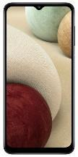 | 13
002 | Laptop | 15.6 "(1920x1080) Full HD  Screen type IPS  Screen refresh rate 60 Hz  Built-in camera  720p HD hidden camera CPU  i3, min 10Gen; min 2,1 GHz  Operating system Windows 10 Home 64bit  Generation of Intel processor  10th Comet Lake  RAM size 8 GB  min 2 x USB Port  1 x USB -C  1 x HDMI port  Wireless 802.11 a/b/g/n/ac  Bluetooth min 5  Warranty: min 1 Yr Onsite/NBD/ Accidental protection | 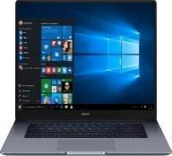 | 14
003 | All-In-One desktop PC | Screen 21.5 "" IPS (1920x1080) Full HD / AMD Athlon Silver 3050U (2.3 - 3.2 GHz) / RAM 8 GB / SSD 256 GB / AMD Radeon Graphics / DVD +/- RW / LAN / Wi-Fi / Bluetooth / webcam / card reader / Windows 10 Home 64bit / 5.7 kg / white / mouse + keyboard  CPU  AMD Athlon Silver 3050U Dual Core (2.3 - 3.2 GHz)  RAM 8 GB  Ports  Behind:  2 x USB 3.2 Gen 1  2 x USB 2.0  1 x HDMI  1 x LAN (RJ-45)  Headphone / microphone combo audio jack  Bottom:  Card reader  Power supply unit 65 W (external power supply unit)  AMD Radeon Graphics  Pre-installed software Windows 10 Home 64bit  Dimensions 490.3 x 380.74 x 204.51 mm  Weight 5.7 kg  Contents of delivery  All-In-One desktop PC  Wired keyboard  Wired mouse  Power Supply  Documentation  Additional features  5MP pop-up camera with built-in dual array digital microphones  SSD 256 GB  Display 21.5 "" Full HD (1920x1080)  Graphics card type Integrated  Pre-installed WiFi module Yes  Optical drive DVD +/- RW  GPU manufacturer AMD  White color  Core frequency 2.3  Matrix type IPS  VESA mountable - No VESA mountable  Additionally  Built-in web-camera  Built-in speakers  Built-in microphone  Card reader  12 months warranty  Resolution 1920 x 1080  Network interface 1 Gbps | 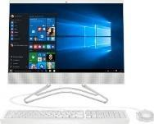 | 9
004 | TVset | Screen diagonal 32 ""  Smart TV support - with Smart TV  Resolution 1366x768  Year of issue 2020  Screen shape Flat  Frame color Basalt  Purpose In the bedroom  Sound output power, W 2 x 8  Android operating system  Technologies  Bluetooth  HDR  WI-Fi  Response time 10 ms  Digital tuner bands  DVB-C  DVB-T2  Screen coverage  Matt  VESA  200x100 mm  additional characteristics  Uniformity +  HDMI ARC  HDMI CEC  Contrast Super Contrast Control  Supported formats  AVI, MKV, MP4, MOV, VOB, DAT, FLV, MPG, ASF, WMV, TS, TP, TRP, M2T, M2V, M2TS, M4V, MPEG, OGM, 3GP, MJPEG and others  Image Processor A.C.E Pro Engine  Additional connectors (ports)  2 x USB  3 x HDMI  CI (PCMCIA) slot  1 x 3.5 audio input  1 x RCA  1 x optical audio output  Color system (standards supported)  PAL B \ G, PAL I, PAL D \ K, SECAM B \ G, SECAM D \ K, NTSC  Viewing angle 178 ° / 178 °  Energy consumption Class A  12 months warranty  Dimensions with stand 730 x 467 x 180 mm  Dimensions without stand 730 x 427 x 68 mm  Set Weight with Stand 4.3 kg  Set Weight without Stand 4.2 kg  Contents of delivery  Television  Stand  Remote control (with batteries)  Instructions  Warranty card | 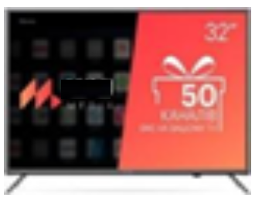 | 4
005 | Tablet | Screen diagonal 10.3 ""  RAM 4 GB  Wireless capabilities  Bluetooth  Wi-Fi  Built-in memory 64 GB  Operating system Android 10.0  Screen resolution 1920x1200  Number of cores 8  MediaTek Helio P22T processor or equivalent (2.3 GHz)  Navigation System No  Matrix type IPS  Color Platinum  Front camera 5 MP  MicroSD card support  Main camera 8 MP  Maximum capacity of memory cards 256 GB  Built-in 3G module No  Calling capability No  Number of SIM cards None  Refresh rate 60 Hz  Connectors  USB Type-C  3.5mm jack  Body material Metal  Additional functions OTG support  additional characteristics  Two front stereo speakers  Dolby Atmos support  Accelerometer  FM radio  Battery Li-polymer, 5000 mAh  Web surfing time: 9 hours  Video playback time: 8.5 hours | 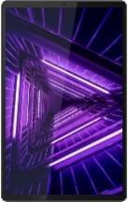 | 2
006 | Multi-Function Printer laser | Maximum print resolution 1200x1200 dpi  Printing technology Laser printing  MFP device type  Printer / MFP Image Resolution  Printing: up to 600 x 600 dpi  Copying: up to 600 x 600 dpi  Scan: Optical: Up to 600 x 600 dpi, Enhanced mode: 9600 x 9600 dpi  Network interfaces  Ethernet  Wi-Fi  Number of colors 1 (black)  Peculiarities  Duplex  Phone Printing  Seal  Black and white  Paper size and weight  Cassette: A4, A5, A5 (Landscape), B5, A6, Legal, Letter, Executive, Statement, OFFICIO, B-OFFICIO, M-OFFICIO, GLTR, GLGL, Foolscap, 16K, Envelope (COM10, DL, C5) , custom format: min. 76.2 x 127 mm, max. 215.9 x 355.6 mm  MP Tray: A4, A5, A5 (Landscape), B5, A6, Legal, Letter, Executive, Statement, OFFICIO, B-OFFICIO, M-OFFICIO, GLTR, GLGL, Foolscap, 16K, Index Card, Envelope (COM10, Monarch, DL, C5), custom format: min. 76.2 x 127 mm, max. 215.9 x 355.6 mm  Auto Document Feeder: A4, A5, B5, B6, Legal, Letter, Custom Size (W x L): Min. 105 x 148 mm, max. 216 x 356 mm  Density:  Cassette: 60-163 gsm  Multi-purpose tray: 60-163 gsm  Automatic document feeder: 50-105 g / m²  Two-side print:  Automatic  A4, Legal, Letter, OFFICIO, B-OFFICIO, M-OFFICIO, Foolscap  60-105 g / m2  OS support  Linux  Mac OS  Windows  Black and white print speed, ppm 28  Borders of the printable area  Print margins:  5 mm each top, bottom, left and right  10 mm each top, bottom, left and right (envelope)  USB 2.0 interfaces  Printing without a computer Supports Google Cloud Print  iOS: AirPrint, Canon PRINT Business app  Android: Mopria certified, Canon Print Service Plug-in, Canon PRINT Business app  Compatible cartridges  Cartridge 051 (1,700 pages)  Cartridge 051H (4,100 pages)  Drum Cartridge 051 (23,000 pages)  Power consumption  Max: Approx. 1180 Wt  Standby: Approx. 5.7 Watt  Sleep Mode: Approx. 0.8 watts  Power off: no more than 0.5 W  Typical energy consumption: 0.8 kWh per week  Idle time before entering sleep mode: 1-30 min (default: 1 min)  Idle time before entering auto shutdown mode: 4 hours (default)  Weight (kg) 12.9  additional characteristics  Copy machine  First Copy Out Time: Approx. no more than 8.2 sec  Copy modes: Text / Photo, Text / Photo (high speed), Photo, Text  Duplex copying: 1 side to 2 sides (automatic)  Number of copies per cycle: up to 999 copies  Reduce / Enlarge: 25-400% in 1% steps  Other functions: Collate, 2in1, 4in1 copy, ID copy  Scanner  Type: Colored  Scanning speed:  Monochrome single-sided: 20 ipm (300x600 dpi)  Color single-sided: 15 ipm (300 x 600 dpi)  Color scan depth: 24 bit / 24 bit (input / output)  Grayscale: 256 levels  Compatibility: TWAIN, WIA, ICA  Max. scanning area width: 215.9 mm  Scan to PC: TIFF / JPEG / PDF / Compact PDF / Searchable PDF  Scan to Cloud: TIFF / JPEG / PDF / PNG  Specifications  Recommended monthly page volume: 250-2500 pages per month  Productivity: max. 30,000 pages per month  Processor frequency: 400 MHz  Memory: 256MB | 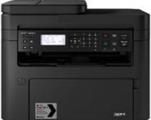 | 12
007 | Laser printer | Maximum print resolution 1200x4800 dpi  Printing technology Inkjet printing  MFP device type  Printer / MFP Image Resolution  Print resolution: up to 4800 x 1200 dpi  Scan resolution: 600 x 1200 dpi  Wi-Fi network interfaces  Number of colors 4  Peculiarities  Built-in CISS  High quality photo printing  Minimum droplet size (pl) 2  Paper size and weight  A4, A5, B5, 10 x 15 cm, 13 x 18 cm, 20 x 25 cm, Envelopes (DL or Commercial 10), Letter, Legal  Plain paper weight: 64 - 105 g / m²  Canon photo paper weight: up to 275 g / m²  OS support  Android  Windows  Black and white print speed, ppm 9  Printable area borders Borderless printing  Other printing surfaces  Envelopes  Interfaces  USB 2.0  Color print speed, ppm 5  Print area  A4, Letter, 20 x 25 cm, 13 x 18 cm, 10 x 15 cm  Compatible cartridges  Black: Canon GI-490  Cyan: Canon GI-490 (C)  Magenta: Canon GI-490 (M)  Yellow: Canon GI-490 (Y)  Power consumption  Off: approx 0.2 W  Standby (connected to PC via USB): Approx.1.2 W  Standby (all ports connected): approximately 1.2 W  Time to enter standby mode: 10 min 50 sec  Copying: Approx. 11 W  Weight (kg) 6.3  additional characteristics  CIS flatbed scanner for photos and documents:  Scanning speed for A4 document: approximately 19 seconds  Scan depth (in / out): Color: 48/24 bit, Grayscale: 16/8 bit  Maximum document size for scanning: 216 x 297 mm  Copier:  Copy speed: sFCOT: in about 24 seconds, sESAT: about 2.5 images per minute Number of copies: 21 copies (maximum) Copy functions: document copy (plain paper), borderless copy, enlargement copy, full-sheet printing | 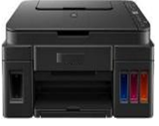 | 2
008 | Telephone (with cable) | Telephone set, handset, handset cord, telephone line cord, wall mount adapter, instruction manual  Number Identification No  Radio type Analog  Type Phone  Button material Rubberized  Color Black  12 months warranty | 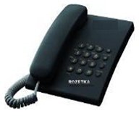 | 6
009 | Electric meter | Single-phase electronic multi-tariff (up to 6 tariffs) electric meters 230V, A ±, cl. v. 1.0, with a PLC modem, with a load on / off relay and a differential current sensor, designed for tariff metering of consumed active electrical energy (consumption and generation) and measuring current power in single-phase AC 220 V circuits with a frequency of 50 Hz at the terminal consumers making individual settlements with the electricity supplier. 1-phase electricity meter NP-07 1F.1SM-U is used for round-the-clock continuous operation in closed rooms. | 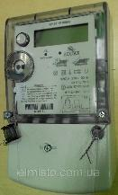 | 2
010 | Internet router (router) | Wi-Fi frequency 5 GHz + 2.4 GHz (dual band)  Interfaces  4 LAN ports 10/100/1000 Mbps  1 WAN port 10/100/1000 Mbps  Purpose of the router Home  LAN port speed 1 Gbps  WAN port  Ethernet  Wi-Fi communication standard  802.11b / g / a  Wi-Fi 4 (802.11n)  Wi-Fi 5 (802.11ac)  Wi-Fi speed, Mbps 1900 Mbps  Peculiarities  Beamforming support  IPTV support  MU-MIMO support  SU-MIMO support  MESH technology support  Security features  Guest access  SPI firewall  Parental control  Antenna design  Fixed  Protocol support  DHCP  IPv4  IPv6  L2TP  NAT  PPPoE  PPTP  Number of WAN Ports 1  Type Stationary  Wi-Fi connection Yes  Wi-Fi Speed ​​Standard AC1900  Encryption type  WEP  WPA  Black color  Dimensions and weight 215 x 117 x 32 mm  Warranty 24 months  Contents of delivery  Router  Power adapter  Ethernet cable (RJ-45)  Quick setup guide  Number of antennas 4 | 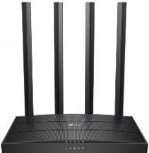 | 9
011 | Office straight table (option 1) | Basic color: black Frame color: graphite Tabletop color: Sonoma oak Dimensions and weight Height: 750 mm Width: 1200 mm Depth: 600 mm Tabletop thickness: 16 mm Technical features Design features: collapsible frame Equipment: metal frame Transport condition: disassembled | 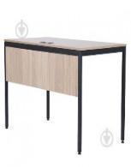 | 47
012 | Recirculator bactericidal | Main characteristics  Installation Type: Wall Mounted  Dimensions of the assembled product, mm 580 * 210 * 120  White color  Gross weight, kg 9  Sterilization  Recirculator type  Prevailing radiation wavelength, nm 253.7  Number of lamps, pcs. 2  Complete with cord Yes  Body material Metal / Plastic  Lamp power, W 8  Power supply parameters, V 220  Power consumption, no more, W 50  Installation method Wall mounted  Equipment installation type Stationary  Effective lamp life, at least, h 9000 | 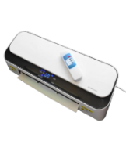 | 2
013 | Stepladder | Number of steps: 6 Additional equipment: tool tray Platform height: 1,1-1,5 m Width: 47,9 cm Folded size: 194 cm Type: one-sided Material: aluminum Color: gray Additional information Number of steps in section: 6 pcs. Height to the platform: 1.21 m Maximum load: 150 kg Size and weight Weight: 5 kg | 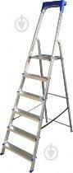 | 2
014 | Executive chair | Chair type for executives  The maximum load is 120 kg  Adjustments  Seat height  Swing stiffness  The basis  Crosspiece with rollers  Features  Armrests  Swing mechanism  Color Black  Corps  Chrome armrests and crosspiece (steel)  Upholstery Ecological leather  Seat dimensions 47 x 47 cm  The dimensions of the backrest are 64 x 45 cm  Chair height 109.5-119.5 cm  Additional features  Chair width: 55 cm  Diameter of a crosspiece: 65 cm  12 months warranty | 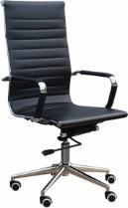 | 2
015 | Chest of drawers | Height 986 mm. 2 doors. Width 804 mm. Depth 448 mm. Transport condition dismantled. Facade color alder. Construction - with shelves. Frame material laminated chipboard. | 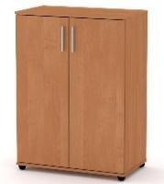 | 9
016 | Adult mattress (option 1) | Type: springless. Hardness level: medium. Filler: coconut coir, polyurethane foam, cotton wool. Fabric type: jacquard. Number of zones of rigidity: 7. Size and weight Length: 200 cm. Height: 15 cm. | 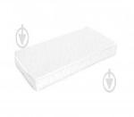 | 17
017 | Bedding set 1.5 (bed linen) | Fabric composition: cotton. Base color: multi.  Main characteristics  Scope 1.5 bedding set multi-colored Size: one and a half. Design: printed. Fabric type: calico. Number of items: 3. Type of drawing: abstraction.  Size and weight  Pillowcase size: 50x70 cm.  Complete set: duvet cover 160x220, sheet 160x220, 1 pillowcase 50x70 | 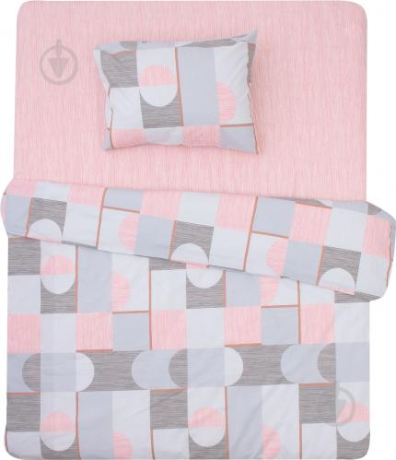 | 70
018 | Towel | Type: towel. Base color: yellow.  Main characteristics  Towel Braid 70x140 cm yellow. Purpose of the towel: bath. Density: 360 g / m2. Fabric composition: 100% cotton. Length: 140 cm. Width: 70 cm. | 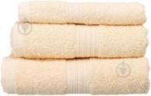 | 60
019 | Cleaning set | Bucket Mop  Material Polypropylene  Bucket shape Round  Features With long handle  Additional features  Mop with telescopic handle  12 months warranty | 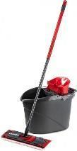 | 1
020 | Mop for a floor | Type: mop. Purpose: for a floor. Nozzle material: polyester. Handle type: telescopic. Existence of the mechanism of extraction: without extraction. Width: 40 cm. Length of the handle: 130 cm. Handle material: metal. Additional characteristics: length in the folded look - 80 cm | 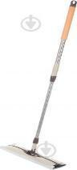 | 1
021 | Dustpan and broom | Type: dustpan + brush. Purpose: for cleaning, universal. Material of the working part: plastic. Handle / handle material: plastic. Length of the handle: 90 cm. | 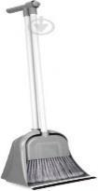 | 12
022 | Kitchen towel | Design: flowers. Type: apron. Base color: beige. Fabric composition: 100% linen. Length: 65 cm. Width: 45 cm. | 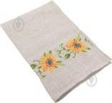 | 12
023 | Pillow | Size 50x70 cm  Quantity, piece 1  Type Hypoallergenic  Polyester filler: 95%, man-made fiber: 5%.  Shape Rectangular  Design and decor Monochromatic models  Color White  Height 50 cm  Cover material Microsatin.  Weight 600 g |  | 37
024 | Blanket | Base color: white. Blanket 1300 g 150x210. Color: white. Width: 150 cm. Length: 210 cm. | 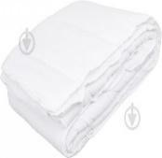 | 27
025 | Plaid | Plaid 200x140 cm gray. Fabric composition: 20% wool, 80% acrylic. Length: 140 cm. Width: 200 cm. Density: 250 g / m2. | 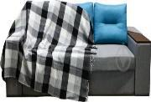 | 25
026 | Round bowl | Volume, l 15  Round shape  Material Polypropylene  Color Blue  Size 43 x 41 x 18 cm | 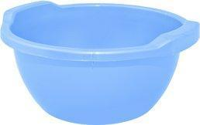 | 6
027 | Corner computer table (option 1) | Type Office desks, Staff desks Length, cm 129  Width, cm 102 Height, cm 75  Thickness of a table-top, mm 18  Manufacturing materials  Particleboard base material  Particleboard countertop material  Particleboard screen material  Handle material Metal  Roller guides  Fastening Confirmat, Minifix  PVC edge  Technical equipment  Angular shape  Orientation Right-handed  Number of seats 1  Base type 2 legs  Drawers With one drawer  With shelves  Rollers Without rollers  Number of boxes 3 boxes  Handles External handle | 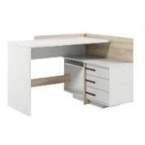 | 1
028 | Armchair | height (cm) 103  Seat height (cm) 42  Backrest height 61  Depth / length (cm) 75  Seat depth 45  Maximum load 120 kg  Maximum load (kg) 120  Body material Wood  Landing surface Soft  Product Prefabricated  Product condition In packages for self-assembly.  Upholstery type Fabric  Width 67 cm  Seat width (cm) 48 | 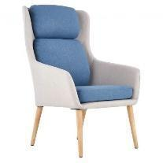 | 10
029 | Round coffee table | Round shape  Type Coffee table  MDF table top material  Material of legs Wood  Color Gray  Height 450 mm  Width 500 mm  Depth 500 mm | 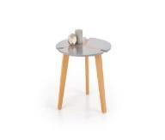 | 3
030 | Straight sofa (option 1) | Type: straight. Frame material: plywood, chipboard, wood. Filler: spring block. Upholstery: fabric. The mechanism of transformation: a walking eurobook. Mattress base: slats. Niche for linen: lifting mechanism. Equipment: with poufs, niche for linen, pillows, with a bed. Width: 2480 mm. Height: 750 mm. Depth: 920 mm. The size of a berth: 145х195 cm. Weight: 113,9 kg. | 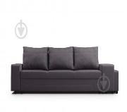 | 3
031 | Shelving (bookcase) | Glass: no. Frame color: Alaska. Frame material: chipboard. Facade material: chipboard. Number of boxes: 1 pc. Number of shelves: 6 pcs. Equipment: open shelves, with drawers, with doors. Length: 840 mm. Width: 840 mm. Height: 1310 mm. Depth: 400 mm. | 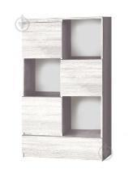 | 22
032 | Mattress orthopedic 90 * 190 (option 2) | Spring type  View of Bonnell  Kind of rigidity Hard  Dimensions 90x190 cm  Sleeping size Single  Height 22 cm  The maximum load on 1 berth is 150 kg  Filler Spunbond Sintepon Flexovoilok Combofelt Termofiber Termofiber Combofelt Flexovoylok Spunbond Sintepon  Jacquard case  Weight 25 kg  18-month warranty | 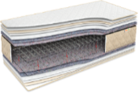 | 6
033 | Desk lamp | Luminous flux: 430 Lm. Color temperature: 4000 K. Light bulb power: 9 W. Power type: network. Voltage: 220 V. Type of switch: on the case, touch. Product material: plastic. Lamp type: built-in LED. Manufacturer's color: white. Features: three-stage brightness adjustment. Installation: on a support. Depth: 15 cm. Height: 36 cm. Width: 15 cm. Dimerization (brightness control function): with dimmering. Number of LEDs: 30 pcs. | 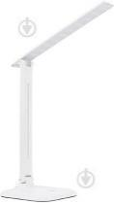 | 6
034 | Office guest chair | Frame material Metal  Upholstery material Fabric  Height, mm 805  Width, mm 470  Depth, mm 410  12 months warranty  Maximum load, kg 100 | 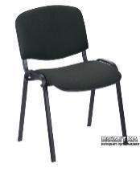 | 86
035 | Electric radiator | Number of sections 10 pcs.  Heating power 900 watts  Power consumption 900 W.  The recommended area is 20 sq.m.  Type of control Electronic  Overall dimensions  Weight 12 kg  Height 560 mm  Depth 80 mm  Width 855 mm  Additional functions and characteristics  Display Yes  Child protection Yes  Overheat protection Yes  Performance indicator Yes  Temperature indicator Yes  Maintaining the temperature Yes  Temperature regulator Yes  Temperature regulator type Smooth  Installation type Floor, Wall  Memory function Yes | 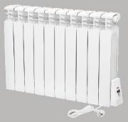 | 3
036 | Wardrobe | Material: Laminated chipboard 16 mm  Wardrobe dimensions (W / H / D):  W 802 / H 2110 / D 500 mm  Weight: 73kg | 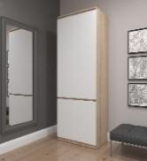 | 22
037 | IroSet of bathroom rugs | Main color Graphite  Rectangular shape  Material Polyvinyl chloride  Quantity in a set 2 | 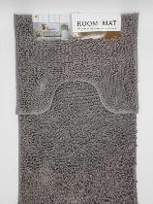 | 3
038 | Iron | SteamGlide Plus sole  Steam shock, g / min 200  Type With steam  Constant steam supply 45 g / min  The volume of the water tank is 320 ml  Cord length 2 m  Features  The scratch-resistant sole. Built-in descaling slider. The "drop-stop" system.  Convenient textured handle  Equipment  Auto shut-off  Self-cleaning of scale "Drop-Stop" system  Dimensions (HxWxD) 14.7 x 31.2 x 12.7 cm  Weight 1,255 kg  Package weight 1,495 kg  Power, W 2600  Modes  Vertical steaming  Steam shock  Steam supply, g / min 45  Power of steam blow, g / min 200  Sole spraying Ceramics (metal ceramics)  There is protection against scale  Additional features  Steam supply regulator  24 months warranty  Product color Black | 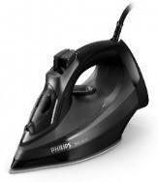 | 6
039 | Ironing board | Size 107x38 cm  Weight 3.85 kg  Color Multicolored | 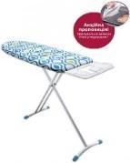 | 6
040 | Children's pot | Material plastic. Type pots. Characteristics: - With an antiskid covering; the pot is stable. | 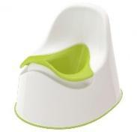 | 2
041 | Clothes dryer | Type Floor folding  Working length of a surface is 19 m  Protection against accidental closing No.  Additional characteristics The design has 3 tiers  Dimensions 66 x 61 x 150 cm  36-month warranty | 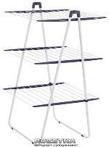 | 7
042 | Clock | Mechanism type: Quartz  Housing: Plastic  Dial color: White  Case size: 24.8 x 4.5 cm | 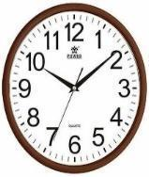 | 2
043 | Bunk bed transformer | Height (cm) 175  Length (cm) 198  Width (cm) 88  Sleeping place (cm) 80х190  Frame material Wood  Number of boxes 2  There are legs  There are lamellas  Existence of a mattress None  There is a box for linen  Lifting mechanism No.  Warranty 12  Weight, kg 80 | 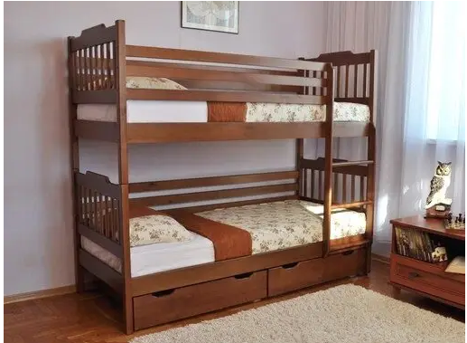 | 1
044 | Corner sofa | Additional characteristics: a box for linen (under rolling out by a seat), pillows in a set: 2 pieces, 80х50х20 cm. Features of a design: a framework: a natural tree, ODSP, plywood. Sleeping place: 2-bed. Base color: brown. Type: angular. Upholstery color: brown. Fabric type: velor.. Frame material: wood. Execution: left-handed, folding, angular. Filler: polyurethane foam. Upholstery: fabric. Transformation mechanism: rotary, eurobook. Mattress base: slats. Linen niche: under a closed lid. Equipment: niche for linen, pillows, with a bed. Width: 2400 mm. Height: 680 mm. Depth: 1600 mm. Bed size: 163x240 cm. Weight: 115.5 kg. | 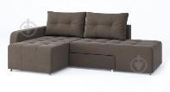 | 3
045 | Antechamber | Material - laminated chipboard;  PVC edge - 0.5 mm;  hanger with shelves and mirror;  large shoe cabinet with 2 shelves.  Overall dimensions of a product:  Width: 800 mm;  Height: 2000 mm;  Depth: 380 mm.  Weight: 35 kg. +/- 5% | 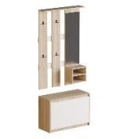 | 1
046 | Rug | Type of Carpets  Type Door  Rubberized  Main color Black  Material Polypropylene  Monochrome design  Dimensions 0.6 x 0.4 m |  | 1
047 | Cordless vacuum cleaner | Main characteristics  Type of cleaning Dry  Noise level, dB 80  Volume of a dust collector, l 0.4  Complete set  Additional nozzles Slotted  The main nozzles Turbobrush  Additional nozzles Slotted nozzle  Complete set  Cordless vacuum cleaner with battery  AC adapter  Slotted nozzle  Built-in brush  Wall docking station  Features  Operating time on one charge 30 min  Number of power levels 1  Full charge time 5 hours  Technical features  Vertical parking  With turbo mode  Turbo mode operation time 15 min  Additional features  Nozzle with suction system 180 °  Two speed modes  18 V lithium-ion battery  Quick cleaning even under low furniture  PowerBlade motor  PowerCyclone technology 7 or equivalent  Washable filter  Dimensions, weight, color  Packaging dimensions (HxWxD) 77.2 x 37 x 17 cm  Weight 2.79 kg  Package weight 4.79 kg  Type  Long handle + mini vacuum cleaner | 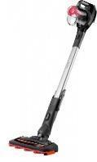 | 1
048 | Washing machine | 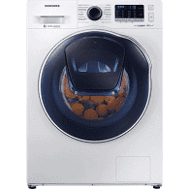  Color: white. Machine type: washer-dryer. Type of loading of linen: front. Maximum load of linen: 8 kg. Number of programs: 14. Energy consumption class: B. Washing class: A. Spinning class: B. Case: narrow. Degree of automation: automatic. Maximum spin speed: 1200 rpm Water consumption per cycle: 112 l. Noise level during drying: 62 dB. Noise level during washing: 56 dB. Squeeze noise level: 75 dB. Maximum load of laundry for drying: 5 kg. Electricity consumption per cycle: 6.48 kW. Washing programs: Air Wash program, washing + drying, daily washing, ecological washing, Eco drum cleaning, steam washing, delicate washing, rinsing + spinning, cotton, synthetics, wool, drying of cotton things, drying of synthetic things. Manufacturer's color: white. Warranty: 36 months. Size and weight Height: 85 cm. Width: 60 cm. Depth: 45.6 cm. Weight: 72 kg. |  | 4
049 | Kitchen faucet | Product width 47  Product depth 220  Product height 386  Material Stainless steel  Color chrome  The control type is single-lever  Swivel spout yes  Installation on furniture or a table-top yes  Cartridge AM.PM SoftMotion 35 mm | 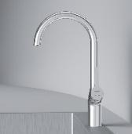 | 1
050 | Electric kettle | Housing material Stainless steel  Glass  Type Normal  Water level scale With scale  Volume, l 1.7  Equipment  With display  With illumination  Protection  Shutdown when removing from the base  From inclusion without water  From overheating  Scale filter type Removable  Functions  With temperature maintenance  With a sound signal  The basis  With cable compartment  Heating temperature setting  100 ° C  60 ° C  70 ° C  80 ° C  90 ° C  Heating element type Hidden (disk)  Cable length, m 0.7  Features  Rated voltage: 230 V ± 10%  LED backlight  Touch screen  Plug: euro  Electronic temperature control (5 temperature modes)  Chlorine removal function  Rated current frequency: 50 - 60 Hz  Additional features  Complete set:  - Electric kettle  - Stand with cable  - Operating instructions  - Warranty card  Power, W 2200  Color Stainless steel / Black | 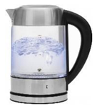 | 13
051 | Microwave | Volume, l 20  Installation method Freestanding  Type of control Electronic  Door opening type Using the button  Additionally  Quick start  Display  Width, cm 44.3  Depth, cm 33  The diameter of the turntable is 25.5 cm  Number of power levels 5  Complete set  Microwave oven  Glass turntable  Operating instructions  Warranty card  Microwave power 800 W.  Features  LED display  3 defrost programs  3 warm-up programs  3 cooking programs  Functions and special programs  Auto defrost (quick defrost)  Child protection (device lock)  Lean roast  Russian cook  Setting the time (clock)  Crispy warm-up | 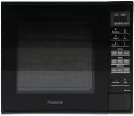 | 7
052 | Two-chamber refrigerator | Refrigerator type Two-chamber  The total volume of the refrigerator is 286 liters  The useful volume of the refrigerating chamber is 202 l  Defrost system No Frost (Frost Free) Without No Frost  The useful volume of the freezer is 84 liters  Installation method Freestanding (solo)  Energy consumption class A +  Refrigerating chamber defrost system Static (drip)  Compressor type Normal  Freezer defrost system Static  Control type Mechanical  Number of compressors 1  Features  Freezer location Lower  Display Without display  Annual electricity consumption 261 kW * year  Climate class N-ST (from +16 to +38 C)  Refrigerant R600a  Noise level 42 dB  Additional features  NanoFrost technology  Odor Neutral function  Adapti Lift system  Special door mechanism SpaceSaverDoor or equivalent  Refrigerating compartment  Refrigerator shelves (material / quantity)  Glass, 3 pcs  Door baskets 4 pcs  Container for vegetables 1 pc  Shelf for bottles In doors Suspended  Freezer compartment  Number of sections in the freezer 3 pcs  Freezing capacity 4 kg / 24 h  Autonomous cold storage in the freezer for 17 hours | 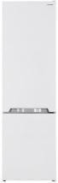  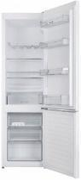 | 6
053 | Cooking surface / electric hob | Type of heating elements (burners) Hi-Light  Diameter and power of burners  Front left (PowerZone): 21 cm in diameter, 2.1 / 3 kW  Front right: diameter 14.5 cm, power 1.2 kW  Rear left: 14.5 cm in diameter, 1.2 kW  Rear right: diameter 12/18 cm, power 0.7 / 1.7 kW  Additional features  Functions  Stop & Go  Child protection  Overflow protection  Sound signal  Residual heat indicator  Keeping the dish warm  Programmer  Turbo mode (Booster)  Edge design Without frame  Features  Polished front edge  BoilControl function  PowerZone function  Complete set  Cooking surface  Operating instructions  Warranty card  Connection information  Possibility of connection to a network  220 V  380 V  Number of power stages 9  Maximum connection power 6200 W. |  | 5
054 | Hair dryer | Regime  Overheat protection  Ionization  Cold air supply  Power 2100  Number of speeds 6  Number of temperature modes 4 and more  Features  Suspension loop  Motor type  DC  Nozzles  The concentrator is standard  ThermoProtect nozzle  Additional features  The length of the power cable is 1.8 m  Dimensions, weight, color  Packaging dimensions (HxWxD) 29.5 x 21.5 x 9 cm  Weight 0.617 kg  Package weight 0.794 kg  Color Black / pink | 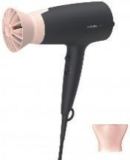 | 6
055 | Kitchen hood | Features  Main characteristics  Number of speeds 3  Type Flat  Control type Slider  Noise level (dB) 65/48 dB  Mounting type Wall-mounted  Color Stainless steel  Productivity is 220/140 m / h cubic. m / h  Display No.  Mounting width 60 cm  Operating mode Air extraction / recirculation  Automatic on / off (sensor) No.  Sound absorbing panel No.  Timer No.  Diameter of an air duct is 12 cm  Number / power of motors 1x95 W.  LED lighting type  Filter type Paper  Complete set  Hood; Instruction  12 months warranty  Productivity range cube. m / h Less than 500  Width range, cm 55-64  Dimensions (HxWxD) (cm) 15x59.8x48.2 cm  Dimensions (HxWxD) (cm) in packing of 21х65х56 cm  Weight (kg) 7.6 kg  Package weight (kg) 8 kg  Design Standard | 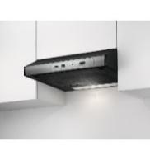 | 4
056 | Kitchen | Technical features  height of the lower modules - 720 + 100 mm  facade thickness - 16 mm  height of the top modules - 720/360 mm  depth of the top modules - 298/316 mm  depth of the lower modules - 522 mm  hinged mechanisms - DS  guides - DS  hinges for facades - DS  handle - DR 10/128 chrome  frame thickness - 16 mm  width of the top modules - 500/600/600/400 mm  width of the lower modules - 500/600/400 mm  The shade is light  Features of a design of facades glossy  the size of a niche for installation of an oven - 600x568x523 mm  The configuration is straightforward  Existence of a table-top without a table-top  The color of the frame is Sonoma oak  Transport condition disassembled  Facade color beige gloss  Thickness of walls of a facade, mm 16  Thickness of walls of the case, mm 16  Type of product ready kitchen  MDF facade material  Particleboard frame material  Complete set  9 packages, the kitchen is completed with a set of fastenings for collecting of curbstones, loops, guides, handles and hinged mechanisms, a sink and household appliances are not included in the package  Length, m 2.1 | 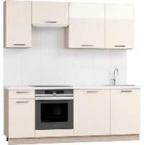 | 1
057 | Lamp | Additional characteristics: pulsation coefficient - 0.2%, scattering angle - 160 °, service life - 50,000 hours. Main characteristics. White LED lamp with remote control 3000-6000 K. Lighting lamp power: 72 W 500 W. Product material: aluminum + polycarbonate. Direction of light: down. Lighting area: 20-30 sq.m. Remote control: with remote control. Luminous flux: 5760 Lm. LED type: (IP): 40. Dimming (brightness adjustment function): with dimming. Color rendering index: 80 Ra. Operating temperature: -15...+50 °C. LED type: SMD. Light color: Warm white to cool white. Color temperature: -6000 K. Size and weight. Height: 7 cm. Diameter: 53.5 cm. | 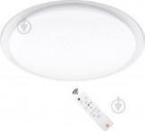 | 6
058 | Set of pots | Set of cooking pots, 18 items / Cast handles, stainless steel. The set consists of 4 pans with lids, 1 ladle with a lid, 1 frying pan with a non-stick coating and a lid, 2 supports under pans, baskets-grids and 3 shovels.  Suitable for all types of hobs: induction, electric, gas, halogen and glass-ceramic.  Heat-resistant transparent covers.  Thanks to the thickened steel case, the heat inside the pan is evenly distributed, which speeds up cooking.  Convenient handles on riveted connection, do not heat up, strong and safe.  Dishwasher safe.  Features:  - Material: stainless steel;  - Material of covers: heat-resistant glass;  - Cast handles;  - Suitable for all types of plates;  - Bottom type: multilayer;  - Internal covering of a frying pan: marble, non-stick.  Complete set:  - Pan with lid diameter: 16 cm, wall height: 10.5 cm, volume: 2.1 l.  - Pan with lid diameter: 18 cm, wall height: 11.5 cm, volume: 2.9 l.  - Pan with lid diameter: 20 cm, wall height: 12.5 cm, volume: 3.9 l.  - Pan with lid diameter: 24 cm, wall height: 14.5 cm, volume: 6.5 liters.  - Bucket with a cover diameter: 16 cm, height of walls: 10.5 cm, volume: 2.1 l.  - Frying pan with lid diameter: 24 cm, wall height: 7.5 cm, volume: 3.4 l with marble coating.  - Mesh basket.  - Stand for pans: 2 pieces.  - Set of blades: 3 pieces.  - Packaging. | 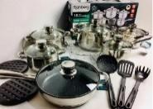 | 5
059 | Set of cutlery | Material Stainless steel  Number of persons 6  Table knife of 6 pieces. Dining fork of 6 pieces. Tablespoon of 6 pieces. Teaspoon 6 pcs | 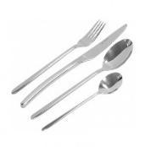 | 29
060 | Tableware set | Composition Plate  Material Impact resistant glass  Number of persons 6  Complete set  Dinner plate (Ø 25 cm) - 6 pcs. Deep plate (Ø 20 cm) - 6 pcs. Dessert plate (Ø 18 cm) - 6 pcs.  Main color White | 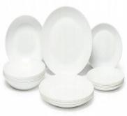 | 6
061 | Tray | Height 30 mm  Width 330 mm  Length 455 mm  Food grade plastic tray. White color. | 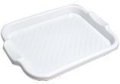 | 4
062 | Sink | Sink installation type: mortise. Width: 50 cm. Length: 58 cm. Depth: 20 cm. Height: 21 cm. Bowl size: 43x33 cm. Main bowl depth: 20 cm. Kitchen sink material: granite. Producer's color: beige. Number of bowls: one main. Surface texture: matte. Kitchen sink shape: rectangular. Wing presence: yes. Minimum cabinet width: 60 cm. Complete set: kitchen sink, fixing. Warranty: 12 months | 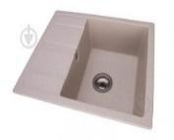 | 1
063 | Trash can | Material: ABS plastic. Shape: rectangular. Purpose: for household waste, for food waste. Basic color: silver. Type: garbage bin. Installation site: indoors. Product material: plastic. Producer's color: silver. Features: with lid. Volume: 10 l. Width: 25 cm. Height: 36 cm. | 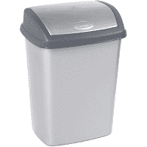 | 10
064 | Electric towel dryer | Location: vertical. Power consumption: 51-100 W. The heated towel rail is left-sided. Power consumption: 98 watts. Heated towel rail material: stainless steel. Height: 60 cm. Width: 48 cm. Depth: 15 cm. Presence of a regulator: with a regulator. Switch location: left. Color: chrome. Maximum operating temperature: 55 ° C. | 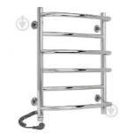 | 1
065 | Mirror with locker | Shape: rectangular. Base color: white. Mirror with locker and removable shelf. Furniture material: chipboard, MDF, mirror cloth. A mirror with a locker. Manufacturer's color: white. Weight: 14 kg. Height: 75 cm. Width: 53 cm. Depth: 16 cm. Weight: 14 kg. Equipment: LED lighting, mirror, shelf. Additional features: recessed chrome LED lamp warm spectrum. Complete set: a mirror with a locker (installation of a case at the left or on the right at choice), a shelf (removable), fastening to a wall, the switch. Warranty: 36 months | 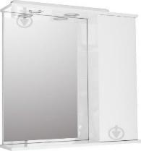 | 3
066 | Glass shower | Material Glass  Type Shower cabin  Rear walls No.  Glass thickness 6 mm  Existence of a roof No.  Presence of a pallet Without a pallet  Swing doors  12 months warranty  Transparent glass | 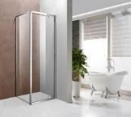 | 1
067 | Compact toilet bowl | В Type of toilet bowl  Installation type Floor  Material Plumbing faience  Dimensions of the toilet (HxWxD) 80 x 36 x 60.5 cm cm  Weight 43 kg kg  Lower water supply  Color White  Features Double drain  With seat  60 months warranty | 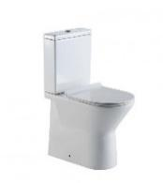 | 1
068 | Bath faucet with thermostat and shower | Features Mixer  wall-mounted bath thermostat  fuse on 38C  protection against the return flow of water  water consumption up to 22 l / min  plastic aerator  Suitable for instantaneous heaters  Scope of delivery Mixer:  thermostat  installation instructions  warranty card  Water mixing principle Thermostatic  Type of installation Wall external  Thermostat type With switch (2 positions)  Installation of the mixer On 2 openings  Color Chrome  Warranty - 60 months | 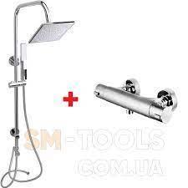 | 1
069 | The brush | Material: plastic. Type of installation: floor. Manufacturer's color: brown. Warranty: 12 months. Height: 36.5 cm. Diameter: 11.5 cm. Complete set: flask, brush Type: brush with flask | 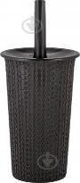 | 6
070 | Kitchen cabinet | Construction: with door. Style: classic. Sonoma oak chest of drawers / white. Transport condition: disassembled. Frame material: chipboard. Facade material: chipboard. Equipment: compartment with a door. Width: 800 mm. Height: 850 mm. Depth: 330 mm | 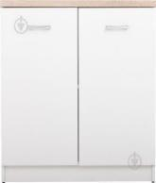 | 2
071 | The kitchen table | Product dimensions:  Length: 118 cm  Width: 74 cm  Height: 75 cm | 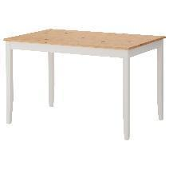 | 3
072 | Kitchen chairs | Warranty period: 12 months. Height: 980 mm. Depth: 400 mm. Width: 410 mm. Maximum load: 100 kg. Type: metal. Frame material: metal. Filler: polyurethane foam. Upholstery: imitation leather. Seat height: 46 cm. Upholstery color: cappuccino. Frame color: chrome. Base color: white. Transport condition: disassembled. Material of legs: metal. | 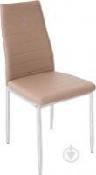 | 21
073 | Set of hand tools | Complete set  Bits  Insulating tape  Pliers  Adjustable wrench  Hex key  Hammer  A knife  Scissors  Organizer  Screwdriver  Pliers  Roulette  Ratchet handle  Number of units 100  Appointment  for home use  universal  Material Chrome-vanadium steel  Weight, kg 3.5  Complete set of 9 pieces  - 1/4 ”heads: 5, 6, 7, 8, 9, 10, 11, 12, 13 mm 1 pc  - Screwdriver with ratchet mechanism and reverse 1/4 "1 pc  - Hammer-nail 350 g 1 pc  - pliers combined 6 ”1 pc  - pliers extended 6 ”1 piece  - Hacksaw universal 1 piece  - Indicator screwdriver 1 pc  - Adjustable wrench 8 ”1 pc  - Roulette 3M x 16 mm 2 pcs  - Screwdrivers: SL6 x 100 mm, PH2 x 100 mm. 10 pcs  - Bits (with holder): SL 4-5-6 mm, PH 1-2-3, PZ 1-2-3, AD 6 pcs  - Screwdrivers for point works: PH 0-1, SL 1.4-2.0-2.4-3.0 mm 1 pc  - channel lock pliers 8 "1 piece  - Knife 1 pc  - PVC insulating tape 8 pcs  - Set of keys of 6- g L-shaped: 1.5, 2, 2.5, 3, 4, 5, 5.5, 6 mm.1 piece  - Blades for a knife of 5 pieces in a cover. 52 pieces  -A set of fasteners (screws, dowels, and pcs) 1 pc  - Plastic case  12 months warranty | 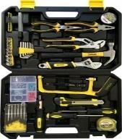 | 1
074 | Hammer drill | Purpose of the tool: household. Type of drill: percussion drill. Operating mode: drilling, drilling with impact. Maximum speed (idling): 3000 rpm. Cartridge type: quick clamp. Maximum diameter of drilling in wood: 30 mm. Maximum diameter of drilling in metal: 12 mm. Number of strokes: 45,000 beats / min. Maximum diameter of drilling in concrete: 14 mm. Supply voltage: 220 V. Main handle: open type. Number of handles: one-handed. Length of a network cable: 2 m. Diameter of a clip of a cartridge: 13 mm. Warranty: 24 months. Additional features: quick-release chuck Press & Lock - easy tool change by locking the drill spindle at the touch of a button;, rotation right / left: ideal for screwing, Additional handle with Anti-Slip function, convenient operation with a built-in continuous mode switch. Electronic systems: overload protection. | 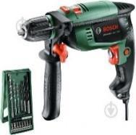 | 1
075 | Set of bathroom accessories | The set consists of: soap dish, soap dispenser, glass, paper holder, brush. | 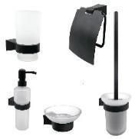 | 14
076 | Laundry basket | Type Plastic  Material Polypropylene  Color Brown  Volume: 45 l  Dimensions: 48x40x30 cm | 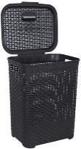 | 16
077 | Corner shelf quadrangular | Shelf quadrangular angular aluminum expansion pipe. Transparent. Width 24.5 cm. The color of the shelf is white. Depth 24.5 cm. Warranty 12 months. Height 260 cm. Material aluminum, plastic. Weight 2 kg. The method of installation is telescopic. The length of the bathroom shelf is more than 81 cm. The length is 260 cm. | 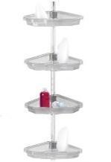 | 12
078 | Projector screen | Dimensions 203 x 114 cm  16: 9 aspect ratio  Covering vinyl matte cloth of white color  Additionally, the mechanism of reverse twisting  Diagonal 92 ' | 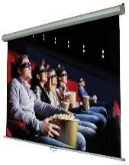 | 3
079 | Projector | Device class Stationary  LCD matrix type  576p, 480i, 480p, 576i, 1080i, 720p, 1080p input signal format support  Interfaces HDMI, USB, VGA (D-sub), Analog video input  Features Built-in speakers  Housing color White  Warranty period of 6 months  Image  Luminous flux 5500 lm  1920x1080 resolution  Contrast 2000  Lamp  LED lamp type  Lamp life 30,000 hours | 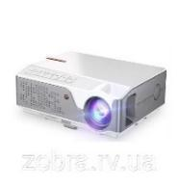 | 3
080 | Armchair-bag | Chair bag pear 120kh85sm violet  Filler material Polystyrene balls  Color Purple | 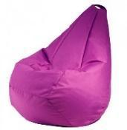 | 8
081 | Baby bed with bedside table and diaper table | cradle + bed + dresser (Beech + chipboard) up to 15 years folding side  bottom adjustable, 2 positions  pendulum swing mechanism  pendulum lock - no  cradle for the child of 60х120 cm  teenage bed 60х170 cm  changing table dresser 60х40 cm  4 boxes for laundry of a chipboard  material beech + chipboard  weight 80 kg | 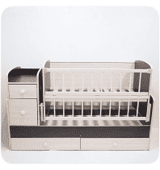 | 6
082 | Toilet seat | Purpose For a toilet bowl  Wheelbase, mm: 158  Overall dimensions (WxD): 36.5 x 43 cm  Plastic hinges, fastening with the steel screw  Features Plastic fastening  Distance between fastenings, mm 155  Weight 1.46 kg  Duroplast material  Color White | 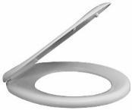 | 2
083 | Children's blanket 110 * 140 | Size 110x140 cm  EcoSilk filler  Cover material Microsatin  Seasonality Demi-season  Filler material German EcoSilk  Additional features  110x140 - blanket - 1 pc.  Weight 810 g | 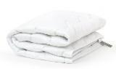 | 6
084 | Children's pillow | size 40x60 cm  Filler  EcoSilk  Sintepon  Hollow fiber  Quantity, piece 1  Type Hypoallergenic  Polyester filler: 95%, man-made fiber: 5%.  Shape Rectangular  Design and decor Monochromatic models  Color White  Height 40 cm  Cover material Microsatin.  Weight 400 g |  | 6
085 | Mobile button phone | 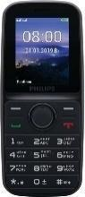  Communication standard / internet  2G communication standard (GPRS / EDGE)  Display  Screen diagonal 1.77  128x160 display resolution  TFT matrix type  Screen material Plastic  SIM cards  Number of SIM cards 2  Mini-SIM card dimensions  Memory functions  RAM 32 MB  Built-in memory 32 MB  Format of supported microSD memory cards  The maximum capacity of a supported memory card is 16 GB  Number of contacts in the phonebook  Limited by the memory of the device itself  Combined slot No.  Front camera  Number of front cameras Without front camera |  | 2
086 | Office safe | 2-bolt door locking system  Electronic code lock  Features  Thickness of the front panel: 1.2 mm + hollow panel  Hidden loops  Number of doors 1  Internal compartment in the safe  Compartment with key (tracer)  Regiment  Additional features  Included:  - 4 keys  - 4 AA batteries  Coating type Powder  The thickness of the side walls is 1.2 mm  The thickness of the front panel is 1.2 mm  Internal dimensions (HxWxD) 86x45x32 cm  Possibility of anchor fastening To a floor and a wall  Dimensions (HxWxD) 87x46x34 cm  Weight 24.5 kg  Package weight 25 kg  Color Gray  Guarantee of 60 months of an official guarantee from the producer on a design + 12 months on the lock | 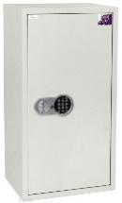 | 6
087 | Air conditioning | Compressor type Normal  Operating modes Automatic  Night fan  Heating  Drainage  Cooling  Air purification  Turbo mode  Operation at negative temperature, ° C -7  Indoor unit installation type Wall-mounted  Split system type  Energy consumption (cooling) class A  Functions Display  Remembering settings  Self-diagnosis  Self-cleaning  Timer  IFeel function  Freon type R410A  Refrigeration capacity 8701  Max. length of the highway, m 15  Heat output 9042  Max. difference in height of the highway, m 10  Refrigeration capacity, kW 2.55  Heat output, kW 2.65  Fine filters  CH SMART-ION Filter technology or equivalent  Power consumption heating / cooling 0.71 / 0.75 kW  Range of external working temperature -7 - +43 C  Noise level, indoor unit 26/31/33 dB  Noise level, outdoor unit 48 dB  Features  Display of the current time of day on the remote control  Intelligent control in AUTO mode  Humidity reduction function without temperature reduction  8C temperature support function  Automatic restart function  Control lock  Protection of the house from frost + 8 ° C  Intellectual defrost  Wide-angle blinds  Nine different options for vertical shutter positions set from the remote control  Anti-corrosion coating of the housing of the outdoor unit  Bactericidal coating of the remote control  Heat exchanger with anti-corrosion coating GREEN-FIN or equivalent  Automatic anti-icing system  Voltage stabilization system and safe low-voltage start  Complete set  Remote control  Dimensions of the indoor unit (HxWxD) 25x69.8x18.5 cm  The weight of the indoor unit is 7.5 kg  Dimensions of the outdoor unit (HxWxD) 42.8x72x31 cm  The weight of the outdoor unit is 24.5 kg  Color White  Warranty 24 months official warranty from the manufacturer | 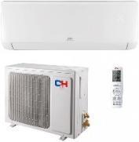 | 12
088 | Straight sofa (option 2) | Type Straight sofa  Width 152 cm  Kind of Unfolding  Upholstery material Textiles  Linen niche No.  Mattress base No.  Frame material Wood + Plywood + Particleboard + Fiberboard  Height 77 cm  Filling Spring block  There are armrests  Seat height 46 cm  12 months warranty | 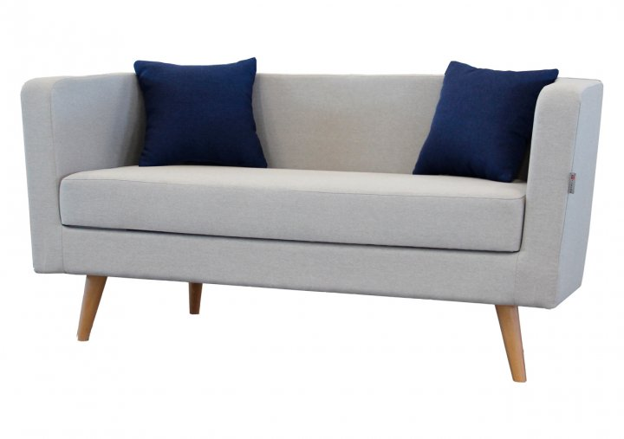 | 7
089 | Office chair | Type  Conference chairs  Staff chairs  Executive chair  Features  Headrest  Lumbar support  Upholstery material  Membrane tissue  Grid  Textile  Maximum load, kg 150  Color Black  Adjustments  Lumbar pillow height  Seat height  Swing stiffness  Crosspiece base with rollers  Housing material  Tree  Metal  Plastic  Mechanisms  Tilt  Armrests  Metal  Plastic  With armrests  Weight, kg 11  Degree of rigidity Medium  Complete set  Back  Removable lumbar support pillow  Seat  Armrests  Tilt swing mechanism  Gas lift class 3  Protective cover of the gas lift  The basis  Rubberized rollers  Mounting kit  Instruction  Seat dimensions 50 x 48 cm  Additional features  Gas lift type 3 class  Type of armrests: plastic with a structured surface + metal  Base: reinforced 5-beam cross made of chromed metal  Reinforced Tilt mechanism: metal thickness 2.5 mm with swing stiffness adjustment and locking in one position  Rubberized rollers  Back frame: metal  Removable back cover made of strong nylon mesh and wear-resistant eco-leather  Seat: reinforced plywood made of increased thickness beech, formed to ensure an anatomically correct position when sitting  Accessory: removable lumbar support pillow  Two-layer soft filler with improved characteristics  Gross weight, kg: 11.9  Package dimensions: 77x23x58 cm  Dimensions of the cross pillow: 45x10 cm | 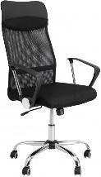 | 16
090 | Children's chair | Size: 54x34x28 cm. Dimensions: chair height - 54 cm, seat height from the floor - 26 cm, total width of the chair - 34 cm, seat depth - 25 cm. Weight: 2 kg. Additional characteristics: surface coating - a mixture of wax and linseed oil. Complete set: chair - 1 piece. | 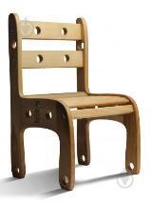 | 10
091 | Children's table | Type: table. Manufacturer's color: beech. Size: 46x55x55 cm. Weight: 6.2 kg. Warranty period: 12 months. | 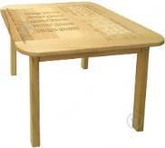 | 5
092 | Tablet | Screen view Capacitive  9.7 "screen diagonal  2 GB of RAM  Wireless capabilities  4G (LTE)  Bluetooth  Wi-Fi  Built-in 32 GB memory  Android 10.0 operating system  Screen resolution 1280x800  Number of cores 4 + 4  Huawei Kirin 710A processor (2.0 GHz + 1.7 GHz) or equivalent  Navigation system  GPS  GLONASS  IPS matrix type  Color Blue  Front camera 2 MP  Support for microSD memory cards  The main camera is 5 MP  The maximum capacity of memory cards is 512 GB  Built-in 3G module Yes  Number of SIM cards 1  Screen refresh rate 60 Hz  Connectors  USB Type-C  3.5 mm connector  SIM card slot  Housing material Metal  Additional features OTG support  Battery 5100 mAh  Width 240.2 mm  Height 159 mm  Depth 7.85 mm  Weight 450 g  Complete set  Tablet  Charger  USB Type-C cable  Documentation  12 months warranty | 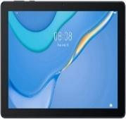 | 6
093 | The video surveillance camera wired | Type Wired  Infrared illumination up to 30 m  View of the Dome  10 / 100BASE-TX Ethernet interfaces  Possibility of use on the street Quantity in packing, piece 1  Matrix size 1 / 2.8 "  Manufacturer and type of Progressive Scan CMOS matrix or equivalent  Focal length 2.8 mm  Horizontal viewing angle 114 °  Resolution and recording frequency  Support for resolutions: 1920 x 1080, 1280 x 960, 1280 x 720  Frame rate (main stream): 1920 x 1080, 1280 x 960, 1280 x 720 - 25 fps  Frame rate (additional stream): 640 x 480, 640 x 360, 320 x 240 - 25 frames / s  Frame rate (additional stream 2): 32 Kbps ~ 8 Mbps  Vertical viewing angle 62 °  Housing material Metal / Plastic  Additional features  Matrix: 1 / 2.8 "progressive scan CMOS or equivalent  Max. resolution: 1920x1080, 2MP  Min. sensitivity: 0.01 Suite (F1.2, AGC on), 0.028 Suite (F2.0, AGC on), 0 Suite with IR  Shutter speed: 1/3 s - 1 / 100,000 s  Slow shutter speed: Supports  Day / night mode: IR filter  Backlight type: IR  Backlight control: Auto / Manual  Illumination range: Up to 30 m  Lens type: Fixed  Focal length: 2.8 mm  Lens mount: M12  Aperture: F2.0  Viewing angles: Horizontal: 114 °, Vertical: 62 °, Diagonal: 135 °  Image settings: Rotation mode, saturation, brightness, contrast, sharpness  Audio compression: G722.1 / G711ulaw / G711alaw / G726 / MP2L2 / PCM  Ethernet: 1 RJ45 10M / 100M  Network protocols: TCP / IP, ICMP, HTTP, HTTPS, DHCP, DNS, RTP, RTSP, RTCP, NTP, IGMP, QoS, UDP  Compatibility: ONVIF (PROFILE S), ISAPI  Browser support: IE8 +, Chrome 31.0-44, Firefox 30.0-51, Safari 8.0+  Software: iVMS-4200, Hik-Connect, iVMS-5200  Mobile platforms: Android, iOS  Alarm triggers: Motion detection, video spoofing, network shutdown, IP address conflict, hard drive overflow, hard drive error, incorrect login  Operating voltage 12 V  Operating temperature range -30 - +60 ° C  Dimensions 134 x 108 mm  Weight 400 g  12 months warranty | 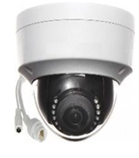 | 46
094 | Freezer | The total volume is 101 liters  Camera Type  Defrost system Static  Energy consumption class A ++  Installation method Freestanding (solo)  Useful volume, l 98  Type of control Electronic  Features  LCD display  Annual electricity consumption, kW * year 149 kW * year  Freezing capacity 11 kg / 24 h  Autonomous cold storage 26 hours  Climate class  SN (from +10 to +32 C)  T (from +18 to + 43C)  Refrigerant R 600a  Additional features  Comfort series  VarioSpace  SmartFrost system  Length of a network cable: 160 cm  Adjustable legs  SuperFrost in time  FrostProtect  Freezer compartment  Functions and features  Fast freezing  Child protection  Number of boxes / baskets 3  Technical characteristics  Color White  Dimensions (HxWxD) 85.1 x 55.3 x 62.4 cm  Dimensions in the package (HxWxD) 91.1 x 56.7 x 71.1 cm  Weight 42 kg  Package weight 44.5 kg  Total volume, l 100 - 139  Depth, cm 62.4  Width, cm 55.3  Noise level, dB 40  Warranty 36 months official warranty from the manufacturer | 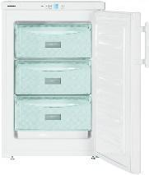 | 1
095 | Kitchen table (round) | Height 1200 mm. Width 100 mm. Length 580 mm. Unfolded length 1100 mm. The color of the table top is oak sonoma. The shape is round. Diameter 1100 mm. Folding functionality. View of a transforming table. Frame color black. The material of the table top is chipboard. The frame material is metal. No glass | 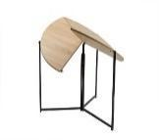 | 2
096 | Vacuum cleaner for dry cleaning | Dust collector type Container type (no bag)  Cleaning type Dry  Cord length 7 m  Noise level, dB 76  Dust container volume, l 1.4  Power  Power adjustment On the case  Power consumption 550 W  Equipment  Additional attachments  Crevice  HEPA 13 outlet filter (washable) or equivalent  Tube type Steel telescopic  Basic nozzles Floor-carpet  Additional attachments  Upholstery nozzle  Hard floor nozzle  Equipment  Vacuum cleaner  Nozzles  Peculiarities  Cleaning radius 9 m  Technical features  Automatic cord rewinder  Extra features  Smart Sensor Control function  Innovative HiSpin motor or equivalent  Universal parking  Dimensions (HxWxD) 30 x 44.5 x 28.8 cm  Packing dimensions (HxWxD) 31.5 x 36.5 x 58 cm  Weight 4.7 kg  Package Weight 7.8 kg | 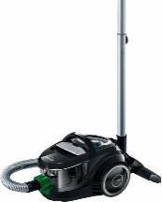 | 5
097 | Children's highchair for feeding | Material Plastic + metal  Backrest recline Five positions  Height adjustment Seven positions  Color Blue  Age 6 months | 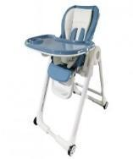 | 4
98 | Walkers | Dimensions (LxWxH): 65x70x50 / 53 cm  Folded dimensions (LxWxH): 65x70x25 cm  Dimensions in packing (LxWxH): 65.5x12x70.5 cm  Walker weight: 3.7 kg  Shipping Weight: 4.5kg | 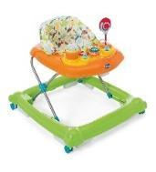 | 3
99 | Call buttons | DISABLED CALL RECEIVER  Receiver with sound signal without dial.  Stylish device with built-in antenna.  Expansion of the kit is possible by ordering additional buttons.  Wide range of call signals. 32 melodies and 4 levels of volume control.  Power type: from the network 110 V - 220 V  Frequency: 433.92 MHz  Size: 93 x 60 x 22mm  Radius of action: up to 100 - 150 m in open space  DISABLED CALL BUTTON  Waterproof and anti-vandal white call button with a plastic case.  Serves to call staff for people with disabilities in a wheelchair.  Works in all weather conditions. Not afraid of rain and direct sunlight.  The button is equipped with a push indicator, easy and convenient to use.  fix the button using screws or a special adhesive element for quick fixing.  Power type: The battery (23A - 12 Volts). Size: 82 x 65 x 28mm.  Radius of action: 150 - 200 m.  DISABLED HELP BUTTON LABEL  The disabled sign is made of PVC (200 x 118 x 3 mm). | 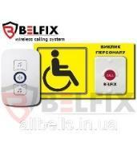 | 10
100 | Closet | Material Laminate, HDF, Particleboard  Color White, Oak  Type Sliding doors  Features of a drawer Full drawing  includes 2 rails for hangers, 2 shelves, 2 sliding doors, 4 drawers  Size in the assembled state width: 122 cm, height: 201 cm, depth: 61 cm | 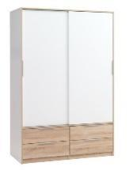 | 3
101 | CCTV camera | Resolution: 4.0 MP | Lens: 2.8 mm | Frequency: 25 fps Illumination: 40 m | microSD up to 256 GB | IP67 | PoE | ColorVu or equivalent | 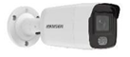 | 2
102 | NETWORK IP VIDEO RECORDER | Designed to record and display video streams from IP cameras; Connection to 16 IP-cameras; HDMI video output: 4K (3840x2160); VGA: 1920x1080;  Recording resolution: up to 8 MP; Support 1 SATA HDD up to 6 TB;  Self-adaptive network interface: 1 RJ-45 10/100 / 1000Mb / s;  USB interface: 2 × USB 2.0; | 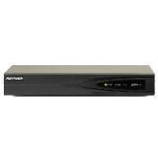 | 5
103 | NETWORK IP VIDEO RECORDER | Network DVR is designed to record and display video streams from IP cameras; Ability to simultaneously connect up to 16 IP-cameras with a recording resolution of up to 8 MP; HDMI / VGA video outputs;  Support for up to 128 remote connections for viewing;  Audio input and audio output;  4 alarm inputs and 1 alarm output; | 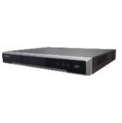 | 1
104 | 4 TB hard drive | Capacity: 4 TB  Buffer memory capacity: 64 MB  Interface: SATA 3 | 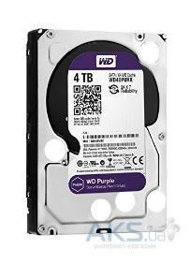 | 7
105 | Port switch | POE switch;  8 RJ45 ports (10/100 Mbps);  Support for Power over Ethrernet technology; Budget PoE 96 W;  Maximum power of one port - ≤60W;  Supports IEEE 802.3af, IEEE802.3at (PoE +), Hi-PoE standards;  MAC address table size: 16000 records; | 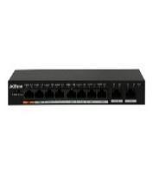 | 7
106 | Box hinged | Overhead metal box. Dimensions: 500x500x100 mm | 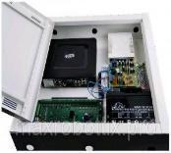 | 15
107 | Cable duct (10 pieces) | The white cable duct is designed for neat wiring inside the building. The accessory protects cables from dust, moisture and mechanical stress. The width and depth of the model are 25x16 mm, respectively, while the length is two meters. | 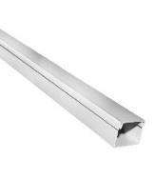 | 50
108 | Cable (10 pieces) | PVC flat wire 2x1 copper wire for internal wiring. It has two stranded conductors of the fifth class of flexibility, sheath - PVC compound. A copper wire PVC flat 2х1 is used to connect electrical equipment both in everyday life and in industry. The rated current is -10 A. Operating temperatures for - 25 ... + 40 ° C. | 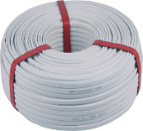 | 10
109 | Connector | Connector RJ45 cat.5e UTP 8P8C 100 pcs - unshielded or equivalent. Contact coating: nickel, with 0.6 µ gilding. Connector housing material: transparent polycarbonate. | 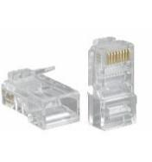 | 5
110 | Monitor min 23" | Display diagonal min 23"  Refresh rate 75 Hz  Maximum display resolution 1920 x 1080  Matrix response time 5 ms  Display brightness 250 cd / m²  Matrix type IPS  DisplayPort HDMI VGA  Display contrast 1000: 1  Pixel size 0.274 mm | 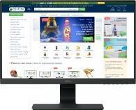 | 5
111 | Network cable | UTP cable type  Material copper  Length 305 m  Section 0.5 mm  Category cat 5  The color is white | 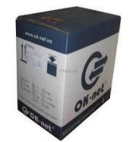 | 5
112 | Distribution box | Distributive box 80х80х40 gray (unitary enterprise. 60 pieces) Does not corrode, shock-resistant and is steady against pressure. Made of durable polymeric material. Properties of self-extinguishing, not spreading combustion. | 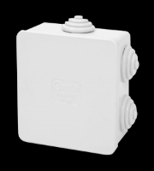 | 80
113 | Wooden cutting board | Material Wood  Width 30 cm | 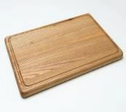 | 4
114 | Dryer stand | Type Stand-organizer  Compartments for ware For plates  Material Metal  Color Chrome  Dimensions 42.5x19x21.3 cm  Quantity in packing, piece 1  Features With pallet  Weight, g 940  Dishwasher safe | 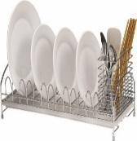 | 2
115 | Measuring mug | Type Measuring cups  Volume, ml 1000  Material Heat resistant glass  Units  Gram  Milliliters  Pints  Delivery type One piece | 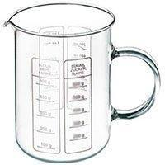 | 1
116 | Knife set | 7-piece knife set:  Cleaning knife 8 cm  Utility knife 12.5 cm  Carving knife 19 cm  Chef knife 20 cm  Bread knife 20 cm  Utility scissors 20 cm  Wooden deck | 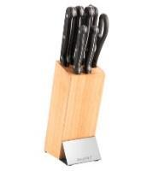 | 4
117 | Iron teapot | Compatibility Gas stoves  Induction cookers  Glass ceramic plates  Electric stoves  Volume, l 3  Material Stainless steel  Color Steel  Features Whistle  Handle material Bakelite | 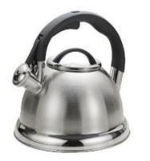 | 1
118 | Cup | Volume: 250  Age category: For adults  Material: Ceramics  Color: Smoky  Type: For tea  Type: One subject  Pattern: No pattern | 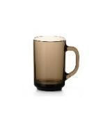 | 37
119 | Stainless steel bowl | Type One subject  Type of Bowls  Material Metal  number of items One item | 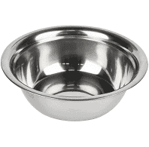 | 3
120 | Bowls (set) | Peculiarities  Microwave use  Freezer use  Type Classic container  Volume  1.3 l  2.2 l  3.2 l  800 ml  Container material Polypropylene  Shape Round  Delivery type Set  Dimensions (edit)  1 bowl 0.8 l (dia. 15 cm, height 8 cm) 1 bowl 1.3 l (dia. 17 cm, height 9 cm) 1 bowl 2.2 l (dia. 20 cm, height 11 cm) 1 bowl 3.2 liters (dia. 23 cm, height 12 cm) 1 bowl 4.7 liters (dia. 25 cm, height 15 cm) | 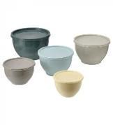 | 23
121 | Bed 90x200 cm | Type: classic bed. Purpose: for home. Type: springless. Laundry niche: drawer. Frame color: oak. Transport condition: disassembled. Frame material: chipboard. Mattress base: slats. Length: 2040 mm. Width: 1210 mm. Height: 950 mm. Bed size: 90x200 cm. | 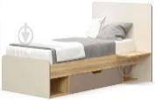 | 15
122 | Water cooler | Type of water temperatures: hot - cold;  Modern compact design  Electronic type of cooling;  Temperature regulation: no;  The water heating tank is made of high quality food grade stainless steel;  Antibacterial coating of internal parts in contact with water  Heating / cooling indicator;  For storing cups on this model, a 12 liter cabinet;  The taps in this model are push-type. Floor standing type. | 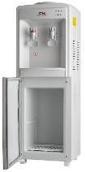 | 2
123 | Blanket 1.5 | The size is One and a half 160 * 220  Classic blanket with anti-allergenic filling. | 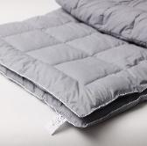 | 12
124 | Towel for hands and face | Sizes 50x90 cm  Material Terry  Design and decor Solid colors  Material features 100% cotton  Density of the material, g / m2 500  Color Red  Quantity in a set, pcs 1  Set complete set 1 towel | 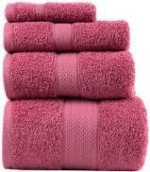 | 32
125 | Round wall mirror for the bathroom | Type Wall  Height, cm 70  Width, cm 70  Shape Round  Chipboard frame material  Depth, cm 3  Features Backlight  12 months warranty | 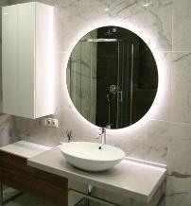 | 5
126 | TV bracket | Mount standard (VESA)  100x100 mm 75x75 mm  Screen diagonal  15 "15.4" 15.6 "16" 17 "18.5" 19 "  20 "20.7" 21 "21.5" 21.6 "22"  23 "23.6" 23.8 "24" 25 "26" 27 "Maximum load 15 kg  Adjustment Swivel  Number of degrees of freedom 4  Black color  compatibility (Diagonal) 13 "- 27"  Minimum supported diagonal 13 "  Maximum supported diagonal 27 "  Dimensions 120 x 195 x 585-3645 mm  12 months warranty | 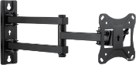 | 3
127 | Extension cord | extension cord  Total power of the connected load ≤ 2200 W.  Rated voltage 220 V  Operating frequency 50 Hz  Maximum current 10 A  Number of sockets 5 sockets  General socket switch yes  Cable length 3 m  Grounding yes  The color is white | 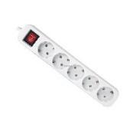 | 6
128 | Laptop | Screen diagonal 14.1 "(1920x1080) Full HD  Screen type IPS  Refresh rate 60 Hz  Processor i3, min 10Gen; min 2,1 GHz  RAM 4 GB  RAM type DDR4  Data storage devices 1  64GB eMMC storage  Integrated graphics  Battery capacity 5000 mAh  Battery characteristics  min 3 cell  Connection  Network adapters  Wi-Fi 802.11ac  Bluetooth 4.0  Connectors and I / O ports  1 x USB 3.0 / 1 x USB 2.0 / HDMI (preferable) or mini HDMI / headphone / microphone combo / TF-CARD card reader | 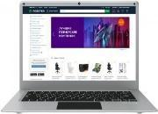 | 3
129 | Shredder | Security level 3  Cutting type Cross  Number of sheets to be destroyed at a time (70 g / m2) 6  Number of sheets to be destroyed at a time (80 g / m2) 5  Basket capacity 14 l  Features Reverse  Weight 3 kg  Destroyer class Personal  Working cycle ("running" / "resting") 2/30 min  Fragment size 4x39 mm  Dimensions 308x180x360 mm  Destruction speed 2 m / min  Noise level 72 dB  Feed slot width 220 mm  12 months warranty | 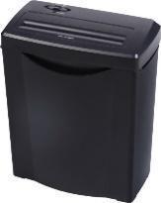 | 1
130 | Window bars | Length: 1000 mm. Height: 1600 mm. Diameter: 12 mm. Additional characteristics: full size: 1610x1350 mm, rod 12x12 mm, distance between rods - 12.5 cm. Material: steel. Covering: primer. | 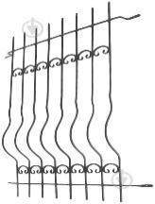 | 13
131 | Information stand | Production material: high-quality plastic PVC 3 mm  Stand size: 1000x900 mm  Number of pockets: 8 pcs of A4 format | 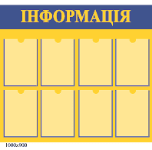 | 5
132 | Ramp | 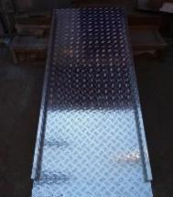  Stationary ramp 120cmx60cmx13cm without handrails  A ramp is a flat area between two surfaces at different levels from the ground. The purpose of the ramp is to provide an opportunity for movement, overcoming obstacles for disabled people in wheelchairs. |  | 3
133 | Armored doors | Entrance doors wenge dark 2050x950 mm left. Product type: metal doors, entrance doors. Complete set: the top lock (lever type) - 5 keys, the lower lock (under the cylinder) - 5 keys. Class: standard. Usage: internal. Equipment: anti-cuts, door eye. Number of loops: 3. Type of loops: external. | 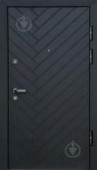 | 2
134 | Multicooker | Total volume, l 2  Type of slow cooker  Extinguishing functions  Additional features  Removable top cover  Control type Rotary switch  Heating type TEN heating  Weight 2,016 kg  Package weight 2,298 kg  Complete set  Slow cooker  Instruction  Housing material Stainless steel  Power of a heating element is 145 W.  Features  3 heating settings: high, low and warm  Tempered glass lid  Ceramic bowl coating  Color Silver / Black  Product color Silver / black  Dimensions in the package (HxWxD) 22.6 x 22.5 x 22 cm | 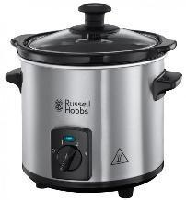 | 3
135 | Corner office table | Sonoma oak color  Height 750 mm  Width 1230 mm  Depth 1200 mm | 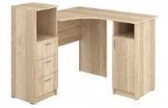 | 2
136 | Cabinet for storage of didactic material | Case for storage of didactic material (2230х460х1864 mm)  Structural components: facades, top and bottom covers, sidewalls and shelves are made of colored laminated chipboard 16 mm thick, emission class E1, pasted on the ends with a shock-absorbing PVC edge 0.45 mm thick. Plastic storage drawers are installed in special niches. | 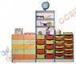 | 1
137 | Soft pouf | Overall dimensions - 480х370х340 mm  The set consists of 5 colored poufs, which can be combined into a straight or wavy line and a "flower".  The frame of poufs is made of high-quality chipboard E1 with a thickness of at least 16 mm and fiberboard with a thickness of at least 3 mm;  - soft part from primary PPU (polyurethane foam) with density not less than 28 kg / cubic meter. height 40mm for seating and 10mm around the perimeter.  Exterior upholstery - mat mat, color: light green, blue, red, pink, beige. | 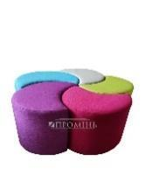 | 6
138 | Children's table 6-seater | Overall dimensions - 1020 * 1160 * H mm;  The table consists of an all-welded metal frame and a table top, which are connected by a screw tie.  The frame of the table is made of pipes 20x20x1.2; Ø27x1.2 and Ø22x1.2. Coating - spraying of wear-resistant powder paint. Height adjustment is carried out by means of telescopically connected pipes of various diameter between which the plastic coupling is established, and a special screw coupler.  Countertops are made of multi-colored chipboard 16 mm thick, emission class E-1, and lined with PVC edge at least 2 mm thick.  The table is adjustable from 2 to 6 age groups | 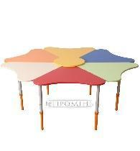 | 4
139 | Straight sofa (option 3) | Frame - Plywood, chipboard, pipe 20 × 20 mm. Upholstery - artificial leather Fly. Overall dimensions (W × D × H) - 1540 × 680 × 720 mm. The weight of the sofa is 30.4 kg  The frame of the sofa is all-welded, made of steel pipe with a cross section of 20 × 20 mm and a wall thickness of at least 1 mm, reinforced with metal scarves 3 mm thick at the legs. The basis of a sofa is made of the polished chipboard 16 mm thick, a back from plywood 12 mm thick, in knots of connection with risers there are special metal arms that allows to assemble or disassemble a sofa quickly and easily. At the joints of the backrests there are special plastic plugs that prevent damage to the upholstery material during assembly and subsequent operation of the sofa. Internal filling - polyurethane foam of the increased density. | 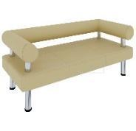 | 2
140 | Alarm button | Operating frequency, MHz: 433.92  Reception range: 180 m in open space  Coding: PowerCode  Features: 60 degree tilt angle  Power supply: 3.6V, lithium battery, size 1/2 AA  Consumption current: 15 μA in normal state | 10 mA when transmitting  Overall dimensions, mm: 120x52x36 | 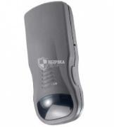 | 3
141 | Office straight table (option 2) | Tabletop material Laminated chipboard  Case thickness 16 mm mm  Color Sonoma Oak  Height 750 mm  Width 800 mm  Depth 500 mm  12 months warranty | 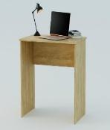 | 2
142 | Marker board | Dimensions and weight Width: 60 cm. Weight: 3.9 kg. Length: 90 cm. Complete set: board, fixing kit, shelf. Modification: wall-mounted. Packing: cardboard box. Producer's color: silver. | 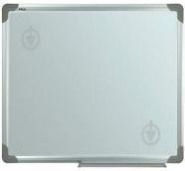 | 1
143 | Rack for booklets | Material: chrome-plated pipe, transparent acrylic 3 mm  The size of the acrylic panel: 1800x500 mm  Base: Particleboard / metal with composite coating  Pockets: A4 format 8 pcs, transparent acrylic 2 mm  Cell depth: 30 mm  Overall size: 600х1840х300mm  The size of the basis: 600kh300mm  Design: removable pockets  Type: one-sided | 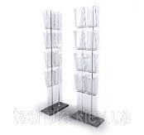 | 2
144 | Sticker board for drawing | Color: black ·  Board material: polypropylene  Dimensions: 200x60 cm ·  Pieces of chalk: 5 pieces measuring 7x0.8 cm  - Equipment -  Black film sticker Black Board Sticker  Pieces of chalk of different colors (5 pcs.)  Cardboard packaging | 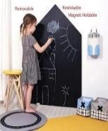 | 2
145 | Folding bed | Folding Bed Type  Frame material Steel  Maximum load 120 kg  Dimensions 198 x 72 x 37 cm  Complete set Folding bed, Mattress  Packing dimensions  90 x 72 x 31 cm | 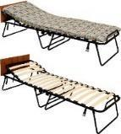 | 2
146 | Children's mattress | size 120x60  Rigidity - hard  Height - 6 cm  Filler - coconut fiber  Side Type - Various | 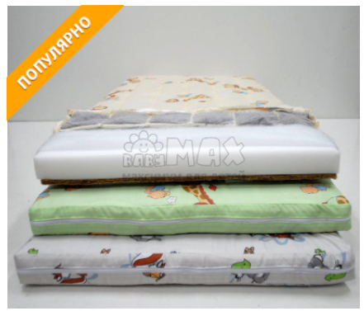 | 3
147 | Carpet | Type Carpets  Type Lint-free  Peculiarities  Type: Indoor  Composition: 70% cotton, 25% polyester, 5% viscose  Main color Multicolor  Package dimensions 1.2 x 1.8 m  Shape Rectangular  Density 1400 g / m2  Material Viscose  Polyester Cotton  Weight 4.8 kg | 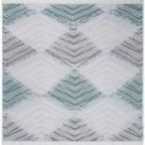 | 14
148 | Adult mattress (option 1) | Size 90x200 cm  Type Mattress Covers  Cover material Calico  Filler material Anti-allergenic fiber | 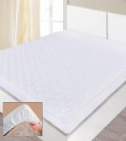 | 11
149 | Bed linen for a children's bed | Sleeping Size Baby  Material Cotton  View For newborns  Quantity, piece 3  Sheet size 90x120 cm  Design & Decor Animal Print  Blue color | 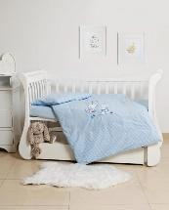 | 4
150 | Hallway (hanger, mirror, shoe shelf) | Black color  Material Metal  Additional characteristics Collapsible  Height 180 cm | 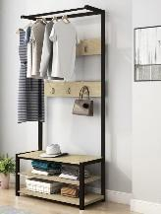 | 1
151 | Hand dryer | Mounting method: dowel. Control type: touch. Material: plastic. Type of installation: wall. Power: 2000 W. Manufacturer's color: white. Warranty: 12 months. Depth: 23 cm Height: 24 cm Width: 22 cm. | 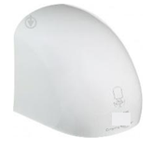 | 1
152 | Boiler 150 l | Type of boiler: boiler for a large family, common models. Temperature regulator: open (on the case). Volume: 150 l. Power: 2400 watts. Type of heating element: closed (dry). Tank material and coating: steel with enameled coating, glass ceramics. Shape: cylindrical (round). Type of installation: vertical, horizontal. Heating time: 218 minutes Type of water heater: electric. Control type: mechanical. Height: 132.9 cm. Width: 47 cm. Depth: 48.6 cm. Eyeliner: lower. | 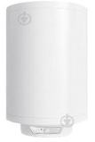 | 1
153 | Bucket | Material Plastic  Features Without cover Color Blue  Additional characteristics  Dimensions: 27.5 x 28 x 24.5 cm  Round shape  Volume, l 10 | 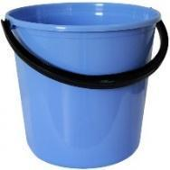 | 13
154 | Reception desk | Dimensions:  Width: 1500 mm  Depth: 600 mm  Height: 1190 mm | 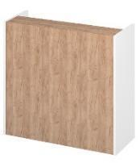 | 1
155 | Fire extinguisher | Weight, kg 7.3  Operating temperature range from -20 to + 50 ° C  Capacity (Volume), l 6  Charge weight 8.2 kg  Extinguishing class A B E C  12 months warranty  Execution Portable  Complete set  Product, passport, warranty card.  Height 480 mm  The maximum pressure is 1.6 MPa  Service life is 10 years  Emission length Not less than 3 m | 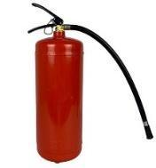 | 14
156 | First aid kit production | First aid kit medical production. Complete set: a plait for a stop of bleeding textile - 1 piece; sterile bandage (5 m x 10 cm) - 2 pieces; bandage n / s (5m x 10cm) - 3; hypothermic cooling package - 1 piece; cotton wool n / s 25g - 1 piece; coil adhesive plaster (1 cm x 500 cm) - 1 piece; bactericidal adhesive plaster (1.9 x 7.2) - 4; napkin with boric acid (10 cm x 18 cm) - 2 pcs; napkin with chlorhexidine (10 cm x 18 cm) - 8 pieces; napkin with furagin (10 cm x 18 cm) - 8; iodine solution 5% - 1 piece; napkin with ammonia solution (10 cm x 18 cm) - 2 pieces; boric acid - 1 piece; napkin with a solution of hydrogen peroxide (10 cm x 18 cm) - 2 pcs; device for artificial respiration - 1 piece; analgin tab №10 - 1 piece; validol tab №10 or №6 - 1 piece; sodium sulfacyl solution 20% - 1 piece; sodium bicarbonate 25g (50g) - 2 pieces (1); panthenol spray - 1 piece; medical p / e pair - 1 piece; cup - 1 piece; mercury medical thermometer - 1 piece; directory - 1 piece; recommendations - 1 piece; form - 1 pc. The composition of the first aid kit: bandage, cotton wool, tourniquet to stop bleeding, instructions, container, disposable gloves, hydrogen peroxide, patch, tablets or capsules, a device for artificial respiration. | 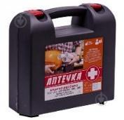 | 2
157 | Rechargeable lamp | Type Emergency lights  Light source type  LED LED (integrated)  Power supply Battery  Maximum power of the luminaire 3 W  Glow color Neutral  Color temperature 4000K  Waterproof No  IP protection class IP20  Shade color Transparent  Installation Invoice  Mains voltage 230 V  Base color White  Base material Plastic  Shade material Polycarbonate  Maximum lamp power 3 W  Luminous flux 210 lm  Lamp life 30,000 h  LED type SMD  Replaceable Light Source No  Swivel cover No  Ballast type Electronic | 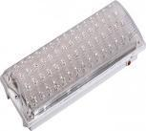 | 4
158 | Automatic tonometer | Blood pressure measurement range 30 - 280 mm Hg.  Pressure measurement type Automatic  The accuracy of blood pressure measurement is 3 mm Hg.  Pulse measurement range 40 - 200 beats / min  Pulse measurement accuracy 5% of value  Average pressure calculation No  Arrhythmia indication Yes  Buzzer No  Pressure measurement area Leverage  Number of memory cells 30  Classification according to WHO standards Yes  Automatic shutdown Yes  Power supply Batteries: 1.5 V AAA (4 pcs)  Cuff size 22 - 42 cm  Features Gentle technology + air inflates and descends very smoothly  IHB technology provides early detection of cardiac arrhythmias  Complete set Tonometer  Cuff tapered  Set of batteries (batteries)  User manual  Warranty card  Dimensions (HxWxD) 11.3 x 9 x 5.6 cm  Power Batteries  Weight 0.5 kg  White color  Warranty 60 months official manufacturer's warranty | 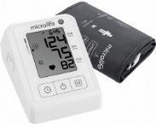 | 1
159 | Contactless thermometer | Type Infrared (non-contact)  Measurement accuracy 0.2 ° C  Temperature measurement range  32-43 ° C (body) 0-100 ° C (other objects) ° C  Battery type  2x1.5V AAA batteries  Number of saved measurements 40  Duration of temperature measurement 1s  Complete set  -thermometer -batteries -instructions -storage bags  12 months warranty | 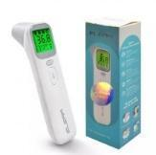 | 1
160 | Quartz lamp bactericidal / bactericidal irradiator | Type Bactericidal lamps  Lamp type Ozone-free  Room area up to 30 m2  Power 25 W  Peculiarities  Service area up to 30 m²  Germicidal wavelength: 253.7 Nm  Lamp type - ozone-free  Lamp power: 25W  Frequency 50 Hz  Wire length: 150cm  Equipment  quartz lamp  Stand with cord  Instructions  Warranty card  Dimensions (HxWxD) 23 x 9 x 9 cm | 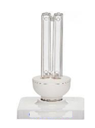 | 2
161 | Office chair without wheels | Staff Chair Type  Upholstery material Eco leather  Maximum load, kg 100  Color Milky  Body material Metal  Armrests With armrests  Seat dimensions 47 x 43 cm  12 months warranty | 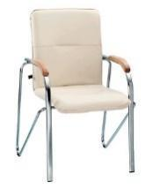 | 7
162 | Folding office chair | Black color  Upholstery material Leatherette  Height, mm 800  Seat dimensions Width: 37.2, depth: 38 cm  additional characteristics  Folding frame  End caps on legs  12 months warranty | 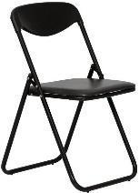 | 19
163 | The oil heater | Service area, sq. m 24  Power, W 1000 1200 2200  Number of sections 9  additional characteristics  Protection class: IP20  Number of heating modes: 3  Three-step overheating protection system  Anti-corrosion treatment of the case  Rated voltage: 230V ± 10%  Rated current frequency: 50-60Hz  Power cord length - 1.45 m  Equipment  Oil radiator  User manual  Warranty card  Dimensions (HxWxD) 65.5 x 45.2 x 15.8 cm  Weight 9.3 kg  Package Weight 10.2 kg  White color  Type of heating element Tubular (TEN)  Control Mechanical  Number of heating modes 3  Dust and moisture protection class IP20  Warranty 24 months official warranty  Protection functions Overheating protection  Peculiarities  Cord storage compartment  Handle for moving  With castors / feet for moving  With thermostat | 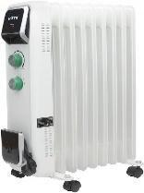 | 2
164 | Floor hanger | MDF material, Solid pine  Finishing Lacquered  Color Black  Size in the assembled state width: 40 cm, height: 175 cm, depth: 40 cm  Assembly instructions Self-assembly  Size in disassembled condition width: 50 cm, length: 42 cm, height: 9 cm  weight 4 kg | 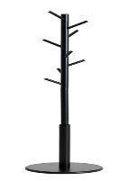 | 1
165 | Projector mount | Material: Aluminum alloy  Mounting system: wall-mounted  Length: 185cm  Mount diameter: 6mm  Load: up to 2 kg  Compatibility: TouYinger M4, TouYinger X20, TouYinger T4, TouYinger G4, TouYinger K2, TouYinger K3, Everycom M7, Everycom M8, Everycom T6, Everycom S6, Everycom S10, Everycom U20, LedProjector E500, XGIMI H1, XGI Z6, XGIM XGIMI H3, XGIMI Z8x, XGIMI MoGo, XGIMI MoGo Pro, XGIMI Halo, JMGO J6S, JMGO N7, JMGO N7L, JMGO X3, Xiaomi Mijia (Youth Edition), Xiaomi Fengmi Smart, Xiaomi Fengmi Smart Lite, Xiaomi Fengmi M1 +, ViewSonic , Byintek M1080, Byintek K1, Byintek K7, AUN C80, AUN X3, AAO YG420, AAO YG421. | 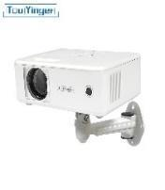 | 2
166 | Boiler 20 l | Volume, l 20  Heating element power 1x1000 W, 1x1500 W  Temperature controller Open (on the body)  Tank shape Rectangular  Heating time 22 minutes to 40 degrees and 35 minutes to maximum temperature (depending on the season) h  Inner tank material Titanium quartz enamelled steel  Power, W 2500  Heating element type (heating element) Open "wet" (in direct contact with water)  Dimensions (HxWxD) 31 x 60.6 x 34.5 cm  Dimensions in packing (HxWxD) 32 x 61.5 x 35 cm  Installation Horizontal | 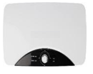 | 1
167 | Garland curtain | Glow color Warm white  Power supply network 220 V  View of Garlands-waterfalls (String-light)  Light source LED  Wire color Transparent  Color Golden  Height 2 m  Controller With controller  Number of light sources, pcs 240 | 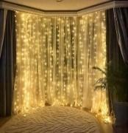 | 1
168 | Mobile nightstand | Type nightstand  Height 53.5 cm  Facade material Laminated chipboard  Body material Laminated chipboard  Number of drawers 3  Design Straight  Installation Mobile  Purpose Office | 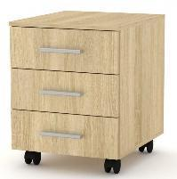 | 21
169 | Infinity light panel | Has a therapeutic effect on the nervous system, soothes, relaxes. Soft caps are attached to the ends of the fibers to secure the product and prevent loosening and abrasion of the thread.  Size - 64x64x7 cm  Material - plywood, wood, plexiglass, LED lamps.  Description:  Is a light panel with warm and cold glow. Has modes of adjustment of switching of shades, brightness, flicker. | 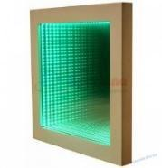 | 1
170 | Night projector Starry sky | Equipment  Projector  Not included: USB cable and AAA batteries - 4 pcs | 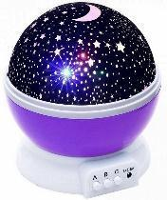 | 1
171 | Lava night lamp | Shade color Green  Replaceable light source Without replaceable light source |  | 1
172 | Bedspread - a blanket for a children’s' bed | Dimensions 160x212 cm  Renfors material  Cotton Features  Quilted Appointment  On the sofa On the bed | 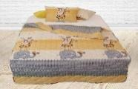 | 2
173 | The bedspread - blanket for the bed | Characteristics: red, white, black  Dimensions 145x210 cm  Color Black + White + Red | 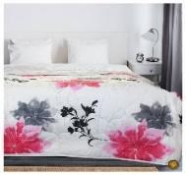 | 11
174 | Transformer table | Length, mm 902  Width, mm 605  Height, mm 520  750 Material of legs Wood  Material of a table-top of LDSP of 16 mm  Folding type  Transformer  Rectangular shape  High-tech style | 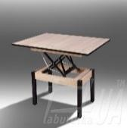 | 2
175 | Chair without back | Shape: square. Base color: white, silver. Transport condition: assembled. Upholstery color: milk. Style: modern. Frame color: chrome. Frame material: metal. Filler: foam rubber. Upholstery: leatherette. Equipment: with pillow. Length: 364 mm. Width: 370 mm. Height: 460 mm. | 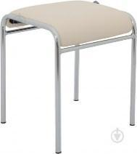 | 16
176 | Mattress topper for children | Parameters and specification  Color: white  Surface fabric material: 70% polyester, 30% bamboo fiber  Recommended washing: 40 ° C  Size: 60 x 120 cm  Dimensions: 60 x 120 cm  Bed type: baby cot | 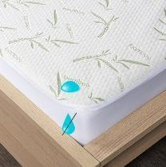 | 2
177 | Fire shield | Characteristics Open-type fire panel with a complete set + 2 fire extinguishers (VP-5) Height 900 mm Manufacturer color red Body material metal Installation type wall-mounted Width 1200 mm Features Thickness of the shield metal - 0.8 mm Country of origin Ukraine Complete set of hook -1pc., Scrap -1pc ., shovel -1 pc., ax -1 pc., bucket -2 pc., VP-5 -2 pc. | 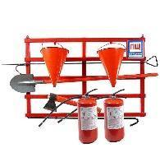 | 2
178 | Toilet paper holder | Additional features: with shelf. Installation method: dowel. Material: metal. Installation type: wall-mounted. Producer's color: gray. | 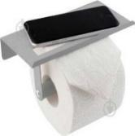 | 5
179 | Shoe cupboard | Material Laminated chipboard  Color Brown with gray  Width, cm 60  Height, cm 49.5  Depth, cm 30  12 months warranty | 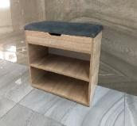 | 2
180 | Set of frying pans | Set type Set of pans  Number of items in a set, pcs 3  Heat source compatibility Induction hobs  Material Aluminum / Marble  Handle material Soft Touch  additional characteristics  Lead free; Diameters: 20.24.28 cm  Equipment  Frying pan - 3 pcs.; Package |  | 1
181 | Baby changing table | Type Changing tables-chest of drawers  Dimensions 60 x 103 x 88 cm  Number of drawers 2  Features Removable Diaper  Complete set Removable changing surface  Weight 24  White color | 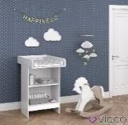 | 2
182 | Metal cabinet for documents | Features: with a lock. Number of sections: 2. Accommodation: hospital, office. Number of shelves: 4 pcs. Producer's color: gray. Appointment: for tools, for clothes (lockers). Lock type: mechanical. Height: 1830 mm. Width: 915 mm. Depth: 458 mm. | 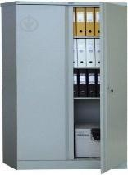 | 4

Schedule of Requirements
The Bidder shall also furnish a list giving full particulars, including available sources and current prices of spare parts, special tools, etc., necessary for the proper and continuing functioning of the goods during 2 years following commencement of the use of the goods by UNFPA.
1. | List of Goods and Delivery Schedule

Line Item | Description of goods | Quantity | Unit of measure | Delivery Schedule
1 | Mobile phone | 13 | pc | to be advised by the bidder
2 | Laptop | 14 | pc | to be advised by the bidder
3 | All-In-One desktop PC | 9 | pc | to be advised by the bidder
4 | Tvset | 4 | pc | to be advised by the bidder
5 | Tablet | 2 | pc | to be advised by the bidder
6 | Multi-Function Printer laser | 12 | pc | to be advised by the bidder
7 | Laser printer | 2 | pc | to be advised by the bidder
8 | Telephone (with cable) | 6 | pc | to be advised by the bidder
9 | Electric meter | 2 | pc | to be advised by the bidder
10 | Internet router (router) | 9 | pc | to be advised by the bidder
11 | Office straight table (option 1) | 47 | pc | to be advised by the bidder
12 | Recirculator bactericidal | 2 | pc | to be advised by the bidder
13 | Stepladder | 2 | pc | to be advised by the bidder
14 | Executive chair | 2 | pc | to be advised by the bidder
15 | Chest of drawers | 9 | pc | to be advised by the bidder
16 | Adult mattress (option 1) | 17 | pc | to be advised by the bidder
17 | Bedding set 1.5 (bed linen) | 70 | pc | to be advised by the bidder
18 | Towel | 60 | pc | to be advised by the bidder
19 | Cleaning set | 1 | pc | to be advised by the bidder
20 | Mop for a floor | 1 | pc | to be advised by the bidder
21 | Dustpan and broom | 12 | pc | to be advised by the bidder
22 | Kitchen towel | 12 | pc | to be advised by the bidder
23 | Pillow | 37 | pc | to be advised by the bidder
24 | Blanket | 27 | pc | to be advised by the bidder
25 | Plaid | 25 | pc | to be advised by the bidder
26 | Round bowl | 6 | pc | to be advised by the bidder
27 | Corner computer table (option 1) | 1 | pc | to be advised by the bidder
28 | Armchair | 10 | pc | to be advised by the bidder
29 | Round coffee table | 3 | pc | to be advised by the bidder
30 | Straight sofa (option 1) | 3 | pc | to be advised by the bidder
31 | Shelving (bookcase) | 22 | pc | to be advised by the bidder
32 | Mattress orthopedic 90 * 190 (option 2) | 6 | pc | to be advised by the bidder
33 | Desk lamp | 6 | pc | to be advised by the bidder
34 | Office guest chair | 86 | pc | to be advised by the bidder
35 | Electric radiator | 3 | pc | to be advised by the bidder
36 | Wardrobe | 22 | pc | to be advised by the bidder
37 | IroSet of bathroom rugs | 3 | pc | to be advised by the bidder
38 | Iron | 6 | pc | to be advised by the bidder
39 | Ironing board | 6 | pc | to be advised by the bidder
40 | Children's pot | 2 | pc | to be advised by the bidder
41 | Clothes dryer | 7 | pc | to be advised by the bidder
42 | Clock | 2 | pc | to be advised by the bidder
43 | Bunk bed transformer | 1 | pc | to be advised by the bidder
44 | Corner sofa | 3 | pc | to be advised by the bidder
45 | Antechamber | 1 | pc | to be advised by the bidder
46 | Rug | 1 | pc | to be advised by the bidder
47 | Cordless vacuum cleaner | 1 | pc | to be advised by the bidder
48 | Washing machine | 4 | pc | to be advised by the bidder
49 | Kitchen faucet | 1 | pc | to be advised by the bidder
50 | Electric kettle | 13 | pc | to be advised by the bidder
51 | Microwave | 7 | pc | to be advised by the bidder
52 | Two-chamber refrigerator | 6 | pc | to be advised by the bidder
53 | Cooking surface / electric hob | 5 | pc | to be advised by the bidder
54 | Hair dryer | 6 | pc | to be advised by the bidder
55 | Kitchen hood | 4 | pc | to be advised by the bidder
56 | Kitchen | 1 | pc | to be advised by the bidder
57 | Lamp | 6 | pc | to be advised by the bidder
58 | Set of pots | 5 | pc | to be advised by the bidder
59 | Set of cutlery | 29 | pc | to be advised by the bidder
60 | Tableware set | 6 | pc | to be advised by the bidder
61 | Tray | 4 | pc | to be advised by the bidder
62 | Sink | 1 | pc | to be advised by the bidder
63 | Trash can | 10 | pc | to be advised by the bidder
64 | Electric towel dryer | 1 | pc | to be advised by the bidder
65 | Mirror with locker | 3 | pc | to be advised by the bidder
66 | Glass shower | 1 | pc | to be advised by the bidder
67 | Compact toilet bowl | 1 | pc | to be advised by the bidder
68 | Bath faucet with thermostat and shower | 1 | pc | to be advised by the bidder
69 | The brush | 6 | pc | to be advised by the bidder
70 | Kitchen cabinet | 2 | pc | to be advised by the bidder
71 | The kitchen table | 3 | pc | to be advised by the bidder
72 | Kitchen chairs | 21 | pc | to be advised by the bidder
73 | Set of hand tools | 1 | pc | to be advised by the bidder
74 | Hammer drill | 1 | pc | to be advised by the bidder
75 | Set of bathroom accessories | 14 | pc | to be advised by the bidder
76 | Laundry basket | 16 | pc | to be advised by the bidder
77 | Corner shelf quadrangular | 12 | pc | to be advised by the bidder
78 | Projector screen | 3 | pc | to be advised by the bidder
79 | Projector | 3 | pc | to be advised by the bidder
80 | Armchair-bag | 8 | pc | to be advised by the bidder
81 | Baby bed with bedside table and diaper table | 6 | pc | to be advised by the bidder
82 | Toilet seat | 2 | pc | to be advised by the bidder
83 | Children's blanket 110 * 140 | 6 | pc | to be advised by the bidder
84 | Children's pillow | 6 | pc | to be advised by the bidder
85 | Mobile button phone | 2 | pc | to be advised by the bidder
86 | Office safe | 6 | pc | to be advised by the bidder
87 | Air conditioning | 12 | pc | to be advised by the bidder
88 | Straight sofa (option 2) | 7 | pc | to be advised by the bidder
89 | Office chair | 16 | pc | to be advised by the bidder
90 | Children's chair | 10 | pc | to be advised by the bidder
91 | Children's table | 5 | pc | to be advised by the bidder
92 | Tablet | 6 | pc | to be advised by the bidder
93 | The video surveillance camera wired | 46 | pc | to be advised by the bidder
94 | Freezer | 1 | pc | to be advised by the bidder
95 | Kitchen table (round) | 2 | pc | to be advised by the bidder
96 | Vacuum cleaner for dry cleaning | 5 | pc | to be advised by the bidder
97 | Children's highchair for feeding | 4 | pc | to be advised by the bidder
98 | walkers | 3 | pc | to be advised by the bidder
99 | call buttons | 10 | pc | to be advised by the bidder
100 | Closet | 3 | pc | to be advised by the bidder
101 | CCTV camera | 2 | pc | to be advised by the bidder
102 | NETWORK IP VIDEO RECORDER | 5 | pc | to be advised by the bidder
103 | NETWORK IP VIDEO RECORDER | 1 | pc | to be advised by the bidder
104 | 4 TB hard drive | 7 | pc | to be advised by the bidder
105 | Port switch | 7 | pc | to be advised by the bidder
106 | Box hinged | 15 | pc | to be advised by the bidder
107 | Cable duct (10 pieces) | 50 | pc | to be advised by the bidder
108 | cable (10 pieces) | 10 | pc | to be advised by the bidder
109 | Connector | 5 | pc | to be advised by the bidder
110 | Monitor min 23" | 5 | pc | to be advised by the bidder
111 | Network cable | 5 | pc | to be advised by the bidder
112 | Distribution box | 80 | pc | to be advised by the bidder
113 | Wooden cutting board | 4 | pc | to be advised by the bidder
114 | Dryer stand | 2 | pc | to be advised by the bidder
115 | Measuring mug | 1 | pc | to be advised by the bidder
116 | Knife set | 4 | pc | to be advised by the bidder
117 | Iron teapot | 1 | pc | to be advised by the bidder
118 | Cup | 37 | pc | to be advised by the bidder
119 | Stainless steel bowl | 3 | pc | to be advised by the bidder
120 | Bowls (set) | 23 | pc | to be advised by the bidder
121 | Bed 90x200 cm | 15 | pc | to be advised by the bidder
122 | Water cooler | 2 | pc | to be advised by the bidder
123 | Blanket 1.5 | 12 | pc | to be advised by the bidder
124 | Towel for hands and face | 32 | pc | to be advised by the bidder
125 | Round wall mirror for the bathroom | 5 | pc | to be advised by the bidder
126 | TV bracket | 3 | pc | to be advised by the bidder
127 | Extension cord | 6 | pc | to be advised by the bidder
128 | Laptop | 3 | pc | to be advised by the bidder
129 | Shredder | 1 | pc | to be advised by the bidder
130 | Window bars | 13 | pc | to be advised by the bidder
131 | Information stand | 5 | pc | to be advised by the bidder
132 | Ramp | 3 | pc | to be advised by the bidder
133 | Armored doors | 2 | pc | to be advised by the bidder
134 | Multicooker | 3 | pc | to be advised by the bidder
135 | Corner office table | 2 | pc | to be advised by the bidder
136 | Cabinet for storage of didactic material | 1 | pc | to be advised by the bidder
137 | Soft pouf | 6 | pc | to be advised by the bidder
138 | Children's table 6-seater | 4 | pc | to be advised by the bidder
139 | Straight sofa (option 3) | 2 | pc | to be advised by the bidder
140 | Alarm button | 3 | pc | to be advised by the bidder
141 | Office straight table (option 2) | 2 | pc | to be advised by the bidder
142 | Marker board | 1 | pc | to be advised by the bidder
143 | Rack for booklets | 2 | pc | to be advised by the bidder
144 | Sticker board for drawing | 2 | pc | to be advised by the bidder
145 | Folding bed | 2 | pc | to be advised by the bidder
146 | Children's mattress | 3 | pc | to be advised by the bidder
147 | Carpet | 14 | pc | to be advised by the bidder
148 | Adult mattress (option 1) | 11 | pc | to be advised by the bidder
149 | Bed linen for a children's bed | 4 | pc | to be advised by the bidder
150 | Hallway (hanger, mirror, shoe shelf) | 1 | pc | to be advised by the bidder
151 | Hand dryer | 1 | pc | to be advised by the bidder
152 | Boiler 150 l | 1 | pc | to be advised by the bidder
153 | Bucket | 13 | pc | to be advised by the bidder
154 | Reception desk | 1 | pc | to be advised by the bidder
155 | Fire extinguisher | 14 | pc | to be advised by the bidder
156 | First aid kit production | 2 | pc | to be advised by the bidder
157 | Rechargeable lamp | 4 | pc | to be advised by the bidder
158 | Automatic tonometer | 1 | pc | to be advised by the bidder
159 | Contactless thermometer | 1 | pc | to be advised by the bidder
160 | Quartz lamp bactericidal / bactericidal irradiator | 2 | pc | to be advised by the bidder
161 | Office chair without wheels | 7 | pc | to be advised by the bidder
162 | Folding office chair | 19 | pc | to be advised by the bidder
163 | The oil heater | 2 | pc | to be advised by the bidder
164 | Floor hanger | 1 | pc | to be advised by the bidder
165 | Projector mount | 2 | pc | to be advised by the bidder
166 | Boiler 20 l | 1 | pc | to be advised by the bidder
167 | Garland curtain | 1 | pc | to be advised by the bidder
168 | Mobile nightstand | 21 | pc | to be advised by the bidder
169 | Infinity light panel | 1 | pc | to be advised by the bidder
170 | Night projector Starry sky | 1 | pc | to be advised by the bidder
171 | Lava night lamp | 1 | pc | to be advised by the bidder
172 | Bedspread - a blanket for a childrens' bed | 2 | pc | to be advised by the bidder
173 | The bedspread - blanket for the bed | 11 | pc | to be advised by the bidder
174 | Transformer table | 2 | pc | to be advised by the bidder
175 | Chair without back | 16 | pc | to be advised by the bidder
176 | Mattress topper for children | 2 | pc | to be advised by the bidder
177 | Fire shield | 2 | pc | to be advised by the bidder
178 | Toilet paper holder | 5 | pc | to be advised by the bidder
179 | Shoe cupboard | 2 | pc | to be advised by the bidder
180 | set of frying pans | 1 | pc | to be advised by the bidder
181 | Baby changing table | 2 | pc | to be advised by the bidder
182 | Metal cabinet for documents | 4 | pc | to be advised by the bidder

- Consignee Address and Consignee-wise Quantity Distribution
Line Item | Consignee Address | Contact person | Quantity | Unit of measure
1-182 | United Nation Population Fund  42-44 Shovkovychna street, 01004  Kyiv, Ukraine  Tel:+38044 281 32 31 | Iryna Shulchenko  e-mail: shulchenko@unfpa.org  tel. mobile +380503823258 | 1539 | unit

SECTION III: UNFPA General Terms and Conditions

The General Terms and Conditions can be found at: http://www.unfpa.org/resources/unfpa-general-conditions-contract

SECTION IV: UNFPA Special Conditions for Contracts

WARRANTY | Details on Warranty Services required are included in Section II: Technical Specifications and Schedule of Requirements.
GOODS AND SERVICES DEFINED | Goods are hereinafter deemed to include, without limitation, equipment, spare parts, commodities, raw materials, components, customized and standard software as required, intermediate products and products which the Supplier is required to supply under the Contract.
AFTER SALES SERVICES | After Sales Services will include particularly maintenance services within warranty requirements as indicated above
TRANSPORTATION AND FREIGHT | Responsibility for transportation of the Goods shall be as specified in the INCOTERMS.  For sea shipments: All non-containerized Goods must be shipped below deck  Partial shipment is allowed (shipment /price details should be thoroughly presented). Transshipment is allowed (shipment /price details should be thoroughly presented).
SHIPPING AND PAYMENT INSTRUCTIONS | Access the following link for shipping and payment instructions:  Shipping Instructions
LIQUATED DAMAGES | In the event of a Contract being issued and in case the Vendor fails to deliver all the goods by the date or dates of delivery specified in the Contract, UNFPA reserves the rights to claim liquidated damages from the Vendor and deduct 1% of the total value of the goods pursuant to the Contract per additional week of delay, up to a maximum of 3% of the value of the Contract. The payment or deduction of such liquidated damages shall not relieve the Vendor from any of its other obligations or liabilities pursuant to any current Contract.

SECTION V: Bidding Forms
The following checklist is provided as a courtesy to Bidders. Please use this checklist while preparing the bid to ensure that your bid contains all required information. This checklist is for the Bidder’s internal reference and does not need to be submitted with the bid.
ACTIVITY | LOCATION | YES / NO/  NOT APPLICABLE | REMARKS
Have you noted the bid closing deadline? | Cover letter,
Have you read and understood all of the Instructions to Bidders in Section I of the bidding documents? | Section I
Have you reviewed and agreed to the UNFPA General Conditions of Contract? | Section III
Have you reviewed and agreed to the UNFPA Special Conditions for Contracts? | Section IV
Have you completed the Bid Confirmation Form? | Section V, 1
Have you completed the Bid Submission Form? | Section V, 2
Have you completed the Bidder’s Identification Form? | Section V, 3
Have you completed the Product Item Overview Form? | Section V, 4
Have you completed and signed the Price Schedule Form? | Section V, 5
Have you provided evidence that your firm is established as a company and legally incorporated in the country where it resides? | Section I, Sub-Clause 7.2, a
Have you provided written confirmation that your company is neither suspended by the United Nations system nor debarred by the World Bank Group? | Section I, Sub-Clause 2.2
Have you prepared documentary evidence that the goods conform to the technical specifications and standards specified in Section II Technical Specifications and Schedule of Requirements? | Section I, Sub-Clause 7.3, a.
Have you prepared the manufacturer’s technical product specifications or data sheets? | Section I, Sub-Clause 7.3, d.
Have you provided any copies of current certificates such as certificate of conformity as stated in the Technical Specifications and Schedule of Requirements, in Section II? | Section I, Sub-Clause 7.3, e.
Have you furnished a list of full particulars, regarding the available sources and current prices of space parts, special tools, etc., necessary for the proper and continuing functions of the goods within the Product Item Overview Form, Section V, 5? | Section I, Sub-Clause7.3, f.
Have you sealed and marked the bids according to Instructions to Bidders Clause 13 (hard copy bids) or Clause 14 (electronic bids)? | Section I, Sub-Clause 13 & 14
If submitted electronically, is the file size of the bid less than 10MB? (If the file size is above 10MB, refer to Instructions to Bidders Sub-Clause 14.4) | Section I, Sub-Clause 14.4
Have you prepared a copy of the previous year’s audited company Balance and Financial Statements? | Section I, Sub-Clause 27.3
For non-manufacturer Bidders: Have you provided a legally enforceable authorization from the manufacturer, assuring full guarantee and warranty obligations as per the tender conditions for the goods offered? | Section I, Sub-Clause 27.3, a.
1. Bid Confirmation Form
(Complete this page and return it prior to bid opening)

 |  | Date:
To: | UNFPA, Ukraine  Iryna Shulchenko | email: shulchenko@unfpa.org
From: | [Company name]
 |  | [Contact person]
 |  | [Telephone]
Subject: | ITB No.: UNFPA/UKR/ITB/22/01

YES, we intend to submit a bid.

NO, we are unable to submit a bid in response to the above mentioned Invitation to Bid due to the following reason(s):
( ) The requested products and services are not within our range of supply
( ) We are unable to submit a competitive bid for the requested products at the moment
( ) The requested products are not available at the moment
( ) We cannot meet the requested specifications
( ) We cannot offer the requested type of packing
( ) We can only offer FCA prices
( ) The information provided for quotation purposes is insufficient
( ) Your ITB is too complicated
( ) Insufficient time is allowed to prepare a quotation
( ) We cannot meet the delivery requirements
( ) We cannot adhere to your terms and conditions (please specify: payment terms, request for performance security, etc)
( ) We do not export
( ) Our production capacity is currently full
( ) We are closed during the holiday season
( ) We had to give priority to other clients’ requests
( ) We do not sell directly, but through distributors
( ) We have no after-sales service available in the recipient country
( ) The person handling bid is away from the office
( ) Other (please specify)

Please confirm one of the following two options:
( ) We would like to receive future ITBs for this type of goods
( ) We don’t want to receive ITBs for this type of goods

If UNFPA has questions to the bidder concerning this NO BID, UNFPA should contact Mr./Ms._________________, phone/email ________________, who will be able to assist.

2. Bid Submission Form
[The Bidder shall fill in this form in accordance with the instructions indicated. No alterations to its format shall be permitted and no substitutions shall be accepted.]

Date: [insert date (as day, month and year) of Bid Submission]
ITB No.:UNFPA/UKR/ITB/22/01

To: UNFPA Ukraine CO

Dear Sir / Madam,

We the Undersigned have examined and have no reservations to the Bidding Documents No. UNFPA/UKR/ITB/19/01 and amendments we hereby offer to supply, in conformity with the Bidding Documents and in accordance with the Delivery Schedules specified in the Schedule of Requirements, the following goods and related services ___________________________________________________ which are subject to UNFPA General Conditions of Contract and other terms and conditions specified in the document.

We agree to abide by this bid for a period of 60 days from the date fixed for opening of bids in the Invitation to Bid, and it shall remain binding upon us and may be accepted at any time before the expiration of that period.

We have no conflict of interest in accordance with Instructions to Bidders Sub-Clause 2.1;

Our firm, its affiliates or subsidiaries—including any subcontractors or suppliers for any part of the contract—have not been declared ineligible by UNFPA, in accordance with Instructions to Bidders Sub-Clause 2.2;

We understand that you are not bound to accept the lowest evaluated bid or any other bid that you may receive.

Dated on .............day of ......................................[year].

Signature: | ………………………………………………………………
[insert signature of person whose name and capacity are shown]
In the capacity of: | ………………………………………………………………  [insert legal capacity of person signing the Bid Submission Form]
Name: | ………………………………………………………………  [insert complete name of person signing the Bid Submission Form]
Company: | ………………………………………………………………  [insert name of company]

3. Bidders Identification Form
Bid No. UNFPA/UKR/ITB/22/01

- Organization

Company/Institution Name
Address, City, Country
Telephone/FAX
Website
Date of establishment
Legal Representative: Name/Surname/Position
Legal structure: natural person/Co.Ltd, NGO/institution/other (please specify)

Organizational Type: Manufacturer, Wholesaler, Trader, Service provider, etc.
Areas of expertise of the organization
Current Licenses, if any, and permits (with dates, numbers and expiration dates)
Years supplying to UN organizations
Years supplying to UNFPA
Production Capacity
Subsidiaries in the region (please indicate names of subsidiaries and addresses, if relevant to the bid)
Commercial Representatives in the country: Name/Address/Phone (for international companies only)

- Quality Assurance Certification

International Quality Management System (QMS)
List of other ISO certificates or equivalent certificates

- Expertise of Staff

Total number of staff
Number of staff involved in similar supply contracts

- Client Reference List
Please provide references of main client details.

Name of company | Contact person | Telephone | E-mail
1.
2.
3.

- Contact details of persons that UNFPA may contact for requests for clarification during bid evaluation

Name/Surname
Telephone Number (direct)
Email address (direct)
P.S.: This person must be available during the next two weeks following receipt of bid

4. Product Item Overview Form
Item No. | Description and minimum /mandatory specifications | Description of items offered and Bidder’s statements on deviations  (To be completed by the bidder) | Compliant? (Y/N)  (To be completed by UNFPA during evaluation)
1 | Mobile phone
2 | Laptop
3 | All-In-One desktop PC
4 | Tvset
5 | Tablet
6 | Multi-Function Printer laser
7 | Laser printer
8 | Telephone (with cable)
9 | Electric meter
10 | Internet router (router)
11 | Office straight table (option 1)
12 | Recirculator bactericidal
13 | Stepladder
14 | Executive chair
15 | Chest of drawers
16 | Adult mattress (option 1)
17 | Bedding set 1.5 (bed linen)
18 | Towel
19 | Cleaning set
20 | Mop for a floor
21 | Dustpan and broom
22 | Kitchen towel
23 | Pillow
24 | Blanket
25 | Plaid
26 | Round bowl
27 | Corner computer table (option 1)
28 | Armchair
29 | Round coffee table
30 | Straight sofa (option 1)
31 | Shelving (bookcase)
32 | Mattress orthopedic 90 * 190 (option 2)
33 | Desk lamp
34 | Office guest chair
35 | Electric radiator
36 | Wardrobe
37 | IroSet of bathroom rugs
38 | Iron
39 | Ironing board
40 | Children's pot
41 | Clothes dryer
42 | Clock
43 | Bunk bed transformer
44 | Corner sofa
45 | Antechamber
46 | Rug
47 | Cordless vacuum cleaner
48 | Washing machine
49 | Kitchen faucet
50 | Electric kettle
51 | Microwave
52 | Two-chamber refrigerator
53 | Cooking surface / electric hob
54 | Hair dryer
55 | Kitchen hood
56 | Kitchen
57 | Lamp
58 | Set of pots
59 | Set of cutlery
60 | Tableware set
61 | Tray
62 | Sink
63 | Trash can
64 | Electric towel dryer
65 | Mirror with locker
66 | Glass shower
67 | Compact toilet bowl
68 | Bath faucet with thermostat and shower
69 | The brush
70 | Kitchen cabinet
71 | The kitchen table
72 | Kitchen chairs
73 | Set of hand tools
74 | Hammer drill
75 | Set of bathroom accessories
76 | Laundry basket
77 | Corner shelf quadrangular
78 | Projector screen
79 | Projector
80 | Armchair-bag
81 | Baby bed with bedside table and diaper table
82 | Toilet seat
83 | Children's blanket 110 * 140
84 | Children's pillow
85 | Mobile button phone
86 | Office safe
87 | Air conditioning
88 | Straight sofa (option 2)
89 | Office chair
90 | Children's chair
91 | Children's table
92 | Tablet
93 | The video surveillance camera wired
94 | Freezer
95 | Kitchen table (round)
96 | Vacuum cleaner for dry cleaning
97 | Children's highchair for feeding
98 | walkers
99 | call buttons
100 | Closet
101 | CCTV camera
102 | NETWORK IP VIDEO RECORDER
103 | NETWORK IP VIDEO RECORDER
104 | 4 TB hard drive
105 | Port switch
106 | Box hinged
107 | Cable duct (10 pieces)
108 | cable (10 pieces)
109 | Connector
110 | Monitor min 23"
111 | Network cable
112 | Distribution box
113 | Wooden cutting board
114 | Dryer stand
115 | Measuring mug
116 | Knife set
117 | Iron teapot
118 | Cup
119 | Stainless steel bowl
120 | Bowls (set)
121 | Bed 90x200 cm
122 | Water cooler
123 | Blanket 1.5
124 | Towel for hands and face
125 | Round wall mirror for the bathroom
126 | TV bracket
127 | Extension cord
128 | Laptop
129 | Shredder
130 | Window bars
131 | Information stand
132 | Ramp
133 | Armored doors
134 | Multicooker
135 | Corner office table
136 | Cabinet for storage of didactic material
137 | Soft pouf
138 | Children's table 6-seater
139 | Straight sofa (option 3)
140 | Alarm button
141 | Office straight table (option 2)
142 | Marker board
143 | Rack for booklets
144 | Sticker board for drawing
145 | Folding bed
146 | Children's mattress
147 | Carpet
148 | Adult mattress (option 1)
149 | Bed linen for a children's bed
150 | Hallway (hanger, mirror, shoe shelf)
151 | Hand dryer
152 | Boiler 150 l
153 | Bucket
154 | Reception desk
155 | Fire extinguisher
156 | First aid kit production
157 | Rechargeable lamp
158 | Automatic tonometer
159 | Contactless thermometer
160 | Quartz lamp bactericidal / bactericidal irradiator
161 | Office chair without wheels
162 | Folding office chair
163 | The oil heater
164 | Floor hanger
165 | Projector mount
166 | Boiler 20 l
167 | Garland curtain
168 | Mobile nightstand
169 | Infinity light panel
170 | Night projector Starry sky
171 | Lava night lamp
172 | Bedspread - a blanket for a childrens' bed
173 | The bedspread - blanket for the bed
174 | Transformer table
175 | Chair without back
176 | Mattress topper for children
177 | Fire shield
178 | Toilet paper holder
179 | Shoe cupboard
180 | set of frying pans
181 | Baby changing table
182 | Metal cabinet for documents

5. Price Schedule Form
[The bidder shall fill in these Price Schedule Forms in accordance with the instructions indicated. The list of line items in column 1 of the Price Schedules shall coincide with the list of goods and related services specified by UNFPA in the Schedule of Requirements.]

BIDDER’S TOTAL PRICES (Price & Currency to be entered by bidder):
TOTAL FIRM FCA PRICE
TOTAL FIRM DAP PRICE
TOTAL PRICE FOR SERVICES (if applicable)
FREIGHT COST PER 20/40 FT CONTAINER (if applicable)

BIDDER’S PRICES FOR GOODS (Price & Currency to be entered by bidder):
ITEM |  |  | DESCRIPTION OF THE GOODS |  | QTY  (a) | CURRENCY:
 |  |  |  |  |  | UNIT PRICE FCA  (b) |  | UNIT PRICE  DAP  (c) |  | TOTAL PRICE FCA  (a)x(b) |  | TOTAL PRICE  DAP  (a)x(c)
1
2
3
4
5
6
7
8
9
10
 | BIDDER’S PRICES FOR SERVICES (Price & Currency to be entered by bidder):
 | ITEM | DESCRIPTION OF THE SERVICES |  | COUNTRY OF ORIGIN |  |  | QUANTITY AND PHYSICAL UNIT (a) |  | UNIT PRICE  (b) |  | TOTAL PRICE PER SERVICE  (a)x(b)
 | 1.
 | 2.
 | 3.
 | 4.
 | 5.

BIDDER’S DELIVERY DATA
Country of origin of offered products: | Item 1
 | Item 2
 | Item 3
FCA point(s) of delivery for offered products: | Item 1
 | Item 2
 | Item 3
Delivery time (FCA from date of order): | Item 1
 | Item 2
 | Item 3
Shipment dimensions of offered products (including package): |  | Gross weight | Total volume | Containers (if applicable):
 |  |  |  | Number | Size
 | Item 1
 | Item 2
 | Item 3
 | Total

BIDDER'S SIGNATURE AND CONFIRMATION OF THE ITB
PROVIDED THAT A PURCHASE ORDER IS ISSUED BY UNFPA WITHIN THE REQUIRED BID VALIDITY PERIOD, THE UNDERSIGNED HEREBY COMMITS, SUBJECT TO THE TERMS OF SUCH PURCHASE ORDER, TO FURNISH ANY OR ALL ITEMS AT THE PRICES OFFERED AND TO DELIVER SAME TO THE DESIGNATED POINT(S) WITHIN THE DELIVERY TIME STATED ABOVE.
Exact name and address of company  COMPANY NAME  ADDRESS  PHONE NO. FAX NO.  EMAIL ADDRESS OF CONTACT PERSON  OTHER EMAIL ADDRESSES | AUTHORIZED SIGNATURE DATE  NAME OF AUTHORIZED SIGNATORY (TYPE OR PRINT)  FUNCTIONAL TITLE OF SIGNATORY  WEB SITE

