Authorized by:
Jaime Nadal
UNFPA Representative

Date: 29/09/2022
Request for Quotation No. UNFPA/UKR/RFQ/22/29

Dear Sir/Madam,

We hereby solicit your quotation for the supply of the items named below and their LAND shipment to United Nations Population Fund CO Ukraine, Kyiv, Ukraine.

Item | Description | Quantity
Laptop | 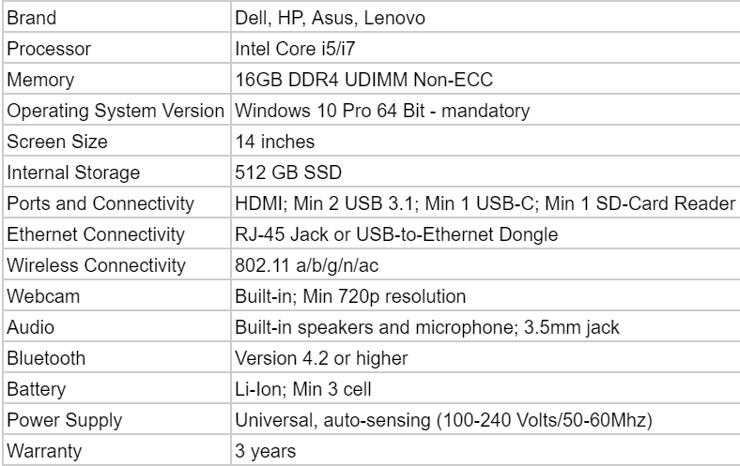 | 33
Monitor | 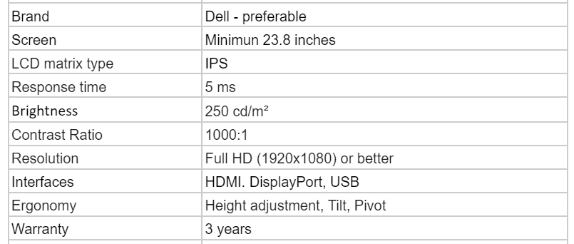 | 24
Hdmi cable | Hdmi cable for monitor (1.5 m) | 24
Mouse | 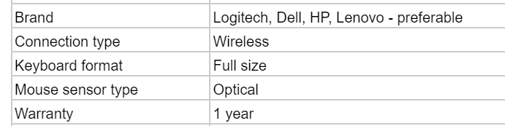 | 33
Keyboard |  | 25
Cell phone | 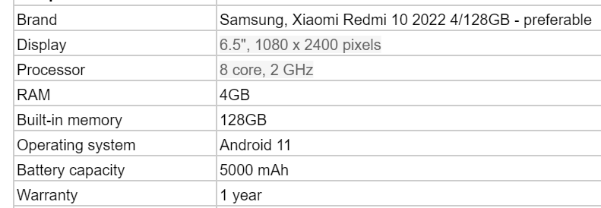 | 24
Stereo Headset | 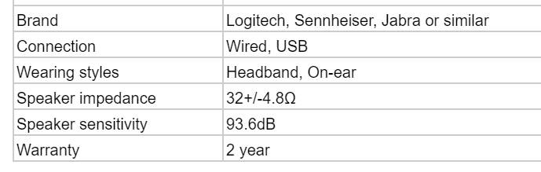 | 25
Accessories | Carrying bag for Laptop | 33

The desired delivery period is up to 7 days upon issuing of PO. The quotation shall be valid at least for 3 month after the closing date.

If you are interested in submitting a quotation for these items, kindly fill in the attached Quotation Form and send by email to the address indicated below:
Contact person | Iryna Bohun
Email address | ua-procurement@unfpa.org

Please submit your quotation in UAH currency. Conversion of currency into the UNFPA preferred currency, if the offer is quoted differently from what is required, shall be based only on UN Operational Exchange Rate prevailing at the time of competition deadline.

Your earliest response to this query would be highly appreciated, but not later than 03/10/2022, 17:00 Kyiv time.

Note: Current UNFPA supplier policies apply to this solicitation and can be found at: http://www.unfpa.org/suppliers.

Best regards,
Anastasiia Baibuzenko
Procurement and Logistics Associate
Email: baibuzenko@unfpa.org

Quotation Form

Name of Bidder:
Date of Bid:
Request for Quotation No: UNFPA/UKR/RFQ/22/29
Currency of Bid price: UAH
Delivery time (weeks from receipt of order till dispatch): 7 days
Expiration of Validity of Quotation (The quotation shall be
valid for a period of at least 3 months after the Closing date.):3 month
Price Schedule:
No. | Item | Specification | Q-ty | DAP Unit price, VAT free | Total
1 | Laptop |  | 33
2 | Monitor |  | 24
3 | Hdmi cable |  | 24
4 | Mouse |  | 33
5 | Keyboard |  | 25
6 | Cell phone |  | 24
7 | Stereo Headset |  | 25
8 | Carrying bag for Laptop |  | 33

In your offer, please include:
- Specific technical specifications of products offered
- Quality standard of the products
Vendor’s Comments:

I hereby certify that this company, which I am duly authorized to sign for, accepts the terms and conditions of UNFPA (http://www.unfpa.org/resources/unfpa-general-conditions-contract ) and we will abide by this quotation until it expires.

Name and title Date and Place

