# Annex 5- Technical Specifications and Design

This annex outlines the technical specifications and design requirements for vehicles procured for police mobile groups to respond to domestic violence and gender-based violence (GBV) incidents. The vehicles are intended for use by the National Police of Ukraine in difficult road conditions and must be equipped with special equipment and supplies. All vehicles must comply with the state standards, technical conditions, and environmental regulations applicable in Ukraine.

1. Technical Specifications and additional requirements:

| **Parameter** | **Description** |
| --- | --- |
| ***Year of manufacturing:*** | |
| *Not earlier than* | 2023 |
| ***Body:*** | |
| *Type* | Crossover |
| *Color* | White |
| *Number seats ( inc.driver),pcs.* | At least 5 |
| ***Engine:*** | |
| *Type* | Gasoline, Diesel, Hybrid |
| *Working volume (cm³)* | 1450 to 3000 |
| *Maximum engine power (hp)* | At least 100 |
| *Maximum speed (km/h)* | At least 160 |
| *Emission standards* | Minimum Euro 5 |
| ***Transmission*** |  |
| *Gearbox* | Automatic |
| *Number of gears* | At least 6. |
| ***Chassis and suspension:*** |  |
| *discs* | light alloy, tires R17 |
| *Wheel drive* | 4WD (4 х 4) |
| *Clearance (mm)* | At least 180 |
| *Front suspension* | Independent, spring with MacPherson struts and anti-roll bar |
| *Rear suspension* | Independent, spring with two double wishbones and anti-roll bar |
| ***Steering:*** |  |
| *Power steering* | Electrical |
| *Steering orientation* | Left Side |
| ***Braking system:*** |  |
| *Type* | Hydraulic with amplifier |
| *Front wheels* | Brake discs |
| *Rear wheels* | Brake discs |
| ***Climate in the cabin:*** |  |
| *Front seats* | Climate control |
| *Back seats* | Climate control (optional and will be considered as an asset) |
| ***Safety:*** |  |
| *ABS* | Anti-lock braking system (ABS); |
| *Airbags* | For the driver and passenger (at least 4 pcs.); |
| *Reinforced bumpers* | Protective front arches or reinforced bumper |
| *Engine Protectio*n | Metal engine compartment protection |
| ***Additional Equipment*** |  |
|  | Spare Wheel: Full-size (Disc diameter at least 17 inches) |
|  | Anti-theft device Immobilizer |
|  | Central door lock: With remote control |
|  | Parking assistance: Parktronic (safe parking device) |
|  | Windows: Armored anti-shock film (4 mil) |
|  | Threshold protection: Protective film (200 microns) |
| ***Other Features*** |  |
|  | The seats must be equipped with covers made of wear-resistant materials and basic safety belts with fasteners; |
|  | sound and light (LED) signal devices (signal-loud-speaking device, LED bar with blue and red strobe lights) with capacity of 100 Wt at least mounted on a special console on the roof; |
|  | Searchlight: Electrical or mechanical control - next to the seats, in an easily accessible and convenient place, installed control unit with special light and sound signaling devices and the device for electric or mechanical control of the searchlight; |
|  | Multimedia system/Car Play/Android Auto with GPS navigation + GPS Tracker |
|  | Radio: VHF car radio station (Range: 148 – 174 MHz)  Range of operating frequencies MHz:148 – 174 ( the radio wave range to be additional agreed with local police department):  Programming of the grid pitch: 12.5 kHz and 25 kHz with frequency deviation +/- 2.5 kHz and 5 kHz, respectively  Sensitivity of the receiver not worse than 0.25 μV at a signal to noise ratio (SINAD) 12 dB |
|  | Cameras: Front and rear video recording during movement |
|  | Winter tires: Must be provided |
| ***Warranty obligations:*** | Duration: minimum two years or 100,000 km from the date of delivery and commissioning  Repair and Maintenance: Warranty services should include regular maintenance checks and repair services at no additional cost.  Authorized Service Centers: Warranty services must be carried out by authorized service centers in Ukraine. The bidder must provide a list of these authorized centers along with their locations and contact details.  Documentation:  - The supplier must provide an official letter indicating the authorized local dealer that will provide warranty services, after-sales support, installation (where applicable), and commissioning.  - The supplier must provide a detailed warranty document outlining the terms and conditions, claim procedures, and contact information for warranty services.  - A warranty card must be included with each vehicle, indicating the start date of the warranty period. |

1. **Design and Logo Requirements:**

The vehicles must comply with DSTU 3849:2018 Road transport standards for color schemes, recognition signs, and special signals. The 'Поліція проти насильства' logo must be placed on the back door of the car.

Colors:

* Blue – 5002 RAL
* Yellow – 1021 RAL
* Black – 9017 RAL
* Gray - 9007 RAL

(Hybrid or summer film with a stretch coefficient of at least 150%)

**Side view**

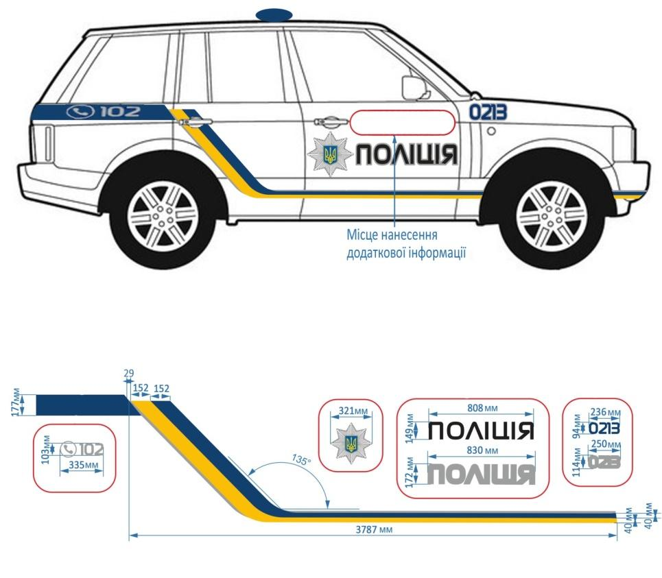

**Up view**

**Front view Back view**

