Addendum 1 to RFQ No.UNFPA/UKR/RFQ/20/07
 | Venue of the event |  | Kyiv / TBC (President, Dnipro will not be considered)
# | List of required services | Comments / additional notes | Unit Price (UAH) | Quantity, units/rooms | Quantity, units, days… | Total (UAH)
1 | Conference room | Such as Depo, Hilton, Park Avenue |  | 1 | 1 | 0.00
 | - Located in the citycentre;
 | - good Wi-Fi connection
 | - availability of daylight will be an asset
 | - seating arrangement: theatre
 | - at least 200 m2
 | - possibility to arrange an exhibition within the hall (apporx. 30-35 pictures A3-A2 format on tripods)
2 | Equipment |  |  | 1 | 1 | 0.00
 | - Led/plazma screen connected with 2 screens with projecors
 | - laptop
 | - 2 microphones and sound system
 | Furniture |  |  | 1 | 1 | 0.00
 | - tables: 2 for registration; 1 for promo materials
 | - Tribune
 | - Podium 5*3m
 | - 4 armchairs and a coffee table for speakers on the podium
 | Accomodation
 | Standard single bed room (10 participants) | at a nearby hotel, 4 stars, breakfast incl. |  | 10 | 1 | 0.00
 | Meals
 | Mineral water (0,5 l) still/sparkling - 50/50 |  |  | 100 | 3 | 0.00
 | Coffee break | Reinforced. Less pastry more healthy food (fruits, granola, yogurt etc.) |  | 100 | 2 | 0.00
 | Lunch | "Swedish line" format, vegetarian dishes must be incl. |  | 100 | 1 | 0.00
 | Transfer
 | Railway/bus tickets reimbursment | roundtrip per person UAH 1500 |  | 10 | 2 | 0.00
 | Printing materials
 | 160 g/m2, A4, matt, black&white |  |  | 100 | 50 | 0.00
 | 160 g/m2, A4, gloss, color |  |  | 100 | 50 | 0.00
 | Branded materials
 | Notebooks with UNFPA and donor logos on cover page and on each page inside |  |  | 110 | 1 | 0.00
 | Eco-pen with UNFPA and donor logo |  |  | 110 | 1 | 0.00
 | SDG pins (metal, round, d=2.5 cm, on magnet, with full colour drawing) | tech.specification is on the next sheet |  | 110 | 1 | 0.00
 | Bedge (on glue) |  |  | 110 | 1 | 0.00
 | Eco bags 40*35 cm, lenth of a handle - 60 cm, color - wet asphalt | photo is on the next sheet;  contacts of a producer's representative:  063 400 34 72 Maryna Poltavets |  | 100 | 1 | 0.00
 | Banner 5*3 m |  |  | 1 | 1 | 0.00
 | Photograph's services | all day long |  | 1 | 1 | 0.00
 | Services on simultaneous translation |  |  | 1 | 1 | 0.00
 | incl. equipment (both, earphones, etc.)
 | Moderator's services | remuneration UAH 20 000 |  | 1 | 1 | 0.00
 | Event manager support |  |  | 1 | 1 | 0.00
 | Total |  |  |  |  | -
 | Service fee
 | Total net of VAT: |  |  |  |  | -

Bag photo
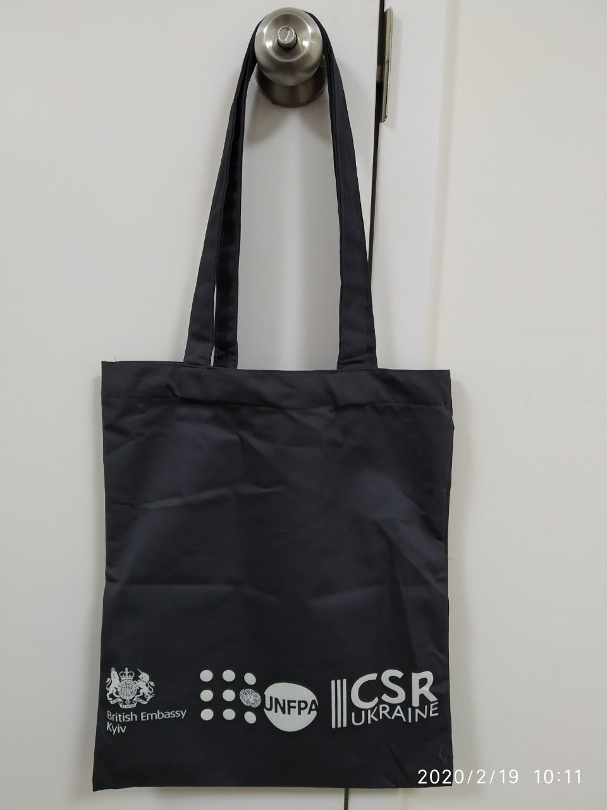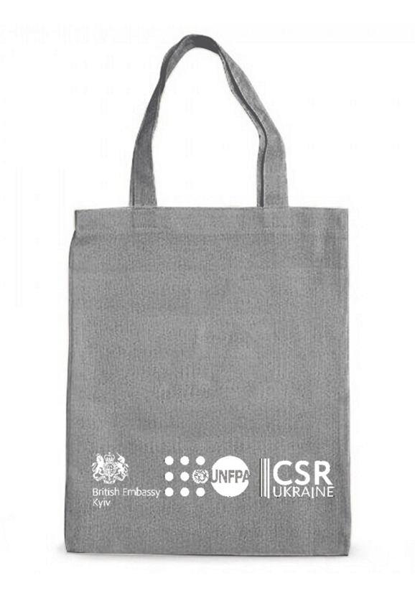

SDG pins Tech.Spec
